Simple Program Design

"Chapter 9: Further modularisation, cohesion and coupling"
Chapter Outline
Further modularisation, cohesion and coupling
Steps in Modularisation
Module cohesion
Module coupling
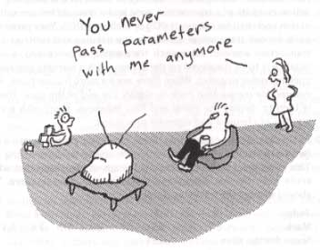

Steps in Modularisation
1. Define the problem.
2. Group the activities into subtasks or functions.
3. Constract a hierarachy chart.
4. Establish the logic of the mainline of the algorithm.
5. Develop each successive module.
6. Desk check the solution.

Example 9.1 Calculate vehicle registration costs
A program is required to calculate and print the registration cost of a new vehicle that a customer has ordered. The input details required are:
Owner's name
Vehicle make
Vehicle model
Weight (in kg)
Body type (sedan or wagon)
Private or business code ('P' or 'B')
Wholesale price of vehicle
The vehicle registration cost is calculated as the sum of the following charges:
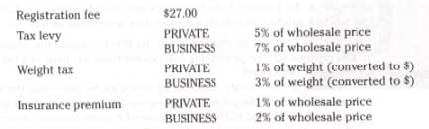
The output on the screen is as follows:
Vehicle make:
Vehicle model:
Body type:
Registration fee:
Tax levy:
Weight tax:
Insurance premium:
Total registration charges:
Federal tax:
Total amount payable:

A Define the problem
Here is the IPO chart for the Vehicle Registration problem..
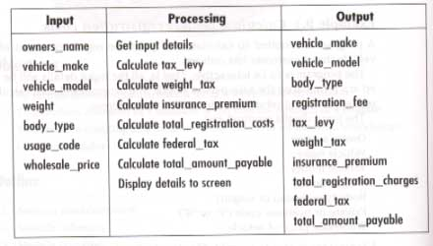

B Group the activities into modules
The activities in the processing component can be grouped into three main functions, as follows:
1. Get input details.
2. Display details to screen.
3. Calculate the total amount payable.

C Construct a hierarchy chart
Here is a Structure Chart for the problem.
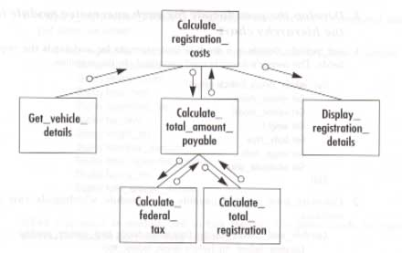

D Establish the logic of the mainline of the algorithm using pseudocode
The mainline requires a DOWHILE loop and calls to the modules as required.
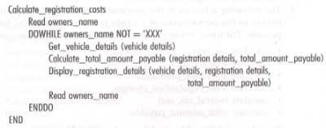

E Develop the pseudocode for each successive module in the hierarchy chart.
Here is the get vehicle details module.
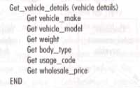
Here is the calculate total amount due module.
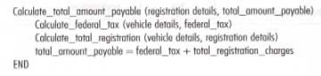
Here is the calculate federal tax module
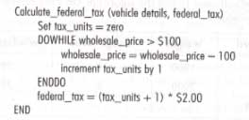
Here is the calculate total registration module.
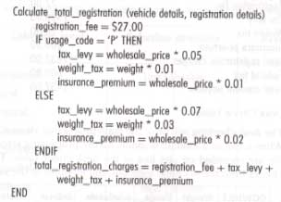
Finally, here is the Display registration details module.
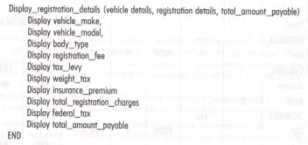

F Desk check the solution algorithm
Here is the test input data.
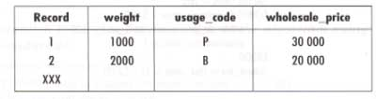
Here are the expected results.
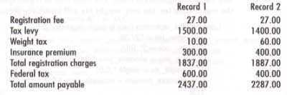
Here is the condensed desk check table.
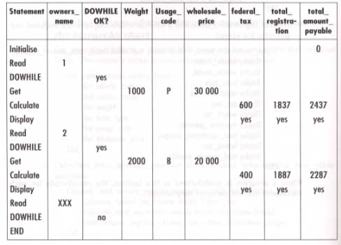

Module Cohesion
A module performs a single function, has a single entry and a single exit. Cohesion is a measure of how well the code of a module fits together in doing a single function! Here is a chart of different types of cohesion.
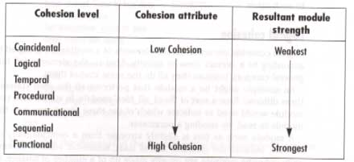

Coincidental cohesion
The weakest form of cohesion a module can have is coincidental cohesion. It elements have no meaningful relationship. It might occur on older systems because a module couldn't have more then 50 program statements! Here is an example of a coincidental cohesion module.
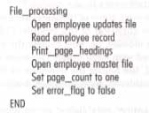

Logical cohesion
Logical cohesion occurs when the elements of a module are grouped together according to a certain class of activity. Here is an example of logical cohesion in the module read all files.
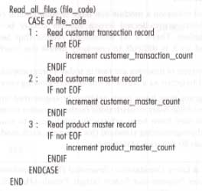

Temporal cohesion
Temporal cohesion occurs when the elements of a module are grouped together because they are related by time. Initialization and finalization module are examples of this.
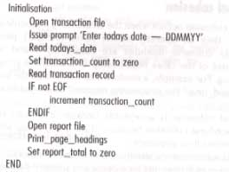

Procedural cohesion
Procedural cohesion occurs when the elements of a module are related because they operate according to a particular procedure, or sequence of execution. The following read student records and total student ages is such a module. The "and" in its name tells that it doesn more than one function!
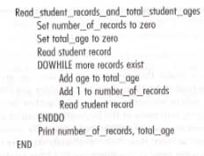

Communicational cohesion
Communicational cohesion occurs when the elements of a module are grouped together because they all operate on the same (central) piece of data. Here is an example in the validate product record module.
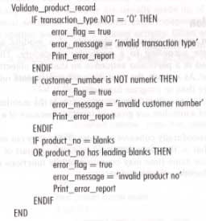

Sequential cohesion
Sequential cohesion occurs when a module contains elements that depend on the processing of previous elements. The following process purchase has sequential cohesion.
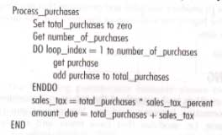

Functional cohesion
Functional cohesion occurs when all the elements of a module contribute to the performance of a single specific task. The following calculate sales tax module has functional cohesion.
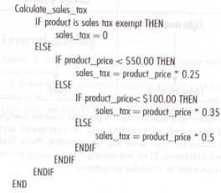

Summary of cohesion levels
When designing modules, try to form modules that have a single problem-related function. If functional cohesion is achieved, the modules will be more independent, easier to read and understand, and more maintainable than modules with lesser cohesion.

Module Coupling
When designing a program, look not only at the cohesion of modules but also at the flow of information between modules. The connections between modules are called interfaces or couples. Tight coupling implies large dependence on the struture of one module by another. Losse coupling makes for more independent and easier to maintain modules. Here is Yourdon and Constantine's coupling scale.
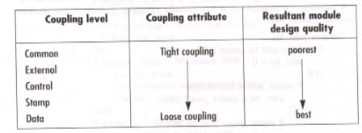

Common coupling
Common coupling occurs when modules reference the same global data structure. A data structure is a collection of variables.
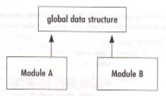
The following pseudocode example shows two modules that experience common coupling because they both access the customer record.
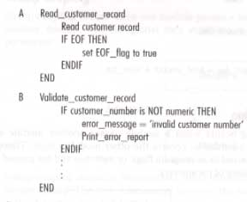

External coupling
External coupling occurs when two or more modules access the same global data variable.
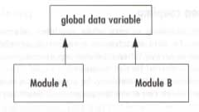
The following shows that two modules both access the sale_tax data item.
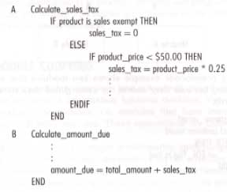

Control coupling
Control coupling occurs when a module passes another module a control variable that is iintended to control the other module's logic.
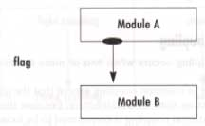
Here is one module passing another a control parameter.
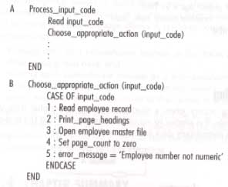

Stamp coupling
Stamp coupling occurs when one module passes a non-global data structure to another module.
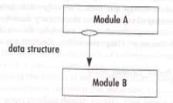
Here, one modules passes another the current_record data structure.
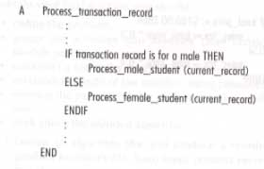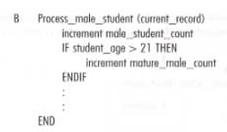

Data coupling
Data coupling occurs when a module passes a non-global data variable to another module.
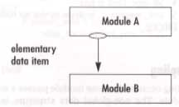
Here the total_price and sales_tax varaibles are passed to another module.
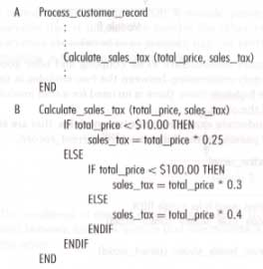

A summary of coupling levels
You should aim towards module independence and a minimum of information interchange between modules. 1. Pass data to a subordinate module in the form of parameters. 2. Write each subordinate modules as a self-contained unit that can accept data as parameters and not modify global data.

