P33

1. Convert the following repeating decimal into a fraction of integers: $3.015842384238423⋯$
2. Suppose in the ancient Mayan calendar, the above decimal expression was a ‘special’ number in which, using the Mayan cycle that 1 pictun $≈7885$ years, that the 7885th digit after the decimal has a special significance as to whether the ‘end of the world’ would occur in 2012 if the digit came out to be a 4 (since there are 4 seasons). What is the 7885th digit after the decimal? Does the end of the world happen in 2012?

P34. In base-10**, 1 mayan calabtun $≈157,000 years.$** Convert this number to the special ‘Mayan’ base-9 system:

|  |  |  |  |  |  |
| --- | --- | --- | --- | --- | --- |
| $$9^{5}=59049$$ | $$9^{4}=6561$$ | $$9^{3}=729$$ | $$9^{2}=81$$ | $$9^{1}=9$$ | $$9^{0}=1$$ |
|  |  |  |  |  |  |

P35. Draw or paste in graph paper of a labeled AREA MODEL depiction of the computation for: $$\frac{{2104}_{5}}{23_{5}}$$

P36. Using BASE X, divide the following and express your answer polynomial form: $\frac{9x^{7}+9x^{6}-x^{5}+5x^{4}+7x^{3}-x^{2}+2}{3x^{3}+x^{2}+2}$

P37-38. (Do bottom two only) (i) Using balance scale drawings, determine the number of chips needed to replace each box in order for the scales to balance. (ii) Then using *x* to represent the number of chips for each box, write the corresponding equation that represents each scale and solve the equation.

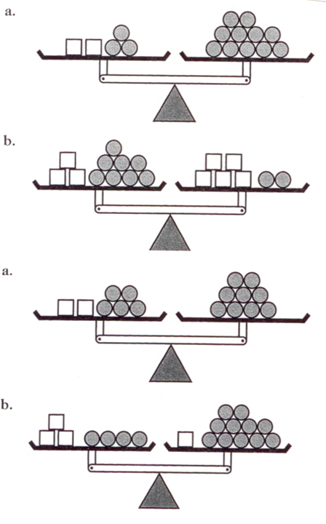

P39. Find the quadratic in the form of $ax^{2}+bx+c=y$ through the points (1, 53) (-1, 29) & (-2, 35).

P40. Based on what you found in the previous problem:

1. Sketch a graph by completing the square and putting the equation in the form $y=a{(x-h)}^{2}+k$ and labeling the graph with the vertex, and roughly the location of the original three points. Scale your graph appropriately to fit below.
2. Factor the quadratic equation you found in P39 using the cloud method and using that factoring, find the ‘roots’ of the equation and include them in your graph below also.