Lab 8: More Sample Final Exam Problems

Deadline/ Grading for Lab 8: attendance and diligent work on Lab 8 during class on Tuesday, Dec. 5 earns 10 points towards Lab 8. Students who need to make up this lab may submit completed work on or before Tuesday, Dec. 12 (at the final or to their instructor’s office by 5 p.m.).

How to work on the lab: for each problem,
- Identify the type of problem (corresponding to the study guide).
- Discuss with your partner what you need to know/ be able to do to solve this type of problem.
- Indicate (in writing) your solution process(es) for this problem.
- Carry out your solution process (using Maple if you wish to help with computations, graphics, etc., and/or to check numerical solutions). Can you solve the problem or verify the reasonableness of your solution in more than one way? If submitting Lab 8 to your instructor, show coherent and complete work.

- A rectangle is expanding in such a way that the area is increasing at a rate of 50 in/min and the base is increasing at a rate of 5 in/min. At what rate is the height changing when the base is 10 in. and the area is 40 in²?

- If 1200 cm² of material is available to make a box with a square base and an open top, find the largest possible volume of the box.

- Find the point on the line $−4x+2y=\text{15}$ that is closest to $(−2, 1)$.

- The number of bacteria in a culture at time t is given by $N=\text{1000}(\text{25}+{\text{te}}^{−t\text{20}})$ for $0≤t≤\text{100}$. Find the largest and smallest number of bacteria in the culture during this interval.

- A TV camera is positioned on the sidelines of a soccer field. A player receives the ball directly opposite the camera and 10 meters away from it, and dribbles towards the opposing team’s goal at a rate of 5 meters per second. How fast is the distance between the player and the camera increasing when the player has gone 24 meters?
camera
player receives ball here

- A cylindrical soda can must hold 240 ml of soda. Find the radius of the can that can be made using the least amount of material. (1 ml is 1 cubic centimeter, i.e. 1 ml = 1 cm³.)

- Water flows from the bottom of a storage tank at a rate of $r(t)=\text{200}−4t$ liters per minute, where $0≤t≤\text{50}$. Find the amount of water that flows from the tank during the first 10 minutes.

- Santa’s elves increase their rate of toy production throughout the year. The rate of production after t weeks is $\text{1000}\sqrt{\text{10}t+\text{40}}+\text{4047}$ toys/week. How many toys do the elves produce during the first 10 weeks of the year?

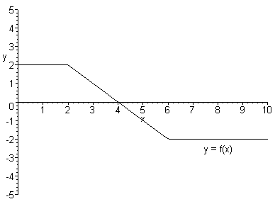
- Say $F$ is an antiderivative of f, and $F(0)=1$. The function f is shown here. Find

a) F(2) b) F(6) c) F(10)

- The graph shows $f(x)$. Answer the questions about $F(x)$, the antiderivative of f.
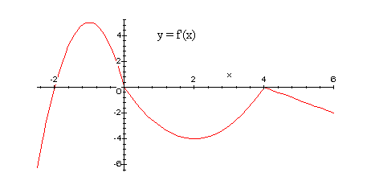
a) On what intervals is F increasing? b) On what intervals is F decreasing?

c) On what intervals is F concave up? d) On what intervals is F concave down?

e) Which is greater, $F(2)$ or $F(4)$? f) Say $F(2)=0$. Sketch $F(x)$.

