Sample Exam 1, Calculus I, F’06

Directions: Show, in an organized fashion, any work you want considered. Erase or cross out scratch work that you do not want considered. (Partial credit will be awarded for partially correct work or reasoning.)

12 1a) For the function f whose graph is given, state the value or that it does not exist (DNE).
$\underset{x→−2^{−}}{\text{lim}}f(x)$ $\underset{x→−2^{+}}{\text{lim}}f(x)$ $\underset{x→−2}{\text{lim}}f(x)$ f(-2)
$\underset{x→0^{−}}{\text{lim}}f(x)$ $\underset{x→0^{+}}{\text{lim}}f(x)$ $\underset{x→0}{\text{lim}}f(x)$ f(0)
$\underset{x→1^{−}}{\text{lim}}f(x)$ $\underset{x→1^{+}}{\text{lim}}f(x)$ $\underset{x→1}{\text{lim}}f(x)$ f(1)
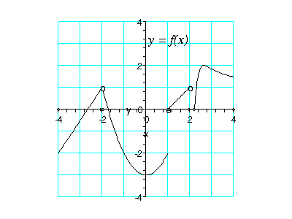
8 b) Analyze the continuity (or discontinuity) of the graph at x = -2, x = 0, and x = 1. Explain in terms of limits, that is, by making clear reference to the definition of continuity.

10 2. Sketch a graph for a function f that satisfies all of the given conditions.
$\underset{x→−∞}{\text{lim}}f(x)=2$ $\underset{x→∞}{\text{lim}}f(x)=0$ $\underset{x→1^{−}}{\text{lim}}f(x)=−∞$ $\underset{x→1^{+}}{\text{lim}}f(x)=∞$ $f(−2)=3$

9 3. Evaluate the following limits. Show your work or briefly (2 – 10 words) give your reasoning.
a) $\underset{t→1}{\text{lim}} t^{3}+3$

b) $\underset{x→−2}{\text{lim}} \frac{x^{2}−x−6}{x+2}$

c) $\underset{h→0}{\text{lim}} \frac{{\left(x+h\right)}^{2}−x^{2}}{h}$
10 4. Use the definition of the derivative to find $f^{'}(x)$ for the function $f(x)=2x^{2}+5$. Show work.

10 5. Find the equation of the tangent line to the function $h(x)=\text{sin}(x)+\text{tan}(x)$ at $x=π3$. Show complete work. Write a sentence as to whether you believe your answer (and why). Give exact values, e.g. $\sqrt{3}2$, not 0.866.
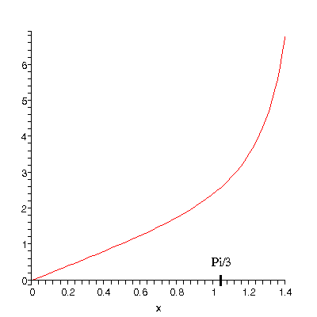
9 6. Use the values given in the table to find the derivatives indicated. Show intermediate steps.
$$x$$ | 0 | 1 | 2 | 3 | 4
$$f(x)$$ | 4 | 1 | 1 | -3 | 4
$$g(x)$$ | 3 | -2 | 2 | -2 | 3
$$f^{'}(x)$$ | 0 | -1 | -3 | -1 | 2
$$g^{'}(x)$$ | -2 | 1 | 4 | 0 | 1

a) $H(x)=f(x)g(x)$; find $H^{'}(2)$

b) $J(x)=\frac{f(x)}{g(x)}$; find $J^{'}(2)$

c) $K(x)=f\left(g(x)\right)$; find $K^{'}(0)$

12 7. Find derivatives of the following functions. Show your work or briefly (2 – 10 words) give your reasoning.
a) $y=t\sqrt{t}$

b) $f(x)=\frac{x^{2}−x−6}{x+2}$

c) $g(x)= {πx}^{3}−\text{cos}x+\sqrt{\text{20}}$
10 8. An astronaut standing on the moon throws a ball straight up into the air with an initial velocity of 40 m/s. The height of the ball in meters after t seconds is given by
$s(t)=\text{40}t−2t^{2}$.
a) Find the average velocity of the ball between 1 second and 3 seconds.

- Find the instantaneous velocity of the ball at 3 seconds.

10 9. Arrange the following numbers in increasing order and briefly explain your reasoning:
0, $f^{'}(1)$, $\frac{f(3)−f(1)}{2}$, $f(2)−f(1)$
10 10. Show that there is a root of the equation $f(x)=\sqrt[3]{x}+x−1$ in the interval (0,1). Show work/ give reasoning.

10 11. Find the value of c that makes the function continuous on the interval $\left(−∞,∞\right)$. Show work/ give reasoning.
$$f(x)=\left\{\begin{matrix}\text{cx}+3 & x∈(−∞,2] \\ (x−3)^{2}+c & x∈(2,∞)\end{matrix}\right.$$

5 Extra Credit: The graph shown is that of the function$f(x)=\frac{1}{x^{2}}$. Note that $\underset{x→2}{\text{lim}}f(x)=0\text{.}\text{25}$.
Find a number $δ$ such that $\left| f(x)−0\text{.}\text{25} \right|<0\text{.}1$ whenever $\left| x−2 \right|<δ$. Sketch or write enough to indicate your reasoning.
