1(a) f(x)=2^x-3

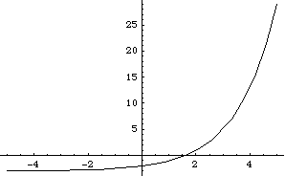

1(b) g(x)=-e^(-x)/2+1

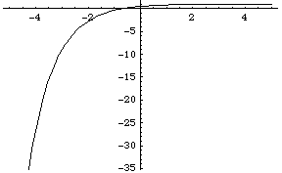

1(c) h(x)=ln(1+x)

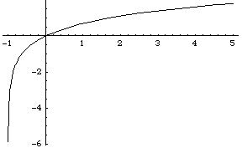

1(d) y=log_5(x-1)

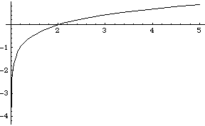

5(a) x=2t, y=3t^2

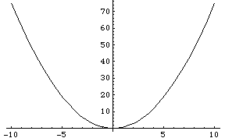

5(b) x=2cos(t), y=3sin(t)

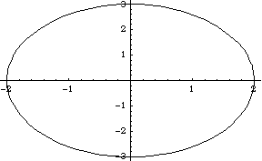

For some reason mathematica refuses to draw in polar coordinates… Please come to my office hours if you have questions about the following two curves.

5(c) r=-2theta consists of 2 spirals (one for positive theta and one for negative theta)

5(d) r=cos(5theta) is a rose with 5 leaves

5(e) x-y^2-2y-3=0

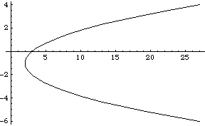

5(f) x^2+y^2-2y-3=0

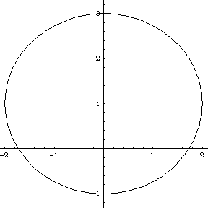

5(g) 4x^2+y^2-2y-3=0

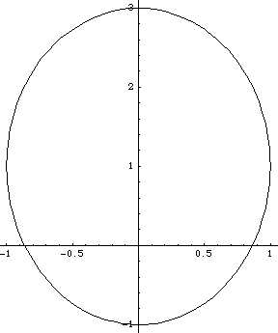

5(h) 4x^2-y^2-2y-3=0

