Mathematica project solutions

ParametricPlot[{t - Sin[t], 1 - Cos[t]}, {t, -Pi, 3Pi}]

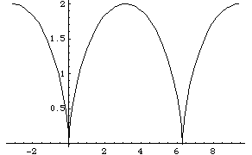

Area:
NIntegrate[(1 - Cos[t])^2, {t, 0, 2\[Pi]}]
9.42478

Arc length:
Integrate[((1 - Cos[t])^2 + (Sin[t])^2)^(1/2), {t, 0, 2\[Pi]}]
8

Surface area (rotate about the x-axis):
2Pi*NIntegrate[(1 - Cos[t])*((1 - Cos[t])^2 + (Sin[t])^2)^(1/2), {t, 0, 2Pi}]
67.0206

Surface area (rotate about the y-axis):
2Pi*NIntegrate[(t - Sin[t])*((1 - Cos[t])^2 + (Sin[t])^2)^(1/2), {t, 0, 2Pi}]
157.914

Extra credit:
Volume (rotate about the x-axis):
Pi*NIntegrate[(1 - Cos[t])^3, {t, 0, 2Pi}]
49.348

Volume (rotate about the y-axis):
2Pi*NIntegrate[(t - Sin[t])(1 - Cos[t])^2, {t, 0, 2Pi}]
186.038

