
IS 130: Management Information Systems
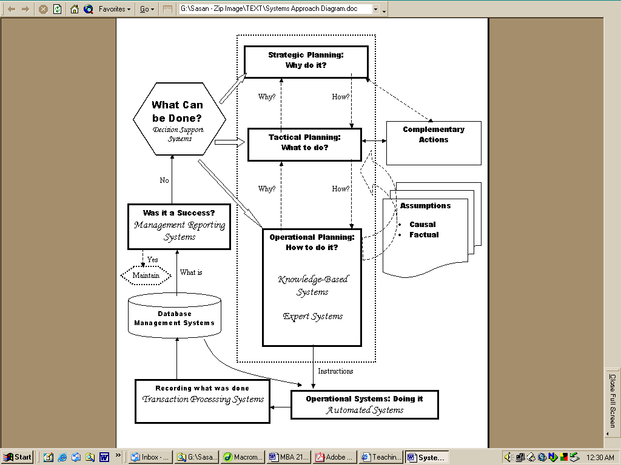
Summer 2007
Details that will be determined later are designated as:
................................ in this document

COURSE
Number of units: 3
CSUF Location: PB 134
Time: ......................................

INSTRUCTOR
Sasan Rahmatian, Ph.D. (sa-san’ ra-ma’-ti-yan)
Peters Building 247
- Phone: 278 – 4376
- Fax: 278 – 4911
- E-mail: sasanr@csufresno.edu

Office Hours:
- ..................................
Please notify me in an advance by email if you need to talk to me in my office so I keep that time slot open for you.

PREREQUISITE
IS 52 and 52L or demonstration of computer literacy; upper-division standing; BA 105W or ENGL 160W (may be taken concurrently)

COURSE DESCRIPTION
Most managers are informationally overfed but undernourished. While they are bombarded with tons of irrelevant data, they seldom get the right information in the right form at the right time. They don’t receive the right information to set goals for the organizational unit under their control, to find out if they are meeting those goals and – if they are not – to understand why not, and what to do about it. Sometimes they are not even sure what information they want. To make it worse, the information they say they want may actually not be the information they really need! And once they determine what information they want/need, it is often not clear what steps they go through to acquire information systems that deliver that information.

The use of information systems is not limited to providing information. Modern information systems help organizations of all types to re-engineer their day-to-day operations in such a way as to achieve substantial gains in efficiency as well as the ability to compete effectively. Hence, they have become important strategic tools.

This summer course is very special in that almost half of it will be conducted in Paris, France. As such, we will take advantage of this unique opportunity to introduce information systems concepts and practices not ordinarily associated with domestic, uni-national information systems. We will explore global information systems and how they have transformed global corporations. This will lead to a solid understnading of globalization issues as manifested through the prism of information systems.

This course presents the following challenges to you as a (prospective) manager, administrator, or executive, and gives you the concepts/theories/tools to deal with them constructively:
- Do you have systems in place that tell you whether/how well you are meeting your goals?
- Do you have systems that highlight poor performance areas and help you drill down all the way to details that reveal the real trouble spots?
- Are your strategic business processes so transparent that you can flowchart them?
- Do you systematically feed information about your actual performance levels back to your operational staff so the necessary operational adjustments/improvements may be made?
- Do you have systems that support you in making complex decisions?
- Do you have systems in place for capturing the experience of your operational staff and making it available to others so they don’t end up making the same mistakes?
- Are your operations at the appropriate level of automation?
- Do you run your operations with proper support from web-based technologies?
- Do your day-to-day operations capture and record the right data for later reporting/analysis?
- Are these data stored and organized the right way?
- Do your emplyees, at various oragnizational levels, use appropriate communication tools to collaborate and coordinate their activities?
- When taking your company global, what unique trans-domestic, boundary-crossing factors do you need to consider in the analysis, design, implementation, and operation of your information systems, and what impacts will these global systems have on your operations as well as on your strategic performance.

We will address the above not as unrelated issues, but as integrated within a powerful framework known as the systems approach. After studying the systems approach, we will derive from it the various application domains of information systems: Transaction Processing Systems, Database Management Systems, Management Reporting Systems, Decision Support Systems, Knowledge-based Systems, Expert Systems, Automated Systems and Collaborative Support Systems. Each application domain will be explored in some detail. Next, we will examine how information systems are developed and implemented by understanding the concept of systems development life cycle and – within that framework – exploring a variety of management issues pertaining to successful systems development. Finally, we will look at the security and ethical issues involved in managing information systems.

Upon completing this course, you should:
- Understand the systems approach to problem solving, and the supporting role played by information systems.
- Be able to identify strategic opportunities offered by information systems stemming from both interfunctional integration of a digital firm as well as IS-driven market globalization.
- Be able to identify and apply the various application domains of information systems (transaction processing systems, decision support systems, expert systems, etc.).
- Appreciate the role played by data as an organizational resource that needs to be collected, stored, controlled, and processed into useful information.
- Understand the role of information in managerial decision making and specifically its contribution to the quality of business decisions.
- Be familiar with the various phases and issues involved in systems development.
- Acquire information systems vocabulary and understanding of technical concepts at the level sufficient to articulate their functional information requirements while working with system analysts at various stages of information system development cycle.

MATERIAL
- Laudon and Laudon, “Essentials of Business Information Systems,” Pearson/Prentice Hall, 2007, 7th edition.
Don:
Please visit this website!
- Thomas Friedman, “The World is Flat,” Farrar, Straus and Giroux, 2007.
- Websites:
http://zimmer.csufresno.edu/~sasanr/Courses/IS-130/IS-130-summer-2007.htm
The above link takes you to a website developed specifically for you and this course. Please visit it now.

PERFORMANCE EVALUATION
- 20% Integration Challenge (APCOA) – Final Report
- 10% Integration Challenge (APCOA) – Annotated Bibliography
- 30% Tests (3@10%)
- 15% Final Examination
- 25% Assignments
- – ½ % points lost for inadequate One-Minute Personal Summary (OMPS)

Integration Challenge
The purpose of this individual assignment is to help you integrate the material you will learn in this course in a practical, real-world setting. It is based on a case that revolves around a familiar industry and a fictitious company in that industry. Imagine you have been assigned the role of a consultant to that company for improving the business system explained in the case. Your assignment is this: Given everything you will have learned in this course, write a report to the Information Systems Steering Committee explaining what the information systems-related issues are, why they are significant, and how information systems can be used to address them constructively. The paper (including diagrams; excluding bibliography) should be 8-10 pages, single-spaced. You can apply a great deal of what you learn in this course to this case. Your report needs to be organized and well written. It is strongly advised that you take separate notes, recording your ideas for this case as they occur to you during the course of the semester.

The case itself, along with a more detailed statement of requirements, can be found at
http://zimmer.csufresno.edu/~sasanr/Courses/IS-130/APCOA.pdf. Please do not use any binder or folder to hold the pages together. Simply staple the pages together on the upper-left corner.

Integration Challenge: Annotated Bibliography
The purpose of the Annotated Bibliography is to give you a head start on the integration challenge project. In this document, you will identify 10 sources that are relevant to the contents of the project. Each source should offer at least one idea that can be used to solve one or more of the problems to be found in the case. Number them 1 through 10. The first 3 sources to be listed must be academic sources, i.e. books or peer reviewed articles in proprietary academic journals. The other 7 sources may be obtained from the free web. For each source, specify:

- Source (10%)
Identify the source thoroughly (if a web-based source, do not just list the URL; include as much information as available, such as title, author, date, etc.). You should strictly adhere to the APA style of citation, as explained at:
http://www.english.uiuc.edu/CWS/wWORKSHOP/writer_resources/citation_styles/apa/apa.htm
Bibliographic research is an individual effort. There should be no consultation or information exchange with others in selecting your sources.
It is not acceptable to list a website as an item, no matter how useful that website is in providing services related to APCOA’s issues. You are finding ideas, concepts and principles pertaining to the APCOA case. You are not referring APCOA to useful websites and inviting them to explore those websites! Hence, by “source” is meant an article or book (whether printed or online does not matter).
- Issue (30%)
In a paragraph, identify and discuss what issue in the case is relevant to the contents of this source. For each issue, start with a short, direct quote (placed in quotes) from the case itself so the reader knows what part of the case you are referring to. Following the quote, explain in some detail why this is an issue and what its significance is. Analyze the issue within the context of APCOA without any reference to the source you have found.
- Content (30%)
In another paragraph (at least 5-7 sentences), summarize the contents of the source in your own words. Do not copy/paste from external sources.

- Relevance (30%)
In another paragraph (at least 5-7 sentences), relate the contents of the source (C) to the issue identified earlier (B): How do the ideas offered in the source help resolve those issues?

The Annotated Bibliography should be typed single-spaced, with a separate cover page. It should not include any source prior to year 2000 or any of the following:
- the textbook
- any article from wikipedia
- any handout material produced by your professor
- any required reading from class

In writing your Annotated Bibliography, use the same numbering/heading notation as above for each item discussed: “B. Issue”, “C. Content”, etc. Clearly distinguish the various sections; do not merge them.
Warning!
This is a very time-consuming assignment and will take 20-30 hours, if not longer. Plan accordingly. Do not wait until last minute.

Late submission policy:
- If you are late less than 24 hours, you lose 5 points.
- If you are late between 24 and 48 hours, you lose 7.5 points.
- Your work will not be accepted if it is over 48 hours late.

Assignments
For every class, you will be responsible for several assignments. These are to be done individually, prior to the class to which they are assigned.

How are you to do an assignment before you are exposed to a detailed explanation of the topic of that assignment?! The purpose of each assignment is to get your mental engine warmed up and in tune with the topic to which it is assigned. Each assignment is real-world and will be used as a springboard for explaining the concepts/principles behind it. The purpose of the assignments is to make your mind itch before I scratch it! Please use your common sense, intuition, and prior business knowledge in doing these assignments.

The written assignments will be graded on a pass/fail basis. Since there is an element of subjectivity involved in this, you are urged to err on the side of caution and put your best foot forward in tackling these assignments. Only unacceptable work will be returned. Hence, “no news is good news”!

Your response to each assignment should take a single page. Please type your work in Times
New Roman 12 font, single-spaced, with no cover page. On the top center, please write the assignment’s title. On the top right hand corner, please write your full name (first, last), and date. Please turn in each assignment on a separate sheet. Do not staple two or more assignments together. Do not send your homework electronically, unless you know you are going to miss a class. In that case, send it prior to class meeting.

One-Minute Personal Summary (OMPS)
For each topic, you will be assigned several words or phrases that are central to an understanding of that topic. Your task is to research each one of these concepts in sufficient detail to be able to produce a one-minute personal summary of it orally (= OMPS). This OMPS must be stated in your own words (“personal summary”) and presented in a conversational tone, as though you were speaking to a friend. The OMPS should include a concrete, real-world-like example of the concept being explained. The sources you may use for the OMPS include (but are not limited to):
- the textbook
- wikipedia (http://en.wikipedia.org/wiki/Main_Page)
- whatis.com (I wrote the URL in a way that you would remember it, although when you enter whatis.com, you will be automatically redirected to http://whatis.techtarget.com/)

You are not allowed to READ from your notes while speaking. If called on, you will be given a few seconds to read your notes and refresh your memory if you need to, but you cannot read from any source when talking to class.

Doing this homework is expected of you; it is the most basic preparation for this class. For every time that you do it unsatisfactorily, you will lose ½ % (half a percentage point) of your total course points. If after your OMPS delivery you are not contacted by me, that means your work was acceptable. If it is not acceptable, you will hear from me.

Your challenge in doing this assignment is information overload: You will find too much information about each assigned word/phrase. Your challenge is to get to the essence of it and be able to explain it to others with an example.

Do not be fooled by the short duration of your presentation. The shorter a presentation, the longer the preparation needed to collect and condense the information. Time yourself if you are not sure about the length of your presentation. “One minute” means “one minute ± 10 seconds”.

If others in class have been called on to do their OMPS on a topic before you are called on the same topic, do not reference their presentation (“as Joe said earlier, ....”).

One final piece of advice: Do not say something you don’t fully understand!

Tests
There will be three tests, and each will consist of multiple-choice questions that will be based on material from the lectures, the portions of the text referenced in class, and the material that may be assigned for your out-of-class reading. Please bring an unfolded 882 SCANTRON form to each test.

Final Examination
This will be a comprehensive exam consisting of 100 multiple questions and covering the entire material covered in the course. Please bring an unfolded 882 SCANTRON form to this exam.

Policy on Class Attendance
Attendance is mandatory and will be taken at all classes. Beyond mere physical presence, you are expected to contribute to class by volunteering to answer questions raised by me as well as by others. Your participation will not only enrich the quality of the ideas discussed in class, it will also help eliminate a monotonous lecture format.

You are entitled to one unjustified cut. Beyond that, you will lose three percentage points for every cut, unless the absence is for a legitimate reason, and is fully documented and turned in. Please make every effort to attend all classes, as your enthusiastic participation is crucial to the success of this course.

If you leave after the mid-class break, that will count as a session-long absence, unless it is for a legitimate reason and you obtain my prior permission.

Policy on Academic Misconduct
Cheating is the actual/attempted practice of fraudulent/deceptive acts for the purpose of improving one's grade or obtaining course credit; such acts also include assisting another student to do so. Typically, such acts occur in relation to examinations. However, it is the intent of this definition that the term 'cheating' not be limited to examination situations only, but that it include any and all actions by a student that are intended to gain an unearned academic advantage by fraudulent or deceptive means. Plagiarism is a specific form of cheating which consists of the misuse of the published and/or unpublished works of others by misrepresenting the material (i.e., their intellectual property) so used as one's own work. Penalties for cheating and plagiarism range from a 0 or F on a particular assignment, through an F for the course, to expulsion from the university.

The policy on academic misconduct is stated in the university catalog and can also be found at:
http://www.csufresno.edu/aps/apm/235.pdf

The “Instructor’s Report of Cheating/Plagiarism” can be found at:
http://www.csufresno.edu/aps/apm/235%20new%20instructors%20form.pdf
Please become familiar with this information, and also with the University Honor Code:

Members of the CSU Fresno academic community adhere to principles of academic integrity and mutual respect while engaged in university work and related activities." You should:
- understand or seek clarification about expectations for academic integrity in this course (including no cheating, plagiarism and inappropriate collaboration)
- neither give nor receive unauthorized aid on examinations or other course work that is used by the instructor as the basis of grading.
- take responsibility to monitor academic dishonesty in any form and to report it to the instructor or other appropriate official for action.

Grading Scale
A: 90-100%
B: 80-89%
C: 70-79%
D: 60-69%

Your course grade will be calculated strictly based on the components discussed earlier. In effect, you are not given a grade; you earn your grade. No special consideration will be given to the fact that you may be graduating in the near future.

Course Evaluation
In an effort to improve the delivery of this course, the IS 130 faculty have designed a special survey that you are required to complete online. You should take the survey on your course Blackboard ANY TIME during the regular week of evaluations.

This survey is totally independent of the standard University instructor evaluation form that may be administered in this class. Taking this survey does not release you from filling out the regular University instructor evaluation form. Conversely, filling out the standard University instructor evaluation form does not release you from doing this online survey.

The completion of this short survey is mandatory in the sense that YOUR FINAL GRADE FOR THIS COURSE WILL NOT BE POSTED UNTIL YOU HAVE COMPLETED THE SURVEY.

This is the ONLY time you will be asked to do this survey. No reminder emails will be sent out later.

Miscellaneous Rules
- Interruptions due to late arrivals are extremely distracting. Due to the large amount of material to be covered, we are going to be hard pressed for time. To be able to start every class on time, please come to class a few minutes before the expected starting time.

- Extra-credit assignments are usually irrelevant and counterproductive. You are encouraged to base your performance on the mastery of the mainstream material covered in class.

- INCOMPLETE grades will be given only under the most extenuating circumstances, which ought to be fully documented.

- If you miss a test, please contact me within 24 hours of the time the class took their test to make arrangements for taking a make-up test. Otherwise, you will receive a grade of zero for that test.

- Should you have a disability which may interfere with your performance in this class, please identify yourself to me as well as to the University so that reasonable accommodations for learning and evaluation can be made.

- Please turn off all mobile communication devices before entering class. These include beepers, pagers, and cell phones. If due to some emergency you need to be accessible in a particular class, please bring this fact to my attention before the class begins.

- You are welcome to bring your laptop to class and use it for academic purposes. You should not use it, under any circumstances, for non-class related activities, such as web surfing, emailing, text messaging, etc.

- All email messages will be sent to your official UCSF email address, the one you entered into the my.csufresno system yourself. It is important that you keep that account in good shape on a regular basis by deleting spam and other undesired message, so that it does not go “over quota”, and will keep receiving valid messages.

- This syllabus and the following schedule are subject to change in the event of extenuating circumstances. If you are absent from class, it is your responsibility to check on announcements made while you were absent.

- If you drop this course, please let me know right away.

N O T E

You can communicate with me through multiple channels. My first choice is e-mail, either for me to answer your question or for us to set up a time when your question can be discussed in person. If you call my office and need to leave a message, please speak slowly and clearly. You will have a better chance of getting an immediate reply with e-mail than with phone messages.

When sending me an e-mail, please take the time to write it well and type it correctly. Your e-mail to me is a formal means of communication and should be distinguished from the informal, casual messages you may send your friends. The fact that e-mail messages are sent easily through an electronic medium should not be an excuse for sending sloppy messages containing typographical and/or grammatical errors.

Please make full use of announced office hours to ask follow-up questions or to talk about any professional/personal matter of interest to you. If the announced office hours are not convenient for you, I will try to meet with you at times that are. Please stop by my office and give me the opportunity of knowing you better.

If you are coming to my office during office hours to ask course-related questions, please drop me an e-mail in advance just in case other students have already made appointments for that same time slot.

Finally …

I hope you will enjoy the material selected for you and the way they unfold during the sessions we spend together. If there is anything I can do to make this a more enjoyable educational experience for you, please do not hesitate to let me know.





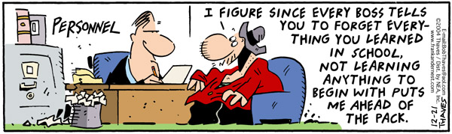
IS 130: Management Information Systems
California State University, Fresno
Fall 2007

Detailed Course Schedule
Each assignment is to be done prior to the class session to which it is assigned.

1. August 28
Course Introduction

What is MIS?
OMPS: information, business process
Assignment Due:
http://zimmer.csufresno.edu/~sasanr/Teaching-Material/MIS/What-Why-MIS/cab-calling.htm

The assignments will be collected in class separately. Do not staple!
2. September 4
The Systems Approach
OMPS: system, cybernetics, feedback

Assignments Due:
http://zimmer.csufresno.edu/~sasanr/Teaching-Material/MIS/Systems-Approach/am-I-blind.htm

http://zimmer.csufresno.edu/~sasanr/Teaching-Material/MIS/Systems-Approach/I-am-quitting-boss.htm

3. September 11
Strategic Information Systems
OMPS: strategy, customer value proposition, revenue management system

Assignments Due:
http://zimmer.csufresno.edu/~sasanr/Teaching-Material/MIS/SIS/purchasing-questions.htm

http://zimmer.csufresno.edu/~sasanr/Teaching-Material/MIS/SIS/business-impact.htm

4. September 18
Management Reporting Systems
OMPS: performance indicator, drill down, data warehouse, Hawthorne Effect

Assignments Due:
http://zimmer.csufresno.edu/~sasanr/Teaching-Material/MIS/MRS/Rewarding-Salesperson-Performance.htm

http://zimmer.csufresno.edu/~sasanr/Teaching-Material/MIS/MRS/shrinkage.htm
5. September 25
Decision Making
OMPS: decision, rational decision making, decision matrix

Assignment Due:
http://zimmer.csufresno.edu/~sasanr/Teaching-Material/MIS/DM/car-buying.htm

Decision Support Systems
OMPS: mathematical model, simulation, optimization

Assignments Due:
http://zimmer.csufresno.edu/~sasanr/Teaching-Material/MIS/DSS/hybrid-car-payoff.htm

T e s t 1 to be taken during the last 30 minutes of class

6. October 2
Knowledge-Based Systems
OMPS: implicit knowledge, organizational learning, algorithm

Assignments Due:
http://zimmer.csufresno.edu/~sasanr/Teaching-Material/MIS/KBS/slow-printer.htm

Expert Systems
OMPS: logic, knowledge engineer, artificial intelligence

Assignment Due:
http://zimmer.csufresno.edu/~sasanr/Teaching-Material/MIS/ES/investment-expert.htm

7. October 9
Operational Systems
OMPS: flowchart, process map

Automated Systems
OMPS: automation, payback period

Assignment Due:
http://zimmer.csufresno.edu/~sasanr/Teaching-Material/MIS/Automation/automation-assignment.htm

8. October 16
Transaction Processing Systems
OMPS: transaction processing

Assignment Due:
http://zimmer.csufresno.edu/~sasanr/Teaching-Material/MIS/TPS/TPS-Assignment.htm

Enterprise Systems
OMPS: ERP, supply chain management, customer relationship management

Assignment Due:
http://zimmer.csufresno.edu/~sasanr/Teaching-Material/MIS/ERP/erp-lessons.htm

9. October 23
E-Business
OMPS: Internet, World Wide Web, client-server (model or architecture), business model

Assignment Due:
http://zimmer.csufresno.edu/~sasanr/Teaching-Material/MIS/E-Bus/E-Business-Assignment.htm

T e s t 2 to be taken during the last 30 minutes of class

10. October 30
APCOA: A Guided Tour
This class will give you the foundation required for doing your Integration Challenge (APCOA), both the Annotated Bibliography and the Final Report.

You don’t want to miss this class!
In this session, I will
- go over the Integration Challenge requirements
- read the case “for you” and “with you”
- teach you how to think about the case
- answer your questions

11. November 6
Database Management Systems
OMPS: database, query language

Assignments Due:
http://zimmer.csufresno.edu/~sasanr/Teaching-Material/MIS/DBMS/Information-Power.htm

http://zimmer.csufresno.edu/~sasanr/Teaching-Material/MIS/DBMS/database-assignment.htm
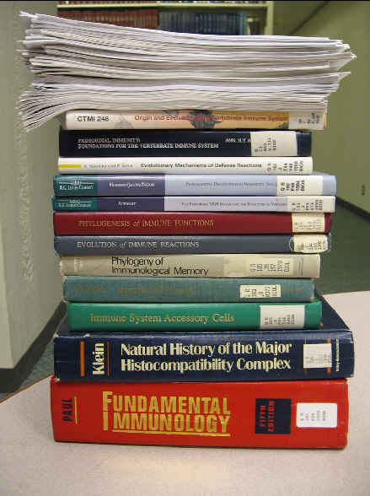
12. November 13
Due: Integration Challenge – Annotated Bibliography

Collaborative Support Systems
OMPS: “the medium is the message”, groupware (= collaborative software)

Assignment Due: to be announced.

13. November 20
The Systems Development Life Cycle
OMPS: design, systems analysis, business case

Assignment Due: to be announced.

14. November 27
Alternative Systems Development Approaches
OMPS: prototyping,

Assignment Due: to be announced.

Information Systems Security
OMPS: denial of service WORM, hacker, trojan horse

Assignment Due: to be announced.

15. December 4
Information Systems Ethics
OMPS: golden rule, categorical imperative, situation ethics

Assignment Due: to be announced.

Due: Integration Challenge Report (APCOA).
This report is due at precisely the time the session is supposed to start. Any report turned in late (even by a minute) during this period, will receive partial credit. Any report turned in late after the class is over will not be accepted.

Class Discussion of APCOA

T e s t 3 to be taken during the last 30 minutes of class
16. December 11
To be announced.

December 18, 8 - 10 PM
Final Examination







