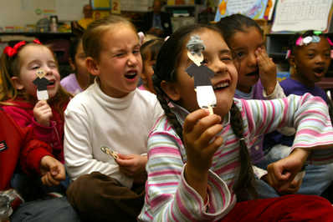
Diana Baldrica / The Fresno Bee
From left, Mackensey Souza, Maleah Donaldson and Anmal Chatrath sing a pirate song Thursday with their "Mr. Beethoven" puppets. Labendeira's kindergarten class is using the puppets to learn about famous composers.

A little help from Beethoven
Local educators weave the lessons of classical music with the lessons of math, English or even 9/11.
By Christina Vance / The Fresno Bee
12/05/06 04:03:21

More information
On the Web
To learn more about Keeping Score, go online to www.keepingscore.org
The 19th-century composer Giuseppe Verdi probably didn't think of himself as a middle school pre-algebra teacher.
Some Kingsburg teens think otherwise.
The drama within Verdi's romantic opera"La Traviata" — combined with teenage drama — has helped seventh-graders at Rafer Johnson Junior High understand a basic algebraic principle.
Teacher Scott Nielsen played snippets of the opera to drive home the emotions behind it. His students heard music celebrating new love turn brooding when that love proved unattainable.
"The kids really identified right away. 'I have a crush on this girl, but she likes someone else,'" Nielsen said.
Enter the mathematics. In 20 + X = 30, if X is the object of our affection, what must we do to get to know X?
"We want to get rid of 20," Nielsen explained. The lesson stuck. Throughout the year, he said, students have said, "Oh, this is the love story. I know how to solve this."
Verdi isn't the only composer working as a guest instructor in Fresno County. Beethoven teaches English, and20thcentury American composerAaron Copland drove home lessons about Sept.11.
Local efforts to blend classical music into everyday lessons began with a program called Keeping Score.
The San Francisco Symphony project aims to strengthen the connection of modern audiences and classical music, partly by reinjecting music into classrooms. Other aspects of the project include a Web site and a television series on PBS.
The educational pilot program — a joint venture between the Fresno County Office of Education and the San Francisco Symphony — began last year with about 20 Fresno County teachers from districts such as American Union, Central and Fresno. About 20 additional teachers from Fresno County districts trained to take part in the program this year, and it expanded to districts in San Jose and Flagstaff, Ariz.
The training program began with $1.5million in grants from the nonprofit Irvine Foundation and the Evelyn & Walter Haas Jr. Fund.
Rafer Johnson teacher Susan Linder began the program last year. She recently asked her seventh-grade students to use emotions evoked in Beethoven's Fifth Symphony to write poetry.
As the composition began with its famous "bah-bah-bah BUM," Linder's students began jotting down emotion words on sheets of paper. Many of them fidgeted in their chairs or tapped their feet. A few tapped their pencils like drumsticks or waved them like conductor's batons.
"We've listened to this every day for three weeks, so they can almost hum along. They know it," Linder said.
Keeping Score's emphasis on blending elements like music and poetry sets it apart from other music and arts programs in the United States, said David Reider, whose company, Education Design of Boston, was hired by the San Francisco Symphony to provide an independent evaluation of the program.
Reider said many programs are small and cash-strapped. For instance, musicians might play in a school assembly.
"What you have is kind of a one-shot deal," he said.
The Fresno County Office of Education is committed to the program, and officials believe it will continue to grow yearly, said Bob Bullwinkel, visual and performing arts coordinator for the county education office.
Keeping Score, by contrast, combines music, integrated lessons, the television shows and a Web site so advanced that Reider said many classrooms probably aren't ready for it.
But students don't need highly advanced computer and musical skills to participate in Keeping Score, as demonstrated by a group of kindergarten students who sang an alphabet song with the helpof "Mr. Beethoven."
The Steinbeck Elementary students in Lynda Labendeira's class knew enough to identify a stuffed toy Mozart and describe basic aspects of the composer's life. He wrote music. He played piano.
"How did Mozart get so good?" Labendeira asked.
"Practice," many of the Fresno students murmured.
"He sailed the ocean blue," Navaeh Mason added.
"No, that was Christopher Columbus," Labendeira said.
The students listened to a story about young Beethoven and thought up sentences about his life. After the story, they made Beethoven stick puppets with "crazy hair." They ended the lesson by waving the puppets as they sang songs about silent letters, vowels and "10 tough words."
"Do you think Mr. Beethoven knows how to use his 10 tough words?" Labendeira asked.
The 16 Beethoven puppets with crazy hair weren't talking, but they sure could dance.
The reporter can be reachedat cvance@fresnobee.com or (559) 441-6197.
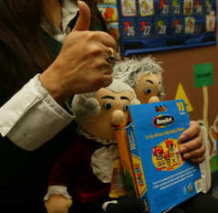
Enlarge this image
Diana Baldrica / The Fresno Bee
Steinbeck Elementary School teacher Lynda Labendeira uses the Keeping Score educational program, using "maestro" dolls.

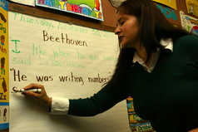
Diana Baldrica / The Fresno Bee
Lynda Labendeira has her kindergarten class at Steinbeck Elementary make sentences about something they remember from the story they heard about "Mr. Beethoven."

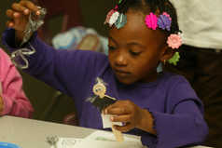
Diana Baldrica / The Fresno Bee
LaVauzhanee Vains, a kindergartner at Steinbeck Elementary School, tries to glue yarn for her Beethoven

