A Decision: Which Car to Buy?

 | # People  35% | Price ($)  25% | Miles/Gallon  40%
A1 | 5 | 18,000 | 20
A2 | 6 | 16,000 | 18

Decision Objective:
Buying the most spacious, cost-effective, and fuel-efficient car.

Rational Decision Making: The Process

Decision Making

Decision Objective Rational Decision

1. Derive decision criteria from decision objective: C₁, C₂, …C_{m}
2. Assign relative weights to decision criteria: W₁, W₂, ...W_{m}, ∑W_{i} = 1 (100%)
3. Generate alternative courses of action: A₁, A₂, …A_{n}
4. Select the subset of viable alternatives
5. Evaluate each alternative i relative to each decision criterion j: E_{ij}
6. Convert individual evaluations (E_{ij}) into uniform scores: S_{ij}
7. Integrate the various pieces into a decision matrix
8. Calculate the total weighted score for each alternative (A_{i}): ∑ (S_{ij})*(W_{ij})
9. Select the rational decision: MAX ∑ (S_{ij})*(W_{ij})

T h e D e c i s i o n M a t r i x
 | C1 | C2 | C3 | C4 | … | Total Weighted Score
 | W1 | W2 | W3 | W4 | …
A1

A2 |  |  | E₂₃  S₂₃ |  |  | (S₂₁*W₁) + (S₂₂*W₂) + (S₂₃*W₃) + …
A3

…

The rational decision: The alternative that maximizes the Total Weighted Score
Rational Decision Making: An Example
1
Decision Objective
To buy the most spacious, cost-effective, and fuel-efficient car.
3
Relative Weight
2
Decision Criterion
4
Course of Action
8
Total
Weighted
Score

 | # People | Price ($) | Miles  Per  Gallon | Overall  Rating
 | .35 | .25 | .40
Car  A1 | 5  7.14 | 18,000  6* | 20  6.67 | 6.66
Car  A2 | 6  8.57 | 16,000  7* | 18  6 | 7.15

Ideal: 7 people=10 $10,000 = 10 30 MPG =10
9
Maximum Total
Weighted Score
7
Decision
Matrix
5
Data
6
Uniform
Score

*

0 1 2 3 4 5 6 7 8 9 10
$
30k 28k 26k 24k 22k 20k 18k 16k 14k 12k 10k

Ingredients of Rational Decision Making

Information ?

Interpretation

Introspection

 | # People | Price ($) | Miles  Per  Gallon | Total Weighted Score
 | .35 | .25 | .40
A1 | 5  7.14 | 18,000  6* | 20  6.67 | 6.66
A2 | 6  8.57 | 16,000  7* | 18  6 | 7.15

Ideal: 7 people=10 $10,000 = 10 30 MPG =10

Analysis
Calculation

F A I T H
Ultimate Ingredient:

What is a Decision?

“A decision is the action an executive must take when he has information so incomplete that the answer does not suggest itself.”

Arthur William Radford (1896 - 1973)

Admiral, US Navy
Chairman, Joint Chiefs of Staff

The Paradox Of Decision Making

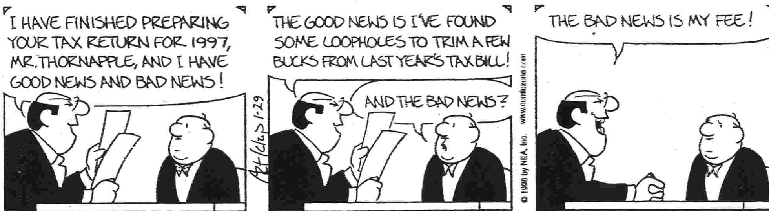

Decision Making Styles and Gender

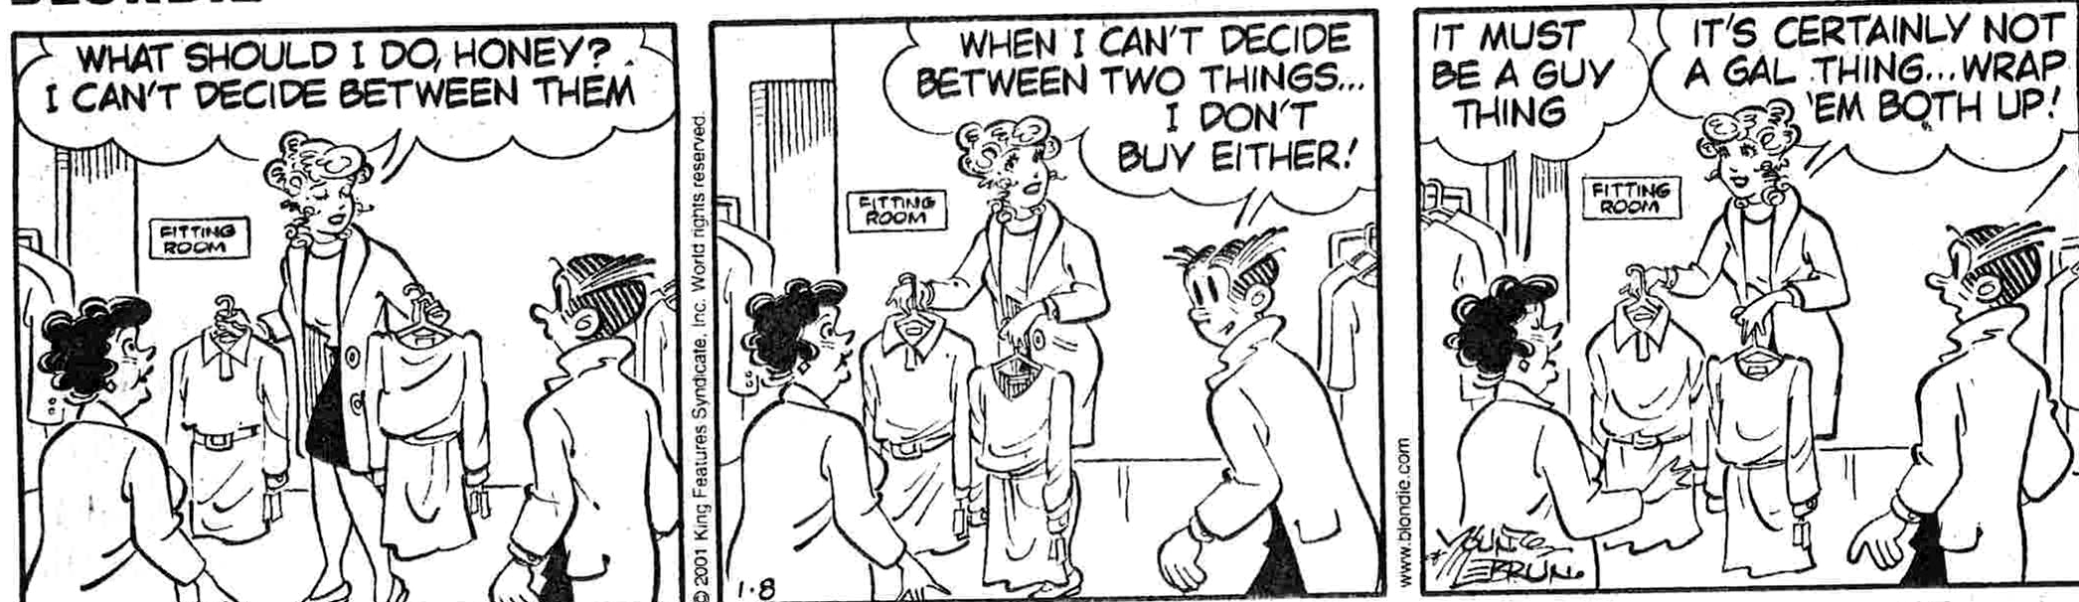

Do We Make Decisions Rationally?

Individual decisions ➔ who cares?!

Group Decisions

- Making decisions with others

- Making decisions for others

Should We Make Decisions Rationally?

Should We Seem To Make Decisions Rationally?

Y E S !

