### Decision Support Systems & Data Mining

How are Decision Support Systems and Data Mining Different?

* **Decision Support Systems**:

Provide the decision maker with an explicit mathematical formula that can be used to build various decision scenarios

[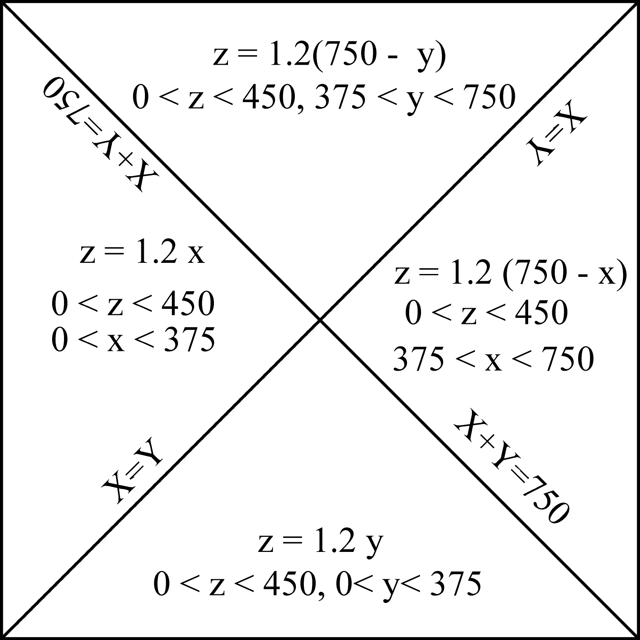](http://www.google.com/url?sa=i&rct=j&q=%22mathematical+model%22+&source=images&cd=&cad=rja&docid=EnLzgUgWzp5meM&tbnid=9i2Hkwnh_hqHRM:&ved=0CAUQjRw&url=http://www.ncgia.ucsb.edu/giscc/extra/e001/e001.html&ei=Cw89UYL5DsqQyAHz44Bo&bvm=bv.43287494,d.aWc&psig=AFQjCNFHzWCcdsSKqSUI1bS7ybY01N9XXg&ust=1363042399306391)

* **Data Mining**:

Provides the decision maker with information about interesting relationships among variables that suggest certain decision scenarios

[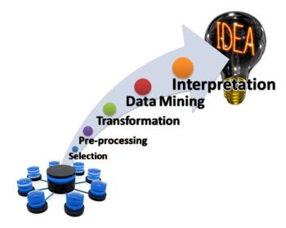](http://www.google.com/url?sa=i&rct=j&q=data+mining&source=images&cd=&cad=rja&docid=QhJ_K597RKnn6M&tbnid=0Eb1QdL64VEXrM:&ved=0CAUQjRw&url=http://libeltyseo.com/2013/02/12/how-data-mining-works/&ei=8w09UbTWJKqQyQGmqoDIDQ&bvm=bv.43287494,d.aWc&psig=AFQjCNEIQCy_DSJeA0cfBMOzb4hNHGkDPg&ust=1363042067630315)

How are Decision Support Systems and Data Mining Similar?

They are both based on **relational**, rather than factual, **information.**

What is Relational Information, and where does it come from?

Factual Data Factual Information Relational Information

Fuel Purchase Data:

Fuel Purchase Information: MPG

* date
* mileage
* #gallons

Proper tire pressure improves fuel efficiency

Tire Pressure Adjustment data:

* date

**is related to**

Tire Pressure Fuel efficiency 🡺 Model

(PSI) (MPG)

MPG = f (PSI)

🡺 Mathematical Model

not directly directly

controllable controllable

**Why Build Models?**

To control those things that cannot be controlled directly

via

controlling those things that CAN be controlled directly

Factual Information: What happens

Relational Information: How factors underlying what happens are related

The Anatomy of Mathematical Models

Mathematical Model

**Y = aX1 + bX2 + c + d**

Y = Dependent/Outcome Variable

That which we want to control/predict, but cannot do so directly

It is the outcome/consequence of other factors that we can control directly

X1 , X2 = Independent/Decision/Controllable Variables

Those factors that we can control directly, and whose correct values are in doubt (hence the need for a DSS)

a, b, c, d = Decision Parameters, Uncontrollable Variables, Environmental Factors

Those factors that affect the Dependent/Outcome Variable but cannot be controlled by the decision maker; their values are “given” in a particular situation.

The Central Challenge of DSS:

* Given certain values of a/b/c/d, what values of X1/X2 will produce the desired value of Y?

DSS ≠ DAS

DSS = Decision Support Systems

A system that supports/aids the decision maker; the decision is made by the decision maker

🡺 semi-structured decision situations

DAS = Decision Automation System

A system that replaces the decision maker; the decision is delegated to the computer

🡺 Fully-structured decision situations

For a brief but useful textbook coverage of DSS, read [An Introduction to DSS](http://zimmer.csufresno.edu/~sasanr/Teaching-Material/MIS/DSS/DSS-Intro.pdf)

<http://zimmer.csufresno.edu/~sasanr/Teaching-Material/MIS/DSS/DSS-Intro.pdf>

The role of Intermediate Variables in facilitating the derivation of the model:

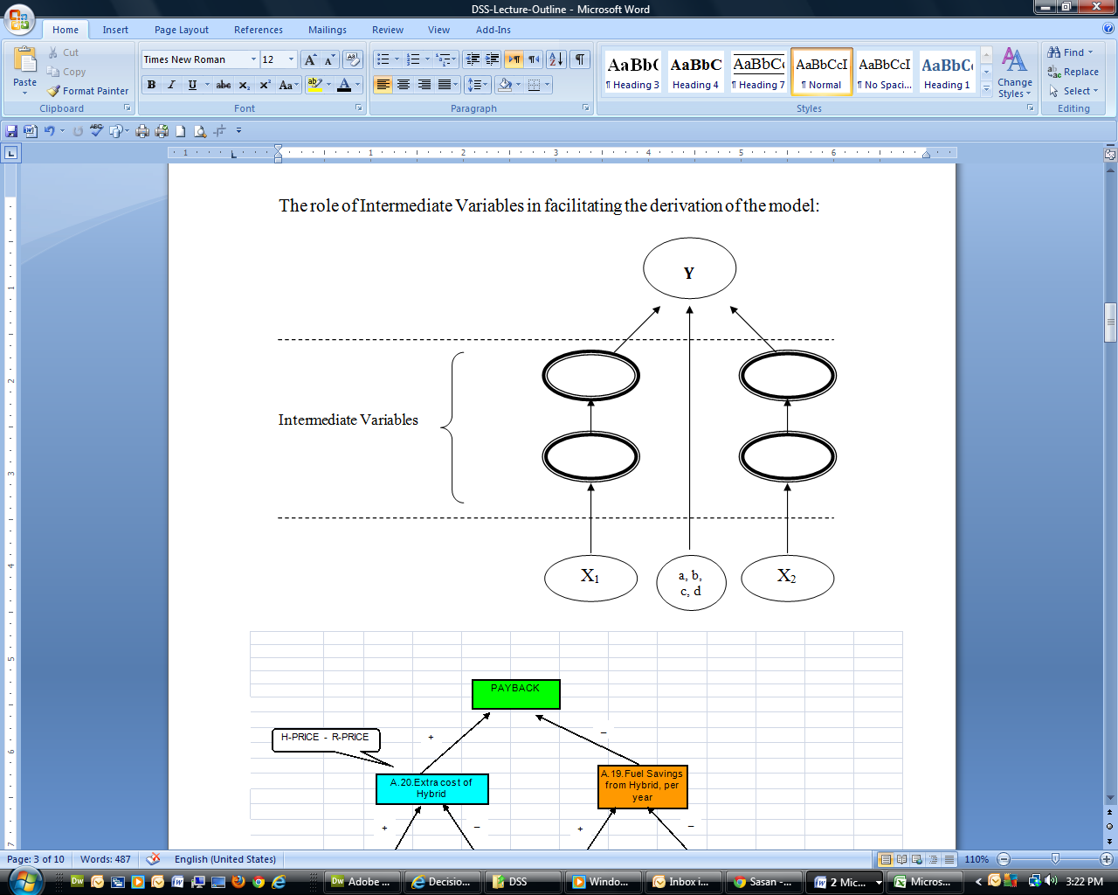



Using Mathematical Models

1. What-if Analysis:

Given certain (hypothetical) values of the independent variables, what is the corresponding value of the dependent variable?

**Y** = ?

**X1** = m

**X2** = n

1. Goal-seek Analysis:

Given a certain desired value of the dependent variable, what values of the independent variables would produce it?

**Y** = k

**X1** = ?

**X2** = ?

1. Sensitivity Analysis:

How sensitive is the dependent variable to changes in a certain independent variable when everything else is kept constant?

**X1** = **X2** = n

* m1
* m2
* m3
* m4

**Y** =

* ?
* ?
* ?
* ?

1. Optimization Analysis:

When the independent variable should not be maximized or minimized because it involves a tradeoff, which value of it will optimize the independent variable?

A Case Study in Sensitivity Analysis

Question:

Which student’s **Course Grade** is more sensitive to their **Term Paper Grade**?

🡺

Which student’s term paper should the professor read more carefully?

Background:

Both students S1 and S2 have met all the course requirements except the term paper (worth 10%)

|  |  |  |  |
| --- | --- | --- | --- |
| Student | Total Score So Far  (Max = 90%) | Term Paper Grade  (Max=10%) | Course Grade  (Max = 100%) |
| S1 | 78% | * A (9-10) * B (8-9) * C (7-8) * D (6-7) * F (< 6) * does not turn in |  |
| S2 | 82% | * A (9-10) * B (8-9) * C (7-8) * D (6-7) * F (< 6) * does not turn in |  |

Grading Scale:

F D C B A

_____________|_____________|_____________|_____________|_____________|

60 70 80 90 100

[](http://www.google.com/url?sa=i&rct=j&q=taco+bell&source=images&cd=&cad=rja&docid=--JqmWbKw301zM&tbnid=jT87O8Z-C7l6wM:&ved=0CAUQjRw&url=http://thinkprogress.org/health/2013/01/08/1413511/taco-bell-obamacare/&ei=aww9UdnICebVyAGSi4DYBQ&bvm=bv.43287494,d.aWc&psig=AFQjCNGgOjv9q9wXGj-nrTJxxnvZ_TU3fQ&ust=1363041726938280)**A Case Study in Optimization: T.A.C.O.**

–

### Profit

+

+ –

### Revenue

### Expense

–

Number of customers likely to balk

(acceptable level < 2.5%)

+

### Payroll

–

Speed of Service

(acceptable level < 3 m)

+ +

Customer-service staffing level per shift (80% of labor requirements)

### Duration/shift

Data Mining

Automated discovery of patterns in large transaction-based data sets and transforming them into an understandable structure for further use

[Computer Models in Hollywood](http://zimmer.csufresno.edu/~sasanr/Teaching-Material/MIS/DSS/computer-models-in-hollywood.pdf)

<http://zimmer.csufresno.edu/~sasanr/Teaching-Material/MIS/DSS/computer-models-in-hollywood.pdf>

The System

Script Projected ROI

The Verdict:

|  |  |
| --- | --- |
| Decision Process | ROI |
| Traditional approach | -24.4% |
| Random selection | -18.6% |
| DSS model | +5.1% |

[Mining Consumer Data in Politics](http://zimmer.csufresno.edu/~sasanr/Teaching-Material/MIS/DSS/mining-consumer-data-in-politics.doc)

<http://zimmer.csufresno.edu/~sasanr/Teaching-Material/MIS/DSS/mining-consumer-data-in-politics.pdf>

The System

Life Style Variable Voting behavior

* + - * car
      * music
      * drink

Drug Industry Mines Physicians' Data to Boost Sales

[Listen to it](http://zimmer.csufresno.edu/~sasanr/Teaching-Material/MIS/DSS/drug-industry-data-mining.mp3)

[Read it](http://zimmer.csufresno.edu/~sasanr/Teaching-Material/MIS/DSS/Drug%20Industry%20Mines%20Physicians.docx)

<http://zimmer.csufresno.edu/~sasanr/Teaching-Material/MIS/DSS/Drug%20Industry%20Mines%20Physicians.pdf>

Pharmaceutical Company:

Promote Product

Doctor:

Write Prescription

Pharmacist:

Fill Prescription

prescription prescription

details data