Chapter 1

ERP History & Evolution

ERP History & Evolution

This chapter focuses on the use of computers in manufacturing industry and one theory of ERP history and evolution.

Computers in Manufacturing Industry

In early 60's few computers in existence were enormous and expensive machines. They were often used for special scientific purposes and thus had little commercial purpose. Initial commercial use of computers in manufacturing industry started with big automobile and aerospace industry. But advances in technology (mini and microcomputer) have led to widespread use of information technology in manufacturing. The result has been islands of automation in which individual processes are automated without concern of compatibility with one another. The following is the list of some functional areas in manufacturing where use of computers was felt.

Drafting
Design
Simulation
Analysis (Stress, Dynamics, Kinematics, Thermal etc.)
Planning (process, personnel, material etc.)
Manufacturing
Storage and retrieval
Material handling
Sales
Finance
Marketing
Forecasting
Quality & Testing
Distribution
Costing
Maintenance
Conveyance
Inventory & Warehouse control

Computer Integrated Manufacturing

The word CIM coined in 1973 by Dr. Joseph Harrington is the process to achieve high levels of productivity and benefits of integration. It is aimed at exploiting the power of integration by tying all these separate islands of automation together into a smooth running, seamless, efficient enterprise.

CIM defined as "the computer-assisted integration of the production process and operations control functions needed for optimal deployment and productive use of the minimum manufacturing and management resources required to meet specific strategic business objectives [George W. Sibbald]

The independent islands resulted from application of information technology can be viewed as three main automated islands of an enterprise integrated through common database. The three islands are computer-aided design (CAD), computer aided manufacturing (CAM) and business data processing system (BDPS). The left-hand side of the wheel is related to the business and organizational tasks, where as right-hand side is related to technical (design & manufacturing) tasks. The detailed discussion on the technical tasks (CAD/CAM) of enterprise is omitted.

As shown in inner circle integrated database is crucial requirement for achieving CIM. The database requirements for computer integrated manufacturing applications are more complex and highly demanding than traditional relational databases used for business and administrative applications.

A typical integrated database has to handle data like

Order data
Customer data
Vendor data
Geometric data
Work center data
Routings
Personnel
Bill of Materials
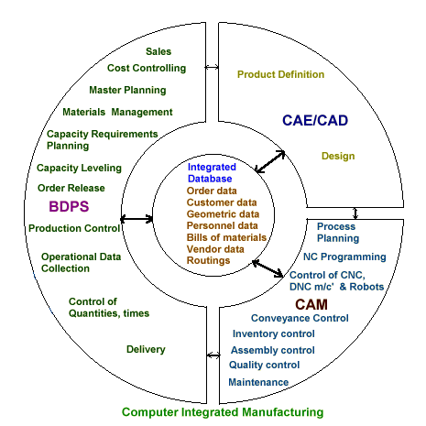
Often the data stored in the central database is application-independent, meaning the data structures are designed independent of their individual applications. The data is represented in more generic form so that it can be available for various functional groups. For example, the material master data defined in integrated database will be available to technical (design group), production planning (MRP, MRP II) and financial users (cost controlling, financial accounting).

Engineering (Traditional) to Re-engineering

Engineering, in this context referred to as a traditional sequential engineering is still being practiced by many of the companies. The information flow in the sequence is linear, with little interaction between the many groups responsible for new product development.

The interaction among the different groups responsible for product development is limited and the information flows strictly in linear fashion. Because of this, the design completed by engineering cannot be manufactured in the shop floor to its exact specifications due to manufacturing constraints. The product developed will have larger lead times, poor quality, high cost and short product life cycle.

To overcome the problems involved with sequential engineering a team approach called concurrent engineering is introduced.

Concurrent Engineering

Concurrent engineering means the simultaneous development of products and their manufacturing processes, with the goal of removing the delays inherent in traditional sequential engineering. It means that the design of a product, and the systems to manufacture, service, and ultimately dispose of the product are considered from initial design concept. [James A. Regh]

In addition to design engineering, a typical concurrent engineering team consists of production engineering, production control, fixture designers, equipment vendors, purchasing, marketing, etc. This entire concurrent engineering team participates in the product design process. With this broad participation most of the problems in production, product service can be eliminated. Some new concepts like Design for Manufacturability, Design for Assembly, continuous improvement and total quality management originated as a result of this team participation.

Concurrent engineering promises to cut product lead-time reduce costs and prolong product life cycles by product quality better adapted to the market.

Reverse Engineering

Reverse Engineering is essentially the development of the technical data necessary for support of an existing production item. Unlike in forward engineering, in reverse engineering the items are already built, the task is to figure out what their design is. Often the need for reverse engineering arises from variety of reasons, chief among them is the need to replace a worn, broken or obsolete part that is no longer available from the original equipment manufacturer. Like concurrent engineering, reverse engineering also requires a team approach for product development. A typical reverse engineering team consists of production engineers, design engineers, draftspeople and shop personnel.

Traditional Engineering vs Reverse Engineering
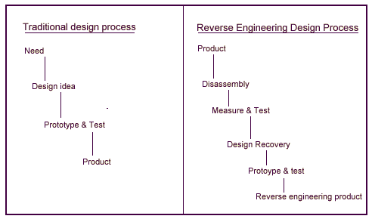

Re-engineering/Business Process Re-engineering

Re-engineering or Business process re-engineering is a catchword of 1990's. Reengineering can be defined as the radical redesign of broad, cross-functional business processes with the objective of order-of-magnitude performance gains, often with the aid of information technology.'

The main notion behind re-engineering is discontinuous thinking - of recognizing and breaking away from the outdated rules and fundamental assumptions that underlie operations. Unless we change these rules, we are merely rearranging the outdated processes. A breakthrough in performance cannot be achieved by simply by down sizing or automating existing processes.

A typical reengineering team consists of members not only from the organization but also some outside consultants. Often, from the organization side participation of upper management, cross-functional personnel, IT personnel is felt.

Evolution of ERP

First of all, the enterprise defined by Eric G. R. Gerelle and John Stark is an organization of people, using technology to make products according to certain predefined processes. This means the people, technology, products and processes are productive resources of the manufacturing enterprise. The following figure depicts an enterprise resource model.
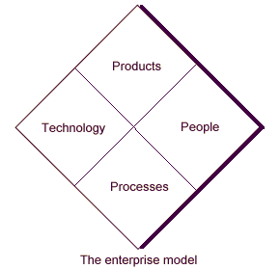

The basic logic in which these resources are seamlessly integrated is based on, together how these resources support the strategic view (business plan) of the enterprise.

Often, the Enterprise Resource Planning is a natural extension or evolution of MRP or MRP II sub systems. Not necessarily all current ERP systems could have taken the same developmental path, but this is true in majority of the cases. The functional scope of ERP compared to MRP and MRP II systems is shown in the figure next page.

MRP to ERP

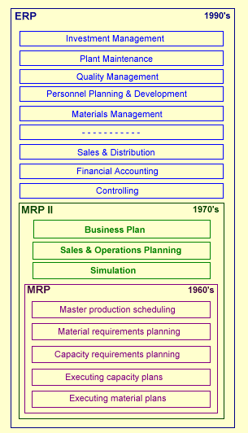

In computer integrated manufacturing perspective (discussed earlier) the ERP is realization of the integration of organizational and planing functions on the left-hand side of the wheel. Today's, ERP systems act more as decision support systems than just data and transaction processing systems.

Future of ERP

More and more functionality will be added to the current ERP systems with an ultimate goal to achieve CIM. The very success of today's ERP systems was enabled by technologies like:
Client/Server, relational database management systems. But, the problem is that conventional relational database management systems do not meet some of the fundamental data base requirements (complex and large schemas; data definition, manipulation, and retrieval in an object-by-object fashion) of CAD and CAM applications. This cannot be viewed as a technical hurdle, because it is simply a mismatch between the requirements of these applications. Enhancing existing conventional DBMS with object-oriented features can clear this hurdle.

A recent study tells that Manufacturers will continue to invest strongly in ERP systems in the next five years. The increase in investment by region is shown below.
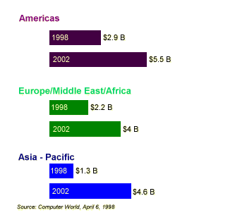
Future investment on ERP software and services by manufacturers

