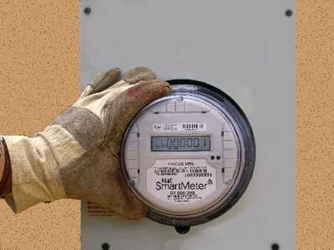
SPECIAL TO THE BEE
Pacific Gas & Electric is installing new electric and gas meters that will allow customers to go online to monitor energy use and reduce their costs joining in the "Smart Day" program.

SmartMeters coming to Fresno
PG&E to install 500,000 readers in the area.
By Marc Benjamin / The Fresno Bee
Pacific Gas & Electric is beginning to install new electric and gas meters that allow people to use the Internet to keep an eye on their power use -- and possibly lower their bills.
About 500,000 meters will be installed in the Fresno region, said Jeff Smith, PG&E public information officer in Fresno. About 300,000 are already installed in the Bakersfield area.
More than 10 million "SmartMeter" units will be installed by 2012 at a cost of $1.74 billion.
The SmartMeter program will eliminate the company's 900 meter readers, who have been told they can be retrained and placed elsewhere in the company, help install SmartMeters or take a severance package.
The program evolved from a 2002 state Public Utilities Commission order for utilities to seek programs that offer customers options to reduce their electricity use.
The electric meter sends a signal once an hour to a box located on a nearby utility pole, and that information goes to the PG&E data center. The data are analyzed to determine power-usage levels and costs.
Customers can go online to monitor energy use through an account set up with PG&E. During peak-use times, electricity users can reduce their costs by participating in the utility's "Smart Day" program -- by turning off lights, setting the air conditioner to run less often and generally cutting back on power use.
Utility officials expect that about 15 days every year, customers will be advised by e-mail or a phone call when electricity supplies may be short. If they heed the advisory and reduce use during peak hours, they will save money, said Jim Meadows, director of the SmartMeter program in the utility's San Francisco headquarters.
Surcharges apply to those enrolled in the Smart Day program when they use energy during those hours, but those enrolled also receive a credit on energy used during other parts of the peak-usage days.
"People can take advantage of the program and know when power is its cheapest," he said. "The SmartMeter allows the customer to make an impact on their own purchases."
Meadows said other benefits include faster detection of outages, the ability to disconnect electricity without using an employee, and avoiding problems meter readers often face, such as vicious dogs and on-the-job injuries from physical work, Meadows said.
The union representing the meter readers said the company has worked with employees to prepare for the technology that will eliminate their jobs.
"For several years, PG&E has been preparing for this change by replacing retiring meter readers with temporary employees knowing there is a limited future in meter reading," said Eric Wolfe, communications director for the Vacaville-based International Brotherhood of Electrical Workers' Local 1245.
Wolfe said the company has been shifting from permanent to temporary meter readers over the past few years.
"By the time they make this switch, there will not be that many people affected," Wolfe said.
There are advantages to having meter readers as the eyes and ears of the company, he said, and some issues they notice will not be spotted with the new meters, such as meter corrosion, tinkering with meters or spotting when electricity is being stolen by neighbors.
But he added: "You can't stop technology from advancing."
The reporter can be reached at mbenjamin@fresnobee.com or (559)441-6166.

