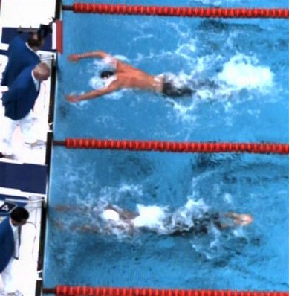
IOC BOB, Pool
This second of three video frame grab images taken from International Olympic Committee Beijing Olympic Broadcasting pool video, shows United States swimmer Michael Phelps, above, as he swims toward the finish of the men's 100-meter butterfly, along side Serbia's Milorad Cavic in the adjacent lane. Phelps beat Cavic by a hundreth of a second setting an Olympic record in 50.58 seconds, earning his seventh gold medal and matching Mark Spitz's seven gold medals from the 1972 Munich Games.

Human eye can't keep up with fast-closing Phelps

By BETH HARRIS

08/15/08 23:39:41

The eyes didn't have it. Lucky for Michael Phelps technology did.
Phelps got his seventh Olympic gold medal to match Mark Spitz's record haul but it took some doing.
The finish was impossible to see with the naked eye, so close that video and timing reviews down to the 10-thousandth of a second were needed.
Anyone watching in the jammed-to-the-rafters Water Cube or on television thought Milorad Cavic of Serbia had pulled off a monumental upset Saturday morning, spoiling Phelps' chance at breaking Spitz's vaunted record of seven golds in a single games.
Not so, thanks to technology.
"The timing system says it all," Phelps said. "There hasn't really been an error in the timing system that I've ever heard of. The scoreboard said I got my hand on the wall first."
But he - and everyone else - wasn't sure until a "1" appeared by Phelps' name and a "2" by Cavic. They were separated by a hundredth of a second, the smallest margin measured in swimming.
"It's almost too close to see," Phelps said after watching a frame-by-frame replay on computer.
Even Phelps' coach was in doubt.
"I wasn't sure he was going to get there," Bob Bowman said.
Serbia's head coach wasn't convinced Phelps touched first, so he filed a protest with FINA, swimming's world governing body.
"We don't want to have any doubts about the decision and the integrity of FINA," Kapor Mladen said. "They say this is how it happened and we assume everybody was treated equally in the race."
Mladen ultimately accepted the final review, even though he wasn't completely satisfied.
"Satisfied is a tough word for this," Mladen told The Associated Press on Saturday night. "We're satisfied with the silver medal. It would have been nice to win gold, but we only wanted silver for this race."
Referee Ben Ekumbo of Kenya, a member of FINA's technical committee, dismissed any suggestion that FINA called Phelps the winner so he could tie Spitz's record and have a shot at winning an eighth gold in Sunday's medley relay.
He said the Serbians were allowed to review the frame-by-frame footage, although the rules don't require it.
"They accepted the ruling because it was not the human eye making the judgment," Ekumbo said. "It was the footage."
Ekumbo confirmed Omega's electronic timing system also was in "perfect order," having been tested as usual before each competition. Large touchpads, the width of each lane and extending down into water, stop the clock when triggered by a swimmer's touch - in this case Phelps' arms crashing into the wall.
"It was very clear that the Serbian swimmer touched second after Michael Phelps," Ekumbo said. "One was stroking (Phelps) and one was gliding (Cavic)."
As they approached the finish, with Phelps' head in line with Cavic's shoulder, the Serb took his last big stroke and glided underwater toward the wall.
Phelps, his timing a bit off but fully aware of where he was, did another half-stroke, propelling his upper body out of the water, swooping his arms in a huge circular motion and slamming the wall with his hands on the follow-through.
"It was kind of hard to see," Cavic said. "I know I had a long finish and Michael Phelps had a short finish."
Cavic watched a replay afterward and said he accepted the results, although the Serb noted, "Technology is also imperfect. The hand is quicker than the eye."
The timing review was done by Ekumbo and a FINA commission member. They confirmed Phelps' time of 50.58 seconds, his only victory in these Olympics that wasn't a world record. Cavic touched in 50.59.
The main timing system is powered by cable and a backup system by battery. Both systems recorded the same times for Phelps and Cavic, Ekumbo said.
"The video says (Phelps) finished first," said Branislav Jevtic, Serbia's chief of mission in Beijing. "In my opinion, it's not right, but we must follow the rules. Everybody saw what happened."
Cornel Marculescu of Switzerland, FINA's executive director, confirmed Ekumbo's findings.
"Michael Phelps is the greatest ever," he said. "There is no doubt the question was for him to share or not to share first place. There is no doubt the first arrival was Michael Phelps."
IOC member Kevan Gosper said FINA's decision was based on who touched first.
"I don't think there's any reason for a protest," he said. "In the old days the judges ruled. Now it's the timers."
Bronze medalist Andrew Lauterstein of Australia had yet to catch a super slo-mo replay, but he heard other swimmers reacting with shock and disbelief at the results.
"They couldn't believe Phelps got there," he said, "and I'm sure I'll feel the same way."
Cavic, born in Anaheim, Calif., to Serbian parents, said he came in simply wanting to earn a bronze medal, so he wasn't bitter about missing out on the gold.
"From the heart, I'm really enjoying this," he said. "I'm not about fighting it. I'm not angry at all."
But he knows the debate will live on.
"People will be bringing this up for years, saying, 'You won that race,'" he said. "If we got to do this again, I would win it."
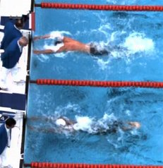
This third of three video frame grab images taken from International Olympic Committee Beijing Olympic Broadcasting pool video, shows United States swimmer Michael Phelps, above, as he swims toward the finish of the men's 100-meter butterfly, along side Serbia's Milorad Cavic in the adjacent lane. Phelps beat Cavic by a hundreth of a second setting an Olympic record in 50.58 seconds, earning his seventh gold medal and matching Mark Spitz's seven gold medals from the 1972 Munich Games.

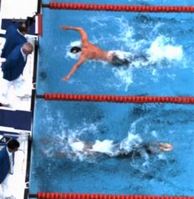
This first of three video frame grab images taken from International Olympic Committee Beijing Olympic Broadcasting pool video, shows United States swimmer Michael Phelps, above, as he swims toward the finish of the men's 100-meter butterfly, along side Serbia's Milorad Cavic in the adjacent lane. Phelps beat Cavic by a hundreth of a second setting an Olympic record in 50.58 seconds, earning his seventh gold medal and matching Mark Spitz's seven gold medals from the 1972 Munich Games.

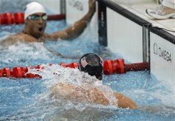

United States' Michael Phelps, front, and Serbia's Milorad Cavic look to each other after the men's 100-meter butterfly final during the swimming competitions in the National Aquatics Center at the Beijing 2008 Olympics in Beijing, Saturday, Aug. 16, 2008. Phelps won the gold medal, Cavic got silver.

