Systems Development: Management Issues

Proposed system feasibility is difficult to measure.

Does the technology exist to do it? Can it be done? (= Technical feasibility)

Does the system fit its intended operating environment? Will it work? (= Operational feasibility)

Will the system be developed in time for ...? Will it be ready? (= Schedule feasibility)

Do the intended users of the system want it enough to handle the problems caused by it? Will it be used? (= Motivational feasibility)

Does the (expected) benefit from the technology exceed its (expected) cost? Should it be done? (= Financial feasibility)
- The expected benefits of a proposed system tend to be overestimated
- The expected costs of a proposed system tend to be underestimated ➔ Total Cost of Ownership
Cost of error correction

Systems Development Life Cycle

Requirements are stated incompletely.

Requirements are stated ambiguously.

Errors are costly to correct.

Systems are delivered behind schedule, over budget, with incomplete functionality.
27% are successful
33% are eventually completed, but
- are late
- are over budget
- have scaled-down functions
40% fail (pull the plug)

Working Functionality
Project
Parameters

Schedule Budget
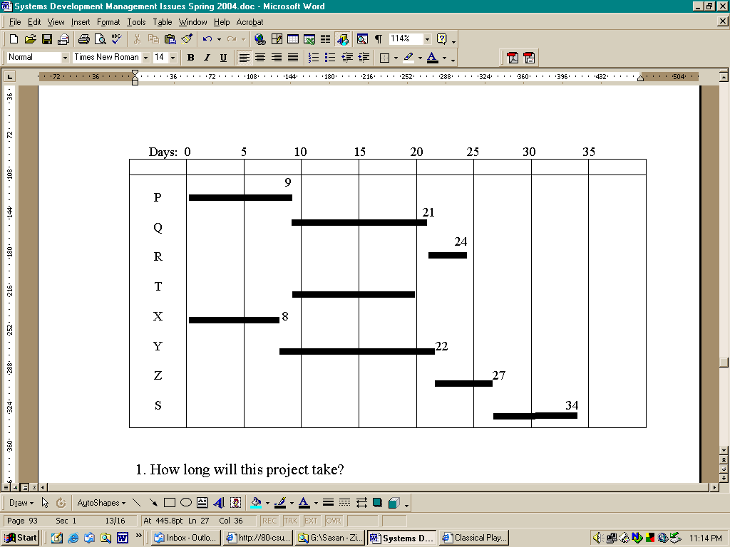

Gantt Chart:

How long will the project take?
- What is the project status now?
- Which tasks can exchange resources?

PERT (Program Evaluation/Review Technique)
- What is the longest path? (= critical path)

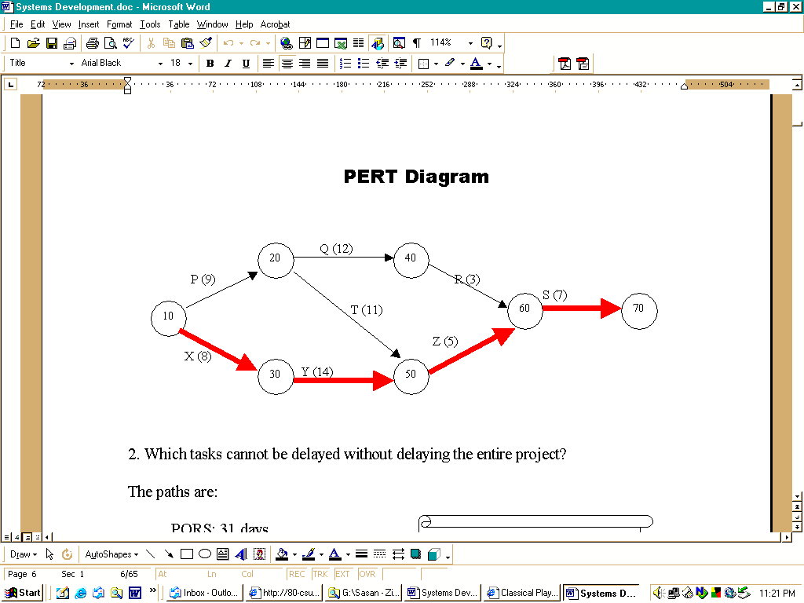
How long can we afford to delay activities on other paths without delaying the entire project? (= slack)

Systems Development: Management Issues

- Proposed system feasibility is difficult to measure.

- Requirements are not completely articulated.

- Requirements are not clearly articulated.

- Errors are costly to correct.

- Systems are delivered late, over budget, and deficient in quality.

The Bottom Line:
IT and Management ➔ An Eternal Conflict!

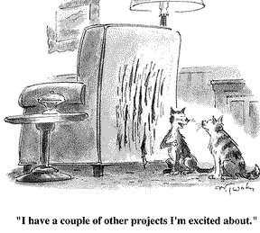

Feasibility Analysis

Feasible = possible, doable, practicable

Technical feasibility
Does the technology exist to do it? Can we do it?
Relatively speaking, this is the easiest form of feasibility to establish

Financial feasibility

Does the (expected) benefit from the technology exceed its (expected) cost?
Should we do it?

Operational feasibility
Does the system fit its intended operating environment? Will it work?
Factors to consider:
- Physical environment
- Trasnaction volume/communication load/number of users

Schedule feasibility
Will the system be developed in time for ...? Will it be ready?

Motivational feasibility
Do the intended users of the system want it enough to handle the problems caused by it? Will they want it?

Determining Financial Feasibility

A problem is solved only if the cost of the solution is less than the cost of the problem!

Expected Benefits

Actual Benefits

Expected Net Benefit Actual Net Benefit

Actual Costs

Expected Costs

The World of Expectations The Real World

A Dose of Reality:
- The expected benefits of a proposed system tend to be overestimated
- The expected costs of a proposed system tend to be underestimated ➔ TCO

 | Obvious | Hidden
Costs | - Hardware  - Software  - Telecommunications  - Staff | - Training  - Operational disruption ➔  poor quality/service during  conversion  - Lower staff productivity during analysis  - Frequent software upgrades  - Disruption (crashes + viruses)  - Facilities upgrade
Benefits | - Cost savings  - Operational flexibility  - Improved productivity  - Enhanced coordination | - Systematization  - Standardization
Two Scenes from MIS Financial Justification

Scene I:

Client: The staff workload will be cut by five hours per day.
Project manager: How does that help?
Client: We'll be able to cut our costs.
Pm: How?
Client: Uh, good question. We don't have enough savings to cut staff.
Pm: What else could these people do with their extra time?
Client: Well, right now they complain of being rushed. More time would enable them to do a better job, which could cut rework. If we could reduce that by just 10%, it would save us, let's see, over $200,000 per year.
Pm: Would the improved quality get you more customers?
Client: Perhaps, but I know that it would improve goodwill among existing customers. There's an intangible benefit!
Pm: So what?

The moral of the story: All benefits are realized in terms of cost or revenue.

Scene II:

Client: The system will be flexible.
Project manager: So what?
Client: So we'll be able to modify it more easily.
Pm: So what?
Client: Well, that means our maintenance time will be cut.
Pm: How much?
Client: Well, perhaps by 15%.
Pm: And what does that work out to in dollars?
Client: We have three maintenance programmers at $60,000 per year. That's $180,000 per year total, so we could probably save about $24,000 each year.

The moral of the story: You have just shifted the benefit from an intangible wish to a real target.

In-Class Assignment: Financial Justification of Systems

Consider an information systems project that is justified by the reduction in time to process business transactions in your company. The numbers indicate that each of five people will have his or her workload reduced by an average of an hour a day. The annual salary of each is $60,000, which comes to $240/day, or $30/hour. So the proposed system can be expected to save your company $150 per day, or $37,500 per year.

Assumption : there are 250 working days in a year.

What is wrong with this justification?

The online “Bible” of Business Case Analysis: http://www.solutionmatrix.com/
In-Class Assignment: The Hand-Free Flashlight Requirements

Your client has the following problem:

Sometimes I have to work outdoors at night, such as when there is a short circuit and the fuse box needs to be opened and fooled around with. The problem is that I often need to use both hands under such circumstances. If I use an ordinary flashlight, I will be unable to use both hands. I would like you to design a hand-free flashlight for me.

Write a set of questions that you – as the designer – would ask your client to further obtain his requirements concerning the kind of flashlight he wants.

The Analysis/Design Continuum

Systems Analysis: Understanding the problem

Requirements specified by the user

Decisions left to the designer

Systems Design: Creating a detailed solution

The Incomplete Specification Principle

The features that users fail to specify explicitly are later determined by system designers, and

- frequently to the regret of the users (why?)

- without their having any right to complain (why?)

The Variety of Systems Designers

An ordinary system designer accepts user requirements.
A good system designer questions user requirements.
A very good system designer understands user requirements.
A great system designer helps the user generate the real requirements.

By designing an information system, you are designing the underlying business processes.

Do not blindly, faithfully, and silently accept any assignment plopping on your lap!

In-Class Assignment: Finding the Cheapest Fuel

Different gas stations in this city offer different prices for the same type of gas. There is a resident who has recently found out that the gas station where he regularly buys gas charges more than some others. He has hired you as a consultant and has given you the following assignment:

Find out which gas station in Fresno offers the least expensive gasoline

This assignment, as formulated above, is fraught with a number of ambiguities and flaws. Identify and list all the ambiguities and flaws that you can find in your client’s information requirements.

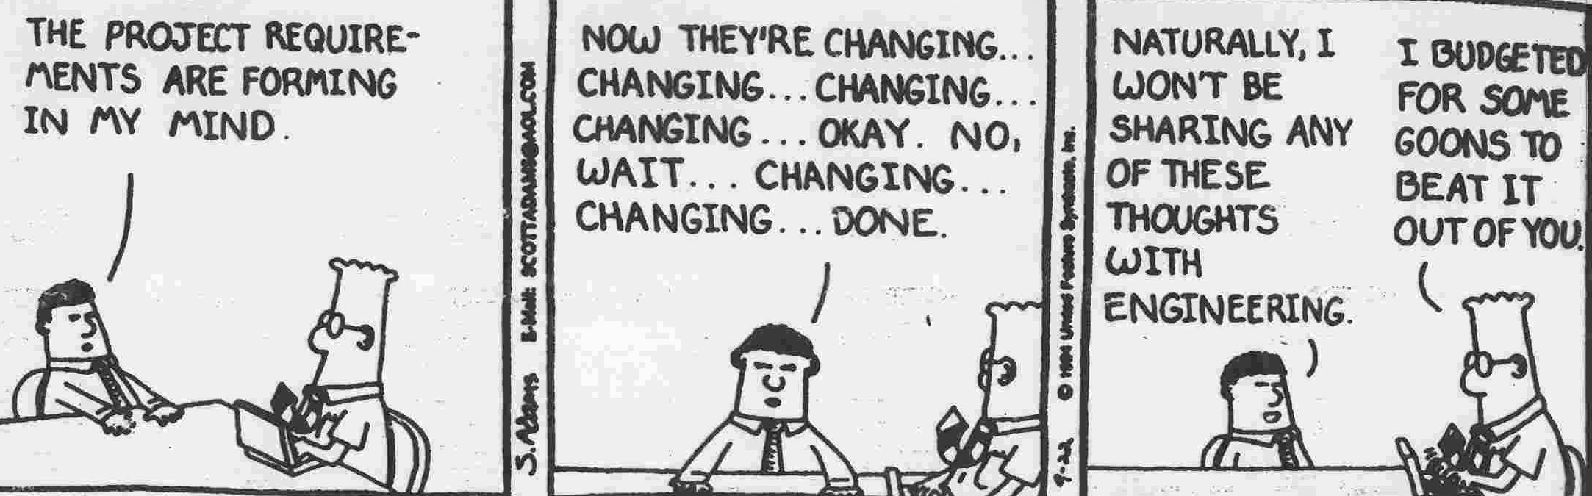

The Cost of Correcting Systems Errors

- The earlier an error is identified and corrected in the systems development life cycle, the lower the cost.
- The later an error is identified and corrected, the higher the cost.

Cost of
Error
Correction

Systems Development Life Cycle

Relative cost to fix a software error

Phase in which error is found | Cost ratio
Requirements  Design  Coding  Development testing  Acceptance testing  Operation | 1  3-6  10  15-40  30-70  40-1000

The Meaning of “Success” in Projects

Source: The Standish Group International
Systems development projects

27% are successful
33%are eventually completed, but
are late
are over budget
have scaled-down features/functions
40% fail (pull the plug)

Functionality/Quality
How many parameters
Project
Parameters
did you get right?!
- all 3 ➔ miracle
- any 2 ➔ in luck
- only 1➔ typical
- none ➔ good luck!

Schedule Budget

Percent of Working Functionality Delivered
Project Success =
[Budget Overrun] * [Schedule Slippage]
Measuring the Risk of
Systems Development Projects

For each of the following systems development projects, assess its risk on a 1(very low) – 5 (very high) scale.

- A $30 million automated order-entry system, covering half of the divisions and geographic regions of the firm, and involving telecommunications technology for which the firm has had other uses over the past four years.

- A $30 million sales forecasting system, covering all of the divisions and geographic regions of the firm, and involving a newly purchased applications software that runs on an operating system never used before in the firm.

- A $150,000 hospital patient billing system, that runs on existing hardware and is the last module of a comprehensive system installed by the hospital's reputable software vendor.

Determinants of Project Success

Factors determining the success of a systems development project:
positive correlation
− negative correlation

- Application structure (+)

Agreement on input/processing/output, especially processing

- Novelty of technology, “high tech” (−)
- Newness to the market
- Newness to our company = staff technical competence

- Project size (−)
- Budget
- Number of people involved directly
- % of organization impacted

- Political openness (+)
Are people getting along/working together, or backstabbing/infighting?

- Cultural openness (+)
Democracy, respect for employees’ views (vs. dictatorial)

- Staff turnover (−)
Particularly of project champion/sponsor

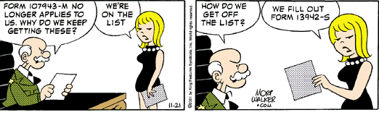

Project Management Assignment
P: DFD (9)
Q: Ddecision tree (12)
R: Revise tree (3)
T: Data Dictionary (11)
X: Report prototype (8)
Y: Rrevise reports (14)
Z: DB (5)
S: Document (7)

Scenario:
A system project requires the following activities before it is completed. First, data flow diagrams have to be drawn for the entire application (P), which will take 9 days. Based on those diagrams, decision trees need to be constructed (Q), which takes 12 days. The revision and fine-tuning of the decision trees (R) will take another 3 days. After data flow diagrams are drawn, the data dictionary needs to be organized (T), and that will take 11 days. Independent of all this, the required management reports need to be prototyped (X), and that will take 8 days. Revising and finalizing the reports will take another 14 days (Y). After the data dictionary is organized and reports have been finalized, the database needs to be designed (Z), which will take 5 days. At the very end, the whole project needs to be written up (S), which takes a week.

1. How long will this project take?

2. Which tasks cannot be delayed without delaying the entire project?

3. If today is the 20th day into the project and everything has been going smoothly according to plan, which tasks have already been completed?

4. If revising the decision trees is going more slowly than you initially thought, how many more days can you afford to delay it without delaying the entire project?

5. If revising the decision trees is done in 2 days instead of 3, to which task will you assign the freed up staff (assuming they have the required skills) to expedite the project’s overall completion?

Gantt Chart
P: DFD (9)
Q: Ddecision tree (12)
R: Revise tree (3)
T: Data Dictionary (11)
X: Report prototype (8)
Y: Rrevise reports (14)
Z: DB (5)
S: Document (7)

Days: 0 5 10 15 20 25 30 35
P  Q  R  T  X  Y  Z  S |  | 9  8 |  |  | 21  24  22 | 27 | 34

1. How long will this project take?

3. If today is the 20th day into the project and everything has been going smoothly according to plan, which tasks have already been completed?

5. If revising the decision trees is done in 2 days instead of 3, to which task will you assign the freed up staff (assuming they have the required skills) to expedite the project’s overall completion?

http://ganttchart.com

PERT Diagram
P: DFD (9)
Q: Ddecision tree (12)
R: Revise tree (3)
T: Data Dictionary (11)
X: Report prototype (8)
Y: Rrevise reports (14)
Z: DB (5)
S: Document (7)

Q (12)
20
40

P (9) R (3)
S (7)
10
60
70
T (11)

Z (5)
X (8)
30
50
Y (14)

2. Which tasks cannot be delayed without delaying the entire project?

4. If revising the decision trees is going more slowly than you initially thought, how many more days can you afford to delay it without delaying the entire project?

http://www.netmba.com/operations/project/pert

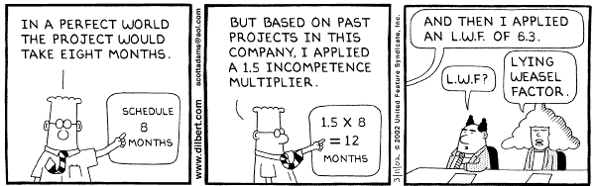

Comparing PERT and Gantt Charts

 | Gantt | PERT
Project duration | √
Project timeline/status | √
Task dependence |  | √
Resource (re)allocation |  | √
Task Duration | √ | √

I.T. and Management: An Eternal Conflict

A man is flying in a hot air balloon and realizes he is lost.

He reduces height and spots a man down below. He lowers the balloon further and shouts: "Excuse me, can you tell me where I am?" The man below says, "Yes, you're in a hot air balloon, hovering 30 feet above this field."

"You must work in information technology,” says the balloonist. "I do," replies the man. "How did you know?” "Well," says the balloonist, "everything you have told me is technically correct, but it's of no use to anyone."

The man below says, "You must be a corporate manager." "I am," replies the balloonist, "but how did you know?" "Well", says the man, "You don't know where you are, or where you're going, but you expect me to be able to help. You're in the same position you were before we met, but now it's all my fault."

