http://www.fresnobee.com/local/agriculture/story/8818786p-9705421c.html
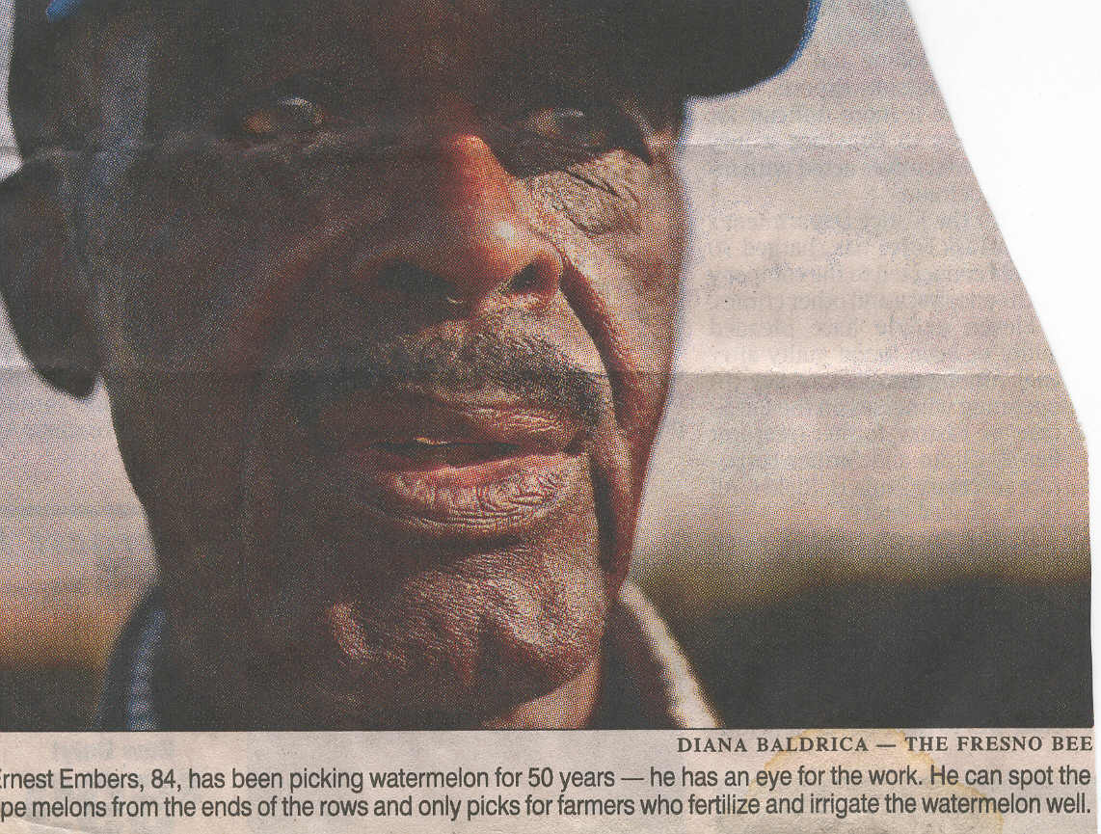

Cut above the Rest
At 84, Ernest Embers has been cutting watermelon for more than 50 years. He's fair, hardworking and possibly the last of his kind.
By Diana Marcum
The Fresno Bee
(Updated Thursday, July 8, 2004, 9:34 AM)
SELMA -- The stone-fruit farmers around here call it watermelon fever.
That's when you push out an orchard of peaches or nectarines to grow roadside-stand watermelon, even though you know you'll never make any money at it. The big, commercial watermelon farms are on the west side of Fresno county, but the 10- to 20-acre watermelon patches scattered among orchards on the east side are grown for more sentimental reasons.
"Because summer doesn't start until you can eat watermelon on a hot, sweaty day," says farmer Parry Klassen.
Once you get the fever, you find Ernest Embers.
Four years ago, when Klassen started growing watermelon, every farmer and packer he knew told him Embers was the only one to cut his fields.
Embers is the one who harvests watermelon right, they said. He can spot a ripe melon from the end of the row; he can tell sweet from waterlogged with a tap of the butt of his knife.
The slender black man who showed up to Klassen's field was in his 80s. That first year, most of his crew were in their 70s.
Embers, 84, has been cutting watermelon for more than 50 years. He never has to look for work. Farmers track him down.
To farmers, he's someone who does right by their crop.
To his neighbors on the west side of Fresno, he's someone who does right by people; an honest, hard-laboring man venerated as the last of his kind.
"The Embers of the world, they were the soldiers, the die-hards, the working class," says Terry Palmer, 54, one of Embers' crew. "But look around. You don't see no young people cutting here. When we're gone, it's pretty much over with our race cutting melons.
"It's an old tradition. You'd come out here and it was a black thing, a neighborhood thing. Part of our culture is dying out. When Embers leaves, it's gone."
Embers taught Palmer how to cut -- spot the ripe ones, leave the green ones --- more than 25 years ago. But there was a time when Palmer wanted nothing to do with watermelon because of racial stereotypes. He remembers seeing black dolls holding watermelon slices.
"I was ashamed to sit in a restaurant eating watermelon, because of that old cartoon of a black man spitting seeds over his shoulder," he says.
Besides, drugs had taken root in the neighborhood, and a man could make a lot more standing on a street corner than bent down in the fields.
Palmer got hooked on heroin, and in the '80s he was arrested trying to sell a gun during an FBI sting. His two sons grew up without a father around while Palmer served a prison sentence.
Terry Palmer Jr., the son who looked just like him, was shot in the head and killed in 1996 when he was 16. His killer was someone he'd once sold drugs with.
Palmer says he now finds comfort and dignity in cutting watermelons.
"This here is something that lets you go home and sleep, knowing within yourself you aint did nobody no wrong that day," he says.
"You know what I see now when I look over these rows? I see an honest day's work. I see a payday. I see I'm among friends, working with people I trust. And that's what it should be about. Maybe the Embers always knew that."
Fast fingers
Embers moved from his father's farm in Arkansas to California in 1948 to work cotton. His brother had come out 10 years earlier and got him a job tying wires around cotton bales to be shipped overseas.
"I was the best cotton-tier in the valley," Embers says. "Once, a supervisor came in from Texas and he said I was the fastest he'd ever seen anywhere. It's just a gift to be fast to tie cotton."
He spent 32 years with California Compress, working his way up to lever-puller. "That's as far as a man like me could go in those days," he says. "Couldn't go higher unless you was a foreman or supervisor."
Embers has always made his way on hard work and dexterity. He quit school in third grade to chop cotton.
"I was 7 years old and they said, 'You chop as much as a grown man, so we're going to pay you a grown man's wages,' and I set out to make my living."
He can read a little -- "not enough to sit down with no newspaper." And he's quick adding numbers -- "I can figure pretty good."
When he first came to the San Joaquin Valley, cotton grew as far as the eye could see. Great empires of cotton created by men with ties to the Old South drew laborers trying to escape Southern poverty. Watermelon was a filler crop that followed the cotton harvest, and black crews made extra money picking melons.
"Some of the black folk knew how to do it, so they'd learned others and the farmers knew to call them. So it was always the black crews picking watermelon. It was just the way it was," says Embers.
The pitchers had to pick up the heavy melons and toss them in the truck. It was dirty, back-breaking, mindless work. Cutting was the higher-up position and cutters were usually older. They went ahead, spotting the ripe melons, cutting their stems and gently rolling them out in the row for the pitchers to pick up.
Embers had it in his mind that he would be a cutter, so he asked Ernest Reed, a cutter and hunting buddy who lived up the street, to teach him.
"He said, 'I'll school you,' and I went from there. I wasn't hard to learn. Some learn easier than others," he says.
Embers soon had his own crew, and people wanted to work for him.
Too many times, crew leaders took off with the money after the watermelons were weighed and never paid people what they had been promised. Embers had a reputation for being fair and dependable.
These days, Embers pays his crew $9 a ton. He won't say how much the farmers pay him per ton, but he says he makes good money.
"Fair," says Embers, "doesn't mean stupid."
He has trouble finding enough people.
"The young ones, I can hardly teach them. They don't like to work. They like the fast money of the dang drugs. What good does that fast stuff do? Up all night, nothing stable."
Once in a while, Embers will hire neighborhood guys trying to hide that they're on drugs.
"They'll be all smooth. They think I don't know. They think I'm stupid," he says. "I know. But I need the bodies, and they need to look and see how they got no sense being on the wrong track."
The respect of men
The core of his crew are men who say they work out of respect for Embers as much as anything.
"I'm retired from a good union job," says Royal Hall, 64. "This is more or less for exercise and to help Ernest out. He and my father were friends. He's a fair man who does right by others. You have to respect that. There's few of his kind left. When Ernest stops, we'll be through with watermelon."
At Klassen's field on the corner of Manning and McCall avenues in eastern Fresno County, in sight of the stand where people are buying just-picked melons for $3 to $6, Embers walks the rows, teaching a new crew member how to cut.
"Ready, ready, ready. Ready as a fox," he calls out over and over again when he points out a ripe watermelon, striped just right.
"See all that green?" he says, pointing to melons the same color as the vines under which they hide. "Let your eyes pass right over them like you don't even see them. People don't want to buy green watermelon."
Cutters yell, "Get the cinch!" when they spot a ripe watermelon that's easy pickings.
"You get paid for the cinch. You don't get paid for the green. You always gotta grab the cinch," Embers says. "That goes for a lotta things."
Embers values gifts that come easy.
For instance, he has a gift -- or maybe, the right recipe -- for fishing.
"Nobody catches as many carp fish as I do. I caught me a chest full of fish last night. You just take some brown bread, water, garlic, mash it up real good and roll it into little balls for bait," he says. He sells the fish straight out of the ice chest on the side of the road before he goes home.
When he's not cutting watermelon, or fishing or scrapping, or running a little fruit stand, he likes to hunt raccoon. But Billie, his wife of 43 years, recently made him take the coonskins in their backyard down. "Get them things outta here!" she told him.
She thinks it's time for him to not work so much, but she has trouble getting him to stay home.
"He just likes to work. His dad taught them all to work, and they all still work, and he's been working all these years," she says.
In the field, Embers moves with a slow, rolling gait, but he's always covering ground. He walks ahead of his arms; they trail behind him waving a rhythm. He wears white fuzzy gloves. He says touching the watermelon with a bare hand could cause it to blister in the sun. Also, he doesn't like to get dirt under his fingernails.
His eyes are lighter than the sky, almost turquoise.
"A lot of the times the girls told me I had pretty eyes," says Embers with a wink.
When there's a question about whether a melon is "tight"-- not quite ready -- or just right, he taps on it with his knife handle.
"If it's like a hollow log, then it's ready. If it's a dead thump, it's green," says Embers, tapping.
He's getting the hollow-log ring, while another tapping cutter is getting the dead thump. Together, it sounds like they're playing music.
Watermelon can be tricky. It's about 92% water and the rest is sugar. Embers says it has to be constantly watered and sugared by hot summer sun. But the sun can't touch it directly, or the rind blisters. Watermelon grow nestled under thick, sheltering vines. Embers says he has the eye for spotting them.
He has no use for store-bought watermelon, and he only picks for farmers who fertilize and irrigate the watermelon well, so the fruit will taste good to him. Those are mostly the farmers growing patches of watermelon just because they like it.
"This field is the sweetest watermelon you'll ever taste," Embers says about Klassen's 15 acres.
When the cutters get thirsty, they cut a chunk of the watermelon heart and eat it off their knives, letting the juice drip to the ground.
They start at dawn and finish around 9 a.m. When they get through cutting for the day, it's starting to warm up and Embers is thinking about getting to a lake to fish.
He puts two heavy, wavy-striped melons in his truck to take with him, and carves an "E" into their skin.
Embers puts his stamp on watermelons.

