Simple Program Design

"Chapter 6: Pseudocode algorithms using sequence, selection and repetition"
Chapter Outline
Pseudocode algorithms using sequence, selection and repetition
Eight solution algorithms
a) Defining the problem
b) The control structures required
c) The solution algorithm
d) Desk checking
Chapter summary
Programming problems
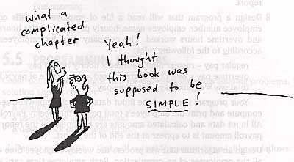
This chapter shows the program development for eight programs that have more than one control structure in them

Eight solution algorithms
We will now look at eight programms of increasing complexity. We have added one step to our design process called: The control structures required. This step comes after the defining diagram and before the solution algorithm.

a) Defining the problem
Breaks the problem up into output, input, and processes.

b) The control structures required
Write do the control structures needed for this problem, such as sequence, selection, and repetiton, along with any extra variables needed to support the structures. NOTE: You can have more than one of each structure.

c) The solution algorithm
Here is the PseudoEnglish outline of the algorithm.

d) Desk checking
Here, you find some test data, and expected answers, and then try them out on the algorithm.

Example 6.1 Process number pairs
You are to get and process pairs of numbers, until a pair of zero values is received. Display the numbers, their sum, product and average and flag values over 200.

A Defining diagram
Here is the IPO chart for this problem. NOTE: It should include the loop and decisions! It doesn't. That is part of the processes.
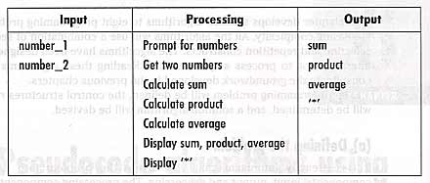

B Control structures required
0. We need to print the report header.
1. You will need a loop! DOWHILE will work.
2. You also need a selection to test the values for being greater than 200.
3. The condition for the DOWHILE can be written without the NOT! It would be: (number_1 <> 0 OR number_2 <> 0)
NOT operator should be avoided!

C Solution algorithm
Here is the solution aglorithm with the rewritten conditon.
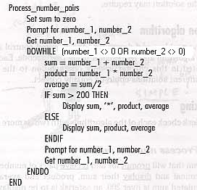

Example 6.2 Print student records
Design a program to read a file of different types of student records and print out the student's number, name, and address.

A Defining diagram
Here is the IPO chart. It should have included the decisons and loops! It doesn't.
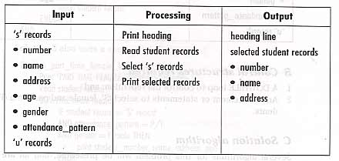

B Control structures required
0. Print report header.
1. We need a loop, a DOWHILE should work.
2. We need a selection to test for which type of records. Of course that will be an IF statement.

C Solution algorithm
Here is the algorithm.
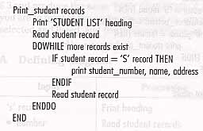

Example 6.3 Print selected students
Design a program to read the above student file and only print female, parttime students.

A Defining diagram
Here is the IPO chart. It should have incluuded the loop and selections.
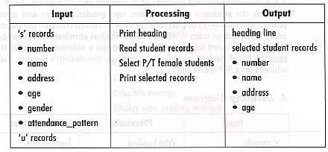

B Control structures required
0. Print report header.
1. We need a loop, DOWHILE will work.
2. We need to test for female.
3. We need to test for parttime.
4. We need to test for record type.

C Solution algorithm
Here is the solution algorithm using three nested IFs.
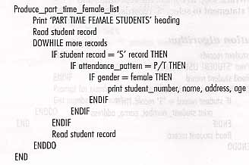
Here is the solution algorithm using a compound IF to test for female and parttime.
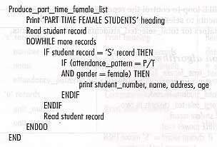
Here is the solution algorithm using a single compound IF conbining al three tests.
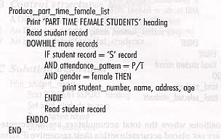

Example 6.4 Print and total selected students
This problem is the same as the above one, but, we also want to print total female-parttime students and total students.

A Defining diagram
Here is the defining diagram which is missing all the tests and loops.
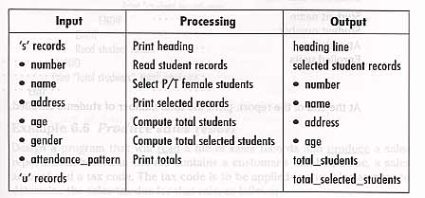

B Control structures required
0. Print report header.
1. We need a loop.
2. We need the three selections we have before.
3. We need additional variables to keep the totals in.

C Solution algorithm
Here is the solution algorithm with the added total logic. Now, we do need two separate IFs so we can count all the students.
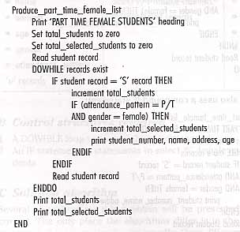

Example 6.5 Print Student Report
Design a program to read the same student file as before, but, we need to print information on each student using the format shown below.
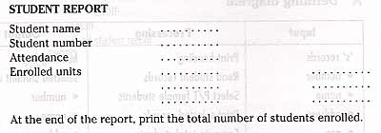

A Defining diagram
Here is the IPO chart missing the loop and selections.
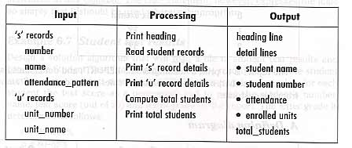

B Control structures required
0. Print report header.
1. We need a loop.
2. We need to selection between S and U records.
3. We need to accumulator total students.

C Solution algorithm
Here is the solution diagram. It even includes an error message if the record is not of type U or S!
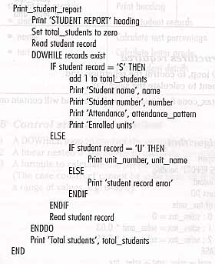

Example 6.6 Produce sales report
Write a program to read a sales record file and produce a sales report. It will process the following tax code table.
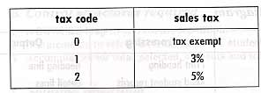

A Defining diagram
Here is the IPO chart missing the loop and selections.
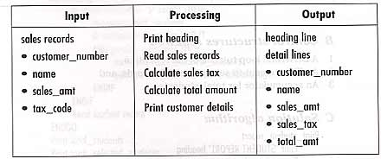

B Control structures required
0. Print report header.
1. We will need a loop.
2. We need a CASE statement for the tax code selection.

C Solution algorithm
Here is the solution algorithm
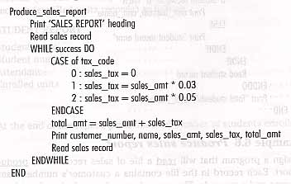

Example 6.7 Student test results
Design a program to read a student test results file and produce a student test grade report. Grades are based on the following table.
A = 90-100%
B = 80-89%
C = 70-79%
D = 60-69%
F = 0-59%

A Defining diagram
Here is the IPO chart missing the loop and selections.
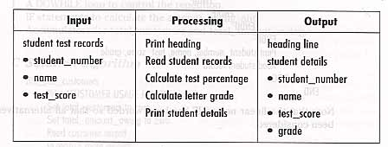

B Control structures required
0. Print report header.
1. We need a loop.
2. We need nested IFs to calculate the grade.

C Solution algorithm
Here is the solution algorithm.
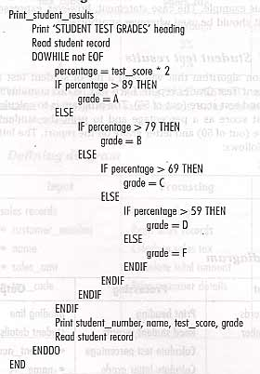

Example 6.8 Gas supply billing
Design a program to read the Customer Usage file and produce a report with totals.

A Defining diagram
Here is the IPO chart missing the loop and selection.
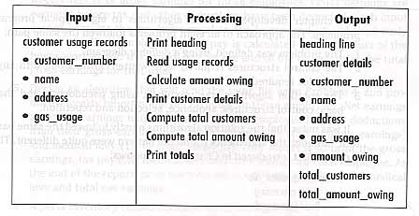

B Control structures required
0. Print report header.
1. We need a loop.
2. We need a selection on amount of usage.
3. We need to accumulate total customers and total owed.

C Solution algorithm
Here is the solution diagram.
