Simple Program Design

"Chapter 3: Developing an algorithm"
Chapter Outline
Developing an algorithm
Defining the problem
Designing a solution algorithm
Checking the solution algorithm
Chapter summary
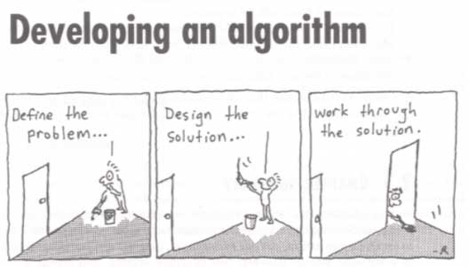

Developing a algorithm
An outline, an algorithm, and most recipes are a list of step-by-step directions on what needs to be done to solve some problem.
RULE 1: You can't program a computer to do something that you can't do yourself with the aid of a calculator!
RULE 2: There are no exceptions to RULE 1.

Defining the problem
Defining the problem is the most difficult and most important part of a programming project. If you don't know what the problem is, how will you know when you have found the solution. Writing down the prolbem definition is also the first step in the program documentation.
To aid in finding the problem definition, the problem can be divided into three components: input, process and output. A tool for collecting these components is the IPO Chart! The book likes to call this a defining chart, but it is an IPO chart, which is part of the HIPO diagram design method. HIPO is short for Hierarchy Input Process Output diagram. A blank IPO chart is shown below.
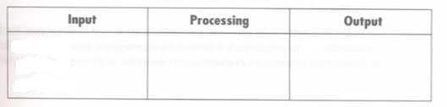
Outputs are the goal of the problem solution. Inputs are the information you get to use to solve the problem. Processes are the steps need to get from the input information to the output results.
WARNING! You can't usually fill in the information of an IPO chart starting with inputs, then list the processes, and final list the outputs. IT DOSEN'T HAPPEN THAT WAY.
Usually, you first find the outputs or GOALS for the problem! Second, you get the inputs for the problem! Third, you find the steps needed to convert the input information into the desired outputs!

Example 3.1 Add three numbers
Your are given a problem of finding the same of three numbers. What is the goal or output? What input information do you have?
Okay, the output or goal is the sum of the three numbers. The input is the value of the three numbers. The IPO chart with the output and input columns filled in is shown below.
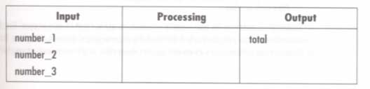
What steps are needed to convert the inputs into the goal(s) or output. The processing requires a) reading the values of the three numbers, b) adding the three numbers together and saving the sum. And c) The output is to display the sum.
Believe it or not! most beginning programmers forget to do the input and output part of the program (problem).
Notice: The processes are written in English (or some other spoken language), or in PseudoEnglish!
The full IPO chart is shown below.
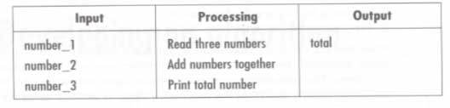

Meaningful names
There is not longer a limit to variable and constant name lenght. The variable or constant name should tell what is stored in it. For example, the result of a payroll calculation should be named Amountofcheck, rather than just Result or Results.

Example 3.2 Find average temperature
Your are given a problem of finding the average tempature for a particular day. Note: Someone is trying to tie your hands on how to solve this problem! This is dangerous as it limits your creativity.
They tell you to prompt the terminal operator for the maximum and minimum temperature readings on a particular day, accept those readings as integers, and calculate and display to the screen the simple average temperature, calculated by (maximum temperature + minimum temperature) / 2. They are telling you HOW to solve the problem, not WHAT steps are needed to solve the problem. The HOW doesn't come until later!
What is the goal or output? What input information do you have?
Okay, the output or goal is the average temperature. The input is the value of the maximum and minimum temperatures for a particular day. The IPO chart with the output and input columns filled in is shown below.
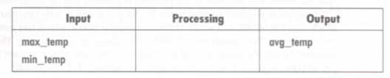
What steps are needed to convert the inputs into the goal(s) or output. The processing requires a) asking the operator for the min and max temperatures, (acturally, this might not be in the top level IPO chart. b) Accepting the numbers, (Making them integers may not be at this level of the chart). c) Calculating the average, (should give the what, not the how at this level,) and saving the average. And c) The output is to display the average.
The full IPO chart is shown below.
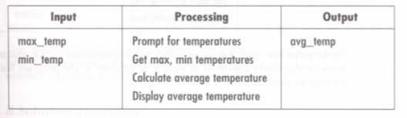

Example 3.3 Compute mowing time
Your are given the problem of finding the mowing time for a particular property. What is the goal or output? What input information do you have?
Okay, the output or goal is to find out how long will it take to mow the lawn of this property. The input is the values of the length and width of the property and the length and width of the house on the property. The IPO chart with the output and input columns filled in is shown below.
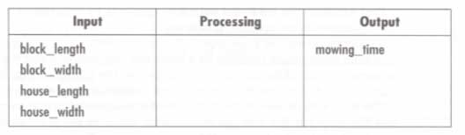
What steps are needed to convert the inputs into the goal(s) or output. The processing requires a) reading or some how getting the length and width of the house and the lot, and the area that can be mow per minute. b) Calculating the mowing area by subtracing the house area from the lot area. c) Calculating mowing time and saving it. And d) The output is to display the mowing time.
The full IPO chart is shown below.
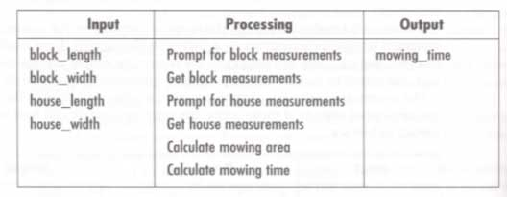
OOPS!! The above doesn't show mowing area per minute

Designing a solution algorithm
The algorithm is the processes part of the IPO chart(s)! It may take more than one chart to show it all. If we did a Hierarchy Diagram, it would show how multiple IPO charts relate to each other.
You may have to take several passes at the IPO chart before you have all of the WHAT needs to be done included in it.
Now, you make the "algorithm" by writing the processes part of the IPO chart in pseudocode (pseudoEnglish in this case.) Notices data or variable names can't have spaces in them so the underline character is used to connect multiple words. The algorithm starts with a title and ends the the keyword END
It would be even better to use the word PROGRAM followed by the program name to start the pseudocode, and end the pseudocode with END PROGRAM.

Example 3.4 Solution algorithm for Example 3.1
There is the problem of find the sum of three numbers.

A Defining diagram (is really a IPO chart!)
Here is the IPO chart.
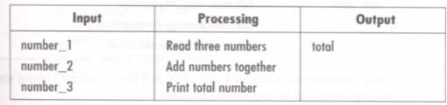

B Solution algorithm (is really the pseudocode that goes in the process part of the IPO chart!) Notice that is gives the How to do it. Acturally, the top level(s) IPO would show the "What" and the lowest level IPO would show the "How". When we get to deskchecking, it should start with the "What" needs to be done level pseudocode. Only after that is correct do we try to write and deskcheck the "How" level pseudocode. The details of the "How" shouldn't be considered until the "What is completely defined.
Add_three_numbers
Read number_1, number_2, number_3
total = number_1 + number_2 + number_3
Print total
END

Example 3.5 Solution algorithm for Example 3.2
Here is the average temperature problem

A Defining diagram (is really a IPO chart)
Here is the IPO chart.
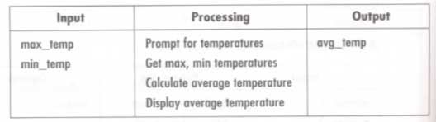

B Solution algorithm
Find_average_temperature
Prompt operator for max_temp, min_temp
Get max_temp, min_temp
avg_temp = (max_temp + min_temp)/2
Output avg_temp to the screen
END

Example 3.6 Solution algorithm for Example 3.3
Here is the mowing time problem.

A Defining diagram
Here is the IPO chart.
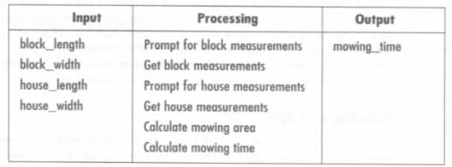

B The solution algorithm
Calculate_mowing_time
Prompt operator for block_length, block_width
Get block_length, block_width
block_area = Block_length * block_width
Prompt operator for house__length, house_width
Get house_length, house_width
house_area = house_lenght * house_width
mowing_area = block_area - house_area
mowing_time = mowing_area / 2
Output mowing_time to screen
END

Checking The Solution Algorithm
Desk checking is the process of checking an algorithm for correction. This is done by a person pretending to be a computer and executing the steps in the algorithm one by one while keeping track of the results.

Selecting test data
Before you can test the algorithm, you need some sample data to feed to the algorithm. This sample data is called test data. More than one set of test data may be needed to fully test the algorithm.
It really helps if the person doing the desk checking is a different person than the one who wrote the algoritjhm!

Steps in desk checking an algorithm
The steps in desk checking are:
1. Choose some sample test data. How many sets will be needed depends on the algorithm.
2. Use some manual method to calculate the correct anwsers. You may use a pocket calculator. These results are called the Expected Results.
3. Make a table of relevant variable names used by the algorithm.
4. Walk the first set of test data through the algorithm by carefully following algorithm instructions, one by one.
5. Repeat the walk through for other test data cases.

Example 3.7 Desk check of Example 3.1
This is the find the sum of three numbers problem.

A Solution algorithm
Here is the algorithm again.
Add_three_numbers
Read number_1, number_2, number_3
total = number_1 + number_2 + number_3
Print total
END

B Desk checking
The first step is to decide on two sets of input test data. Two sets are shown below.
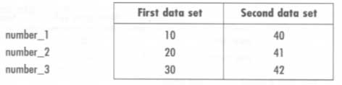
Now calculate the expected results ( hopefully the correct answers), by hand. These results are shown below.
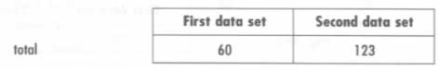
Now, set up a table of relevant variable names, and pass each test data set through the solution algorithm, statement by statement. That is:
1. Pretend to execute the read statement and write down the value for the variables number_1, number_2, and number_3.
2. Pretend to execute the statement to calculate the total. Write down the value for the variable total.
3. Now, pretend to print the total by writing the total value in the print variable. The Yes, shown in the book, doesn't tell you any thing. Show what is to be printed!
4. Repeat steps 1 through 3 with the second set of test values.
5. Check the results against the expected results. If they are the same, all is well. If not, you must recheck the hand calculations and the deskchecking until you find out which is wrong! Fortunately, everything looks great in this example.
These steps are represented in the following table.
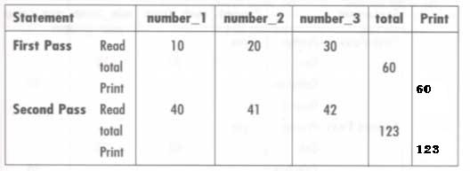

Example 3.8 Desk check of Example 3.2
This is the compute the average temperature problem.

A Solution algorithm
Here is the algorithm again.
Find_average_temperature
Prompt operator for max_temp, min_temp
Get max_temp, min_temp
avg_temp = (max_temp + min_temp)/2
Output avg_temp to the screen
END

B Desk checking
The first step is to decide on two sets of input test data. Two sets are shown below.
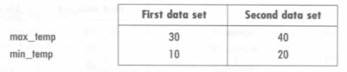
Now calculate the expected results ( hopefully the correct answers), by hand. These results are shown below.
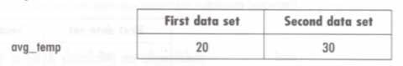
Now, set up a table of relevant variable names, and pass each test data set through the solution algorithm, statement by statement. That is:
1. Pretend to execute the prompt by writing "Enter the max and min temps" in the space for the prompt variable. The Yes, shown in the book, doesn't tell you any thing. Show what is to be printed!
2. Pretend to execute the statement to get the values and place them in the variables max_temp and min_temp.
3. Now, calculate the average place the value in the variable avg_temp.The Yes, shown in the book, doesn't tell you any thing. Show what is to be printed!
4. Now, pretend to print the total by writing the total value in the print variable. The Yes, shown in the book, doesn't tell you any thing. Show what is to be printed!
5. Repeat steps 1 through 4 with the second set of test values.
6. Check the results against the expected results. If they are the same, all is well. If not, you must recheck the hand calculations and the deskchecking until you find out which is wrong! Fortunately, everything looks great in this example.
These steps are represented in the following table.
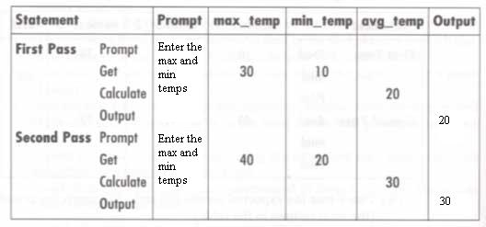

Example 3.9 Desk check of Example 3.3
This is the mowing time problem.

A Solution algorithm
Here is the algorithm again
Calculate_mowing_time
Prompt operator for block_length, block_width
Get block_length, block_width
block_area = Block_length * block_width
Prompt operator for house__length, house_width
Get house_length, house_width
house_area = house_lenght * house_width
mowing_area = block_area - house_area
mowing_time = mowing_area / 2
Output mowing_time to screen
END

B Desk checking
The first step is to decide on two sets of input test data. Two sets are shown below.
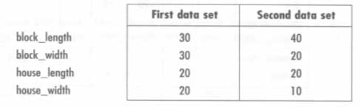
Now calculate the expected results ( hopefully the correct answers), by hand. These results are shown below.
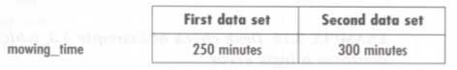
Now, set up a table of relevant variable names, and pass each test data set through the solution algorithm, statement by statement. That is:
1. Pretend to execute the prompt by writing "Enter the block length and block width" in the space for the prompt variable. Okay, the book left this column out. Add it!
2. Pretend to execute the Get statement place the values in the variables block_length and block_width.
3. Now, calculate the block area and place the value in the variable block_area.
4. Pretend to execute the prompt by writing "Enter the house length and house width" in the space for the prompt variable. Okay, the book left this column out. Add it!
5. Pretend to execute the Get statement place the values in the variables house_length and house_width.
6. Now, calculate the house area and place the value in the variable house_area.
7. Now, calculate the mowing area and place the value in the variable mowing_area.
8. Now, calculate the mowing time and place the value in the variable mowing_time.
9. Now, pretend to print the mowing time by writing the mowing time value in the print variable. The Yes, shown in the book, doesn't tell you any thing. Show what is to be printed!
10. Repeat steps 1 through 9 with the second set of test values.
11. Check the results against the expected results. If they are the same, all is well. If not, you must recheck the hand calculations and the deskchecking until you find out which is wrong! Fortunately, everything looks great in this example.
These steps are represented in the following table.
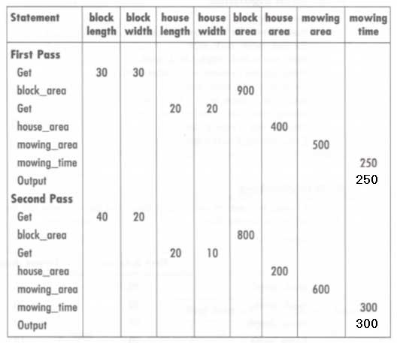

Example 3.10 Desk check of Example 3.4
Here is the mowing time problem with a logical error in the algorithm. Desk checking it should give bad results!

A Solution algorithm
Here is the mowing algorithm with an error in it!
Calculate_mowing_time
Prompt operator for block_length, block_width
Get block_length, block_width
block_area = Block_length * block_width
Prompt operator for house__length, house_width
Get house_length, house_width
house_area = block_lenght * block_width
mowing_area = block_area - house_area
mowing_time = mowing_area / 2
Output mowing_time to screen
END

B Desk checking
The first step is to decide on two sets of input test data. Two sets are shown below. It is same as for the previous example.
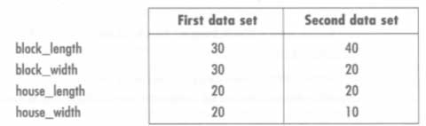
Now calculate the expected results ( hopefully the correct answers), by hand. These results are shown below. This is still the same as before.
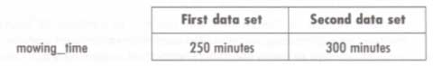
Now, set up a table of relevant variable names, and pass each test data set through the solution algorithm, statement by statement. That is:
1. Pretend to execute the prompt by writing "Enter the block length and block width" in the space for the prompt variable. Okay, the book left this column out. Add it!
2. Pretend to execute the Get statement place the values in the variables block_length and block_width.
3. Now, calculate the block area and place the value in the variable block_area.
4. Pretend to execute the prompt by writing "Enter the house length and house width" in the space for the prompt variable. Okay, the book left this column out. Add it!
5. Pretend to execute the Get statement place the values in the variables house_length and house_width.
6. Now, calculate the house area and place the value in the variable house_area.
7. Now, calculate the mowing area and place the value in the variable mowing_area.
8. Now, calculate the mowing time and place the value in the variable mowing_time.
9. Now, pretend to print the mowing time by writing the mowing time value in the print variable. The Yes, shown in the book, doesn't tell you any thing. Show what is to be printed!
10. Repeat steps 1 through 9 with the second set of test values.
11. Check the results against the expected results. If they are the same, all is well. If not, you must recheck the hand calculations and the deskchecking until you find out which is wrong! Fortunately, everything looks great in this example.
These steps are represented in the following table.
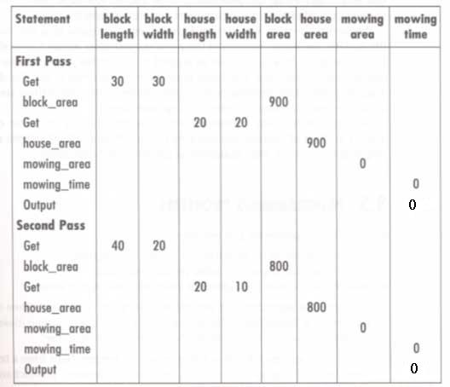
Notice the answers don't match the expect results. What is the error in the algorithm?

Why desk checking is so difficult, or why you can't see your own error!
1. we see what we expect to see!
2. We hear what we expect to hear!
3. We know that we did it right!

Expectation Information
Humans do very fast vision processing with very slow processors by knowing what they expect to see. Of course, if we are wrong about what we expect to see, it takes some time before we realy see what is there!
PLEASE DO AS I ASK, when looking at the next six pictures!

Phonic Reading Sentence
This is an exercise in we see what we expect to see, even if our filters are set up by our own hearing!
Read the follow LARGE sentence out loud once, then move on to the next directions.
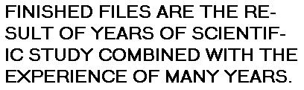
Now, go back to the above LARGE sentence and count the number of F's in the sentence; then return to here.
How many F's did you count? If you found three F's or six F's, you are normal. If you found four or five F's, you are either unduly suspicious of being tricked or inconsistent in the way you looked for the F's. If you found three F's, you probably learned to read by using phonics. By reading the sentence out loud first, you set up a phonic filter that did not interupt the three of's as containing F's. Then when you went back to count the F's in the sentence, you did not notice the F's in the three of's. In case you are not sure, ther are really six F's in the Large sentence.

Related Objects
This time your filters are set up by the introductory instructions and by past visual experiences.
This next picture you are going to look at contains a group of five silhouette figures. One of the silhousettes looks like a comb with teeth missing from the ends; another looks like a living room with a fireplace; a third looks like an arrowhead and the remaining two look like the outlines of other rooms. See if you can make out what the five objects are.

As you may have guessed by now, you were given misleading directions about the above pictures. The deception was aided by your being used to seeing black lettrers on a white background.
To help overcome this filter or scatoma, try imaging two vertical and two horizontal black lines forming a rectangle connecting the outer edges of the five objects. Do you now see the white lettering on black background spelling out the word FLY? The objects in the above picture are really the balckground pieces separating the letters.

More Related Objects
Okay. Here we go again! See if you can find the word WIN in the following picture.
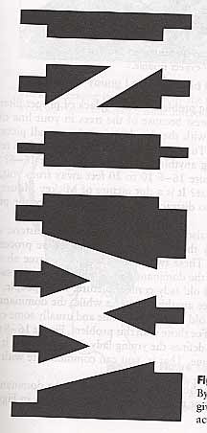

Not Seeing the Forest Because of the Trees
We can still be fooled, even when we expect trouble.
when we look at the following picture, we are two busy looking at the details to see the overall picture.
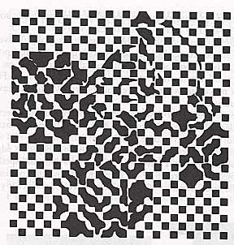
Try getting 10 to 20 feet away from the picture and look at it again!
It is a dot picture of Mickey Mouse.

The Old Lady
Vision processing for humans is complicated by the fact that we have two different processors. These work on vision processing from different viewpoints.
All of us should be able to see the old lady in the following picture.
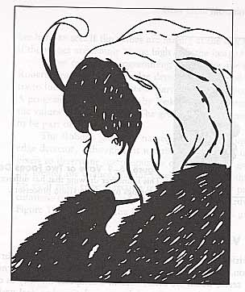

Young Lady
Here is some help on seeing the young lady. The young lady is the hardest part of the above picture to recognize. She is identified by the creative, subconscious, or nondominant processor.


The Vase Problem
Here is another drawing that has different meanins to the two vision processors of your brain. Is it a vase or two faces. Your conscience processor see the vase, your created processor see two faces facing each other.
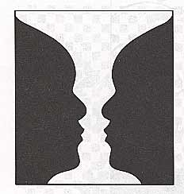

What Can We Do To See What Is Really There?
Desk checking and algorithm or program is hard enough if we see what is really there. What can we do to help us see what's there?
1. Try to pretend you never saw the algorithm before, and of course you didn't write it. You need to mentally step outside your body while you do the desk checking.
2. Or, you need to desk check someone elses algorithm while (s)he checks your algorithm.
3. Remember, you are not trying to place blame for mistakes. You just want to see what is there.
4. Pretend you don't know anything about the algorithm and just follow the steps, one by one, keeping good notes.

