Simple Program Design

"Appendix 1: Flowcharts"
Chapter Outline
Flowcharts
The Three Basic Control Structures
1 Sequence
2 Selection
3 Repetition
Simple Algorithms That Use The Sequence Control Structure
Example 3.1 Add Three numbers
A defining diagram
B Solution algorithm
Example 3.2 Find average temperature
A Defining diagram
B Solution algorithm
Example 3.3 Calculate mowing time
A Defining diagram
B Solution algorithm
Flowcharts and the Selection Control Structure
Simple IF statement
Null ELSE statement
Combined IF statement
Nested IF statement
Simple Alogrithms That Use the Selection Control Structure
Example 4.1 Read three characters
A Defining diagram
B Solution algorithm
Example 4.2 Process customer record
A Defining diagram
B Solution algorithm
Example 4.3 Calculate employee's pay
A Defining diagram
B Solution algorithm
The CASE Structure Expressed as a Flowchart
Example 4.4 Process customer record
A Defining diagram
B Solution Algorithm
Flowchart and the Repetition Control Structure
Simple Algorithms That Use the Repetition Control Structure
Example 5.1 Fahrenheit-Celsius conversion
A Defining diagram
B Solution algorithm
Example 5.2 Print examination scores
A Defining diagram
B Solution alogorithm
Example 5.3 Process student enrolments
A Defining diagram
B Solution algorithm
Example 5.4 Process inventory items
A Defining diagram
B Solution algorithm
Flowcharts and Modules
Example 8.1 Read three characters
A Defining diagram
B Hierarchy chart
C Solution algorithm using a predefined process symbol

Flowcharts
Flowcharts are a visual outlining tool. They can be used to represent an algorithm. The flowing five symbols are enough to flowchart an algorithm.
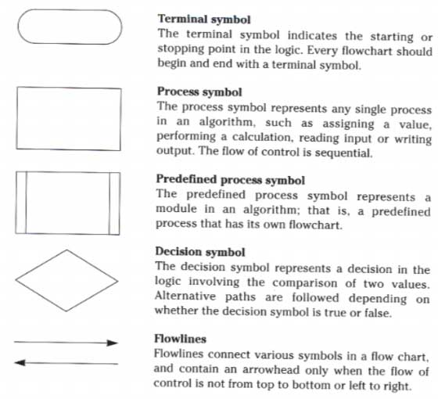

The Three Basic Control Structures
Our programs are made up of the three basic constructures of: sequence, selection, and repetition.

1 Sequence
The sequence control structure is defined as the straight forward execution of one procesing step after another. Here is the general form of a sequence.
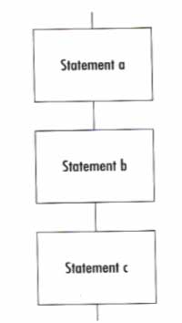
Here is a typical sequence of statements.
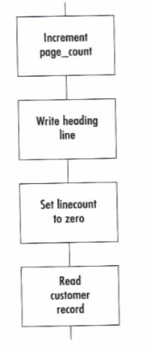

2 Selection
The selection control structure can be defined as the presentation of a condition, and the choice between two actions depending on whether the condition is true or false. Here is the general form of the selection construct.
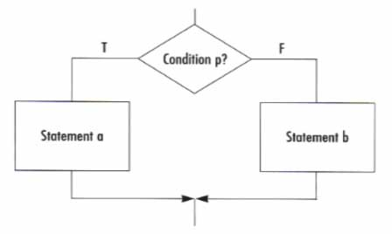
Here is a typical selection statement.
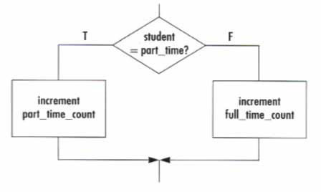
Here is a selection with a empty false side.
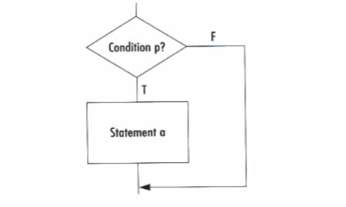

3 Repetition
The repetition control structure can be defined as the presentation of a set of instructions to be performed repeatly, as long as a condition is true. Here is the general form of repetition.
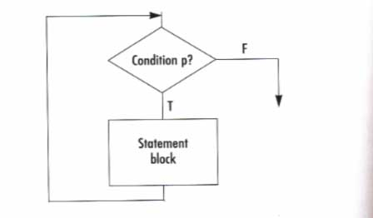
Here is a repetition control structure with typical statements.
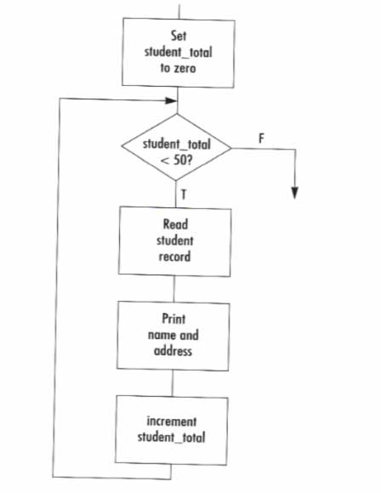

Simple Algorithms That Use the Sequence Control Structure
Here are the examples from chapter 3 using flowcharts.

Example 3.1 Add three numbers
A program is required to read three numbers, add them together and print their total.

A Defining diagram
Here is the IPO (Input, Process, Output) chart.
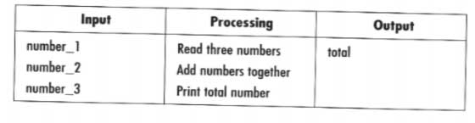

B Solution algorithm
Here is the algorithm as a flowchart.
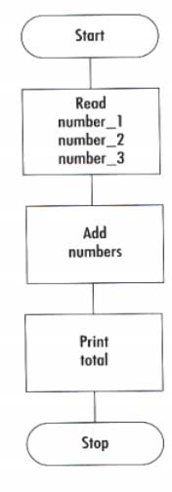

Example 3.2 Find average temperature
A program is to get the maximum and minimum temperatures for a day and calculate and display the average temperature.

A Defining diagram
Here is the IPO chart.
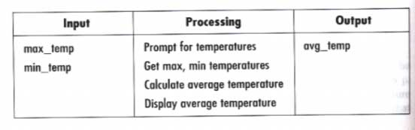

B Solution algorithm
Here is the algorithm as a flowchart.
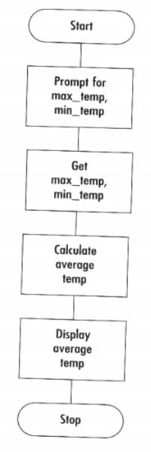

Example 3.3 Calculate mowing time

A program is required to read in the length and width of a lot, and the length and width of the rectangular house that has been built on the lot. Then it computes and displys the mowing time the lot.

A Defining diagram

Here is the IPO chart.

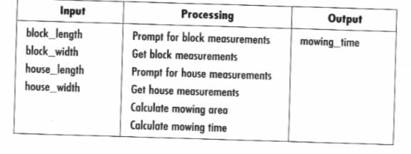

B Solution algorithm

Here is the algorithm as a flowchart.

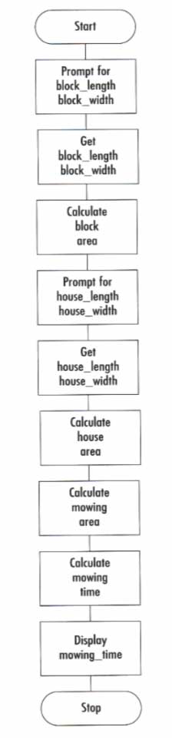

Flowcharts and the Selection Control Structure

Here are the examples from chapter 4 using flowcharts.

Simple IF statement

Simple selection occurs when a choice is made between two alternative paths.

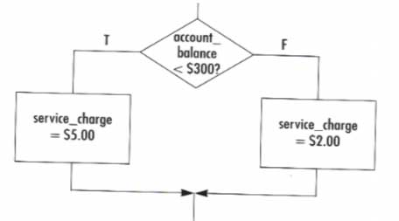

Null ELSE statement

The null ELSE structure is a variation of the simple IF structure with the false side being empty.

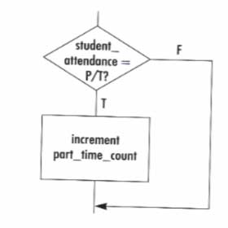

Combined IF statement

A combined IF statement is one that contains multiple conditions in the decision symbol.

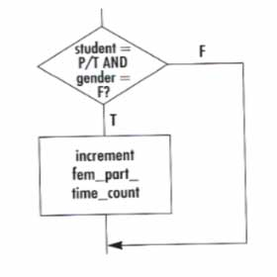

Nested IF statement

A nested IF statement has another IF in either the true or false branch.

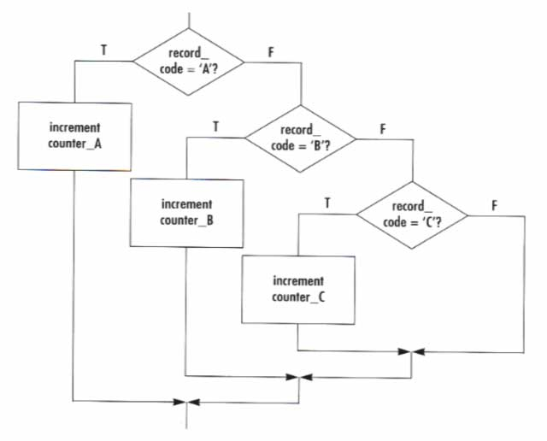

Simple Algorithms That Use the Selection Control Structure

Finally here are the examples from chapter 4 rewritten as flowcharts.

Example 4.1 Read three characters

An algorithm prompts the operator for three characters, gets the characters, sorts them and ouputs them in ascending order.

A Defining diagram

Here is the IPO chart.

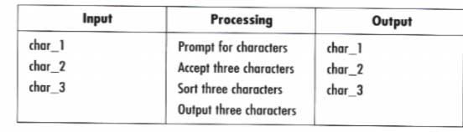

B Solution algorithm

Here is the algorithm as a flowchart.

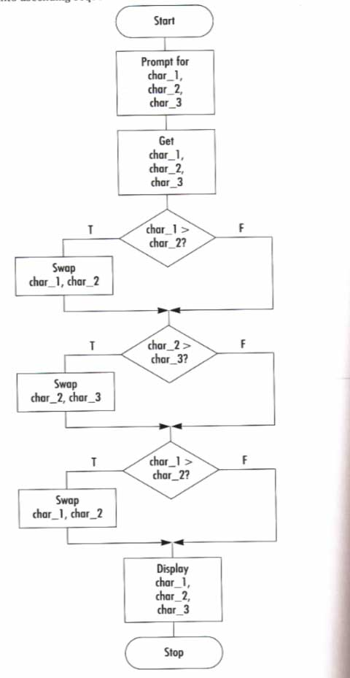

Example 4.2 Process customer record

A program reads a customer's name, purchase amount, and a tax code. The tax code is validated, the sales tax is computed along with the toal. very thing is printed out.

A Defining diagram

Here is the IPO chart.

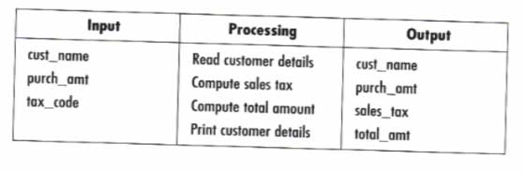

B Solution algorithm

Here is the algorithm as a flowchart.

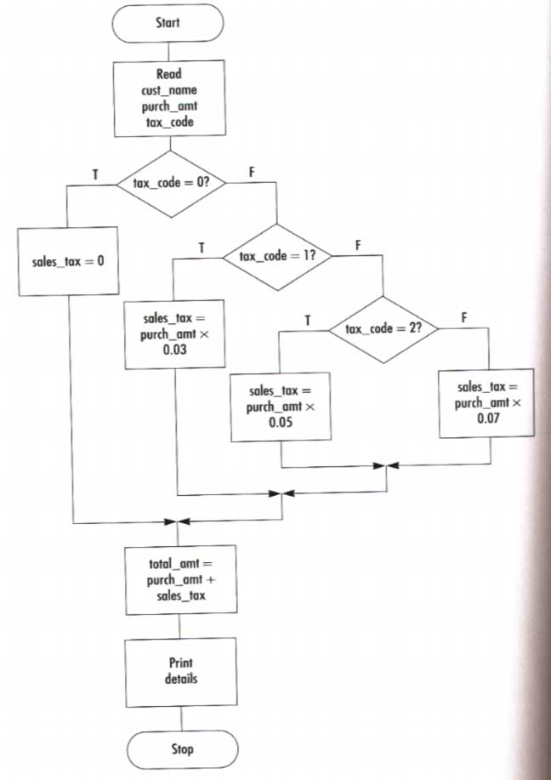

Example 4.3 Calculate employee's pay

A program is to read payroll records, compute an employee's pay, and print out everything.

A Defining diagram

Here is the IPO chart for the program.

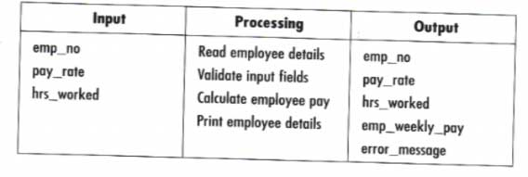

B Solution algorithm

Here is the solution algorithm as a flowchart.

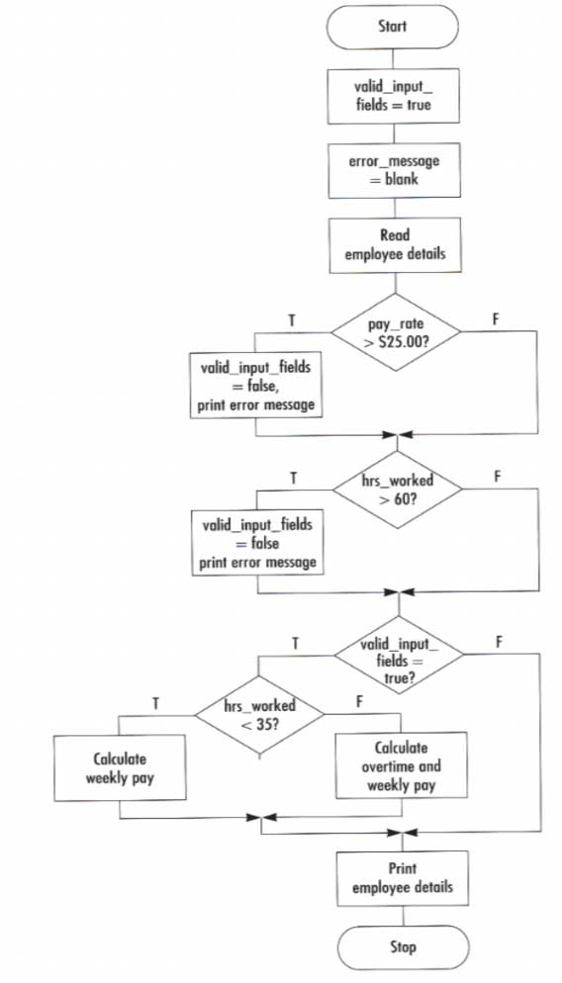

The CASE Structure Expressed as a Flowchart

The CASE statement is great for a test that has many acceptable answers. Here is one way to represent a CASE statement in a flowchart.

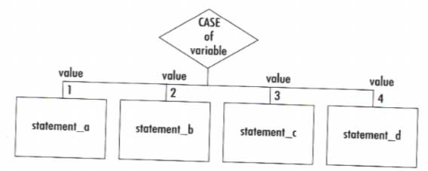

Example 4.4 Process customer record

A program is to read customer records, validate the tax code, compute the sales tax and total and print out everything but the tax code.

A Defining diagram

Here is the IPO chart.

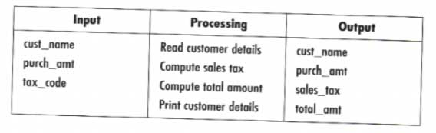

B Solution algorithm

Here is the solution algorithm as a flowchart.

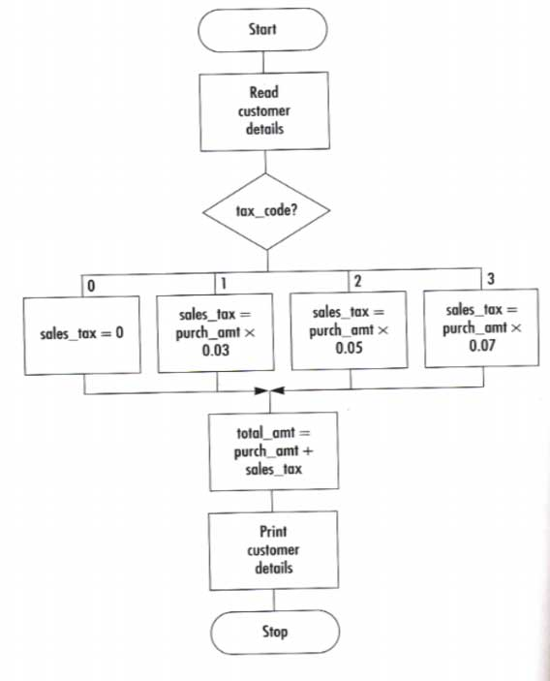

Flowcharts and the Repetition Control Structure

Repetition is used to repeat a group of instructions 0 or more times. It makes for economic programming. Here is the DOWHILE in a flowchart.

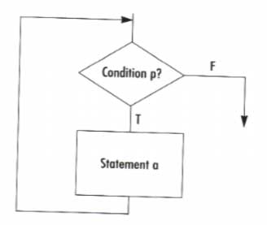

Simple Algorithms That Use the Repetition Control Structure

Here are some algorithms from chapter 5 rewritten as flowcharts.

Example 5.1 Fahrenheit-Celsius conversion

A program is to get 15 Fahrenheit temperatures and convert them to Celsius and display them with a "all temperatures processed" message.

A Defining diagram

Here is the IPO chart.

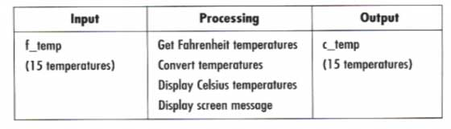

B Solution algorithm

Here is the solution algorithm rewritten as a flowchart.

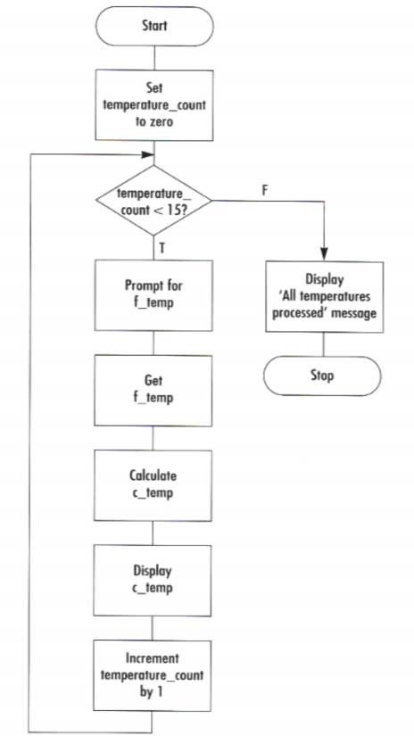

Example 5.2 Print examination scores

A program is to read and print a series of student's names and exams scores. Then it is to print the average score..

A Defining diagram

Here is the IPO chart.

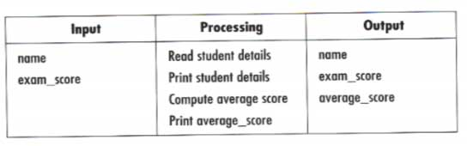

B Solution algorithm

Here is the Solution algorithm as a flowchart.

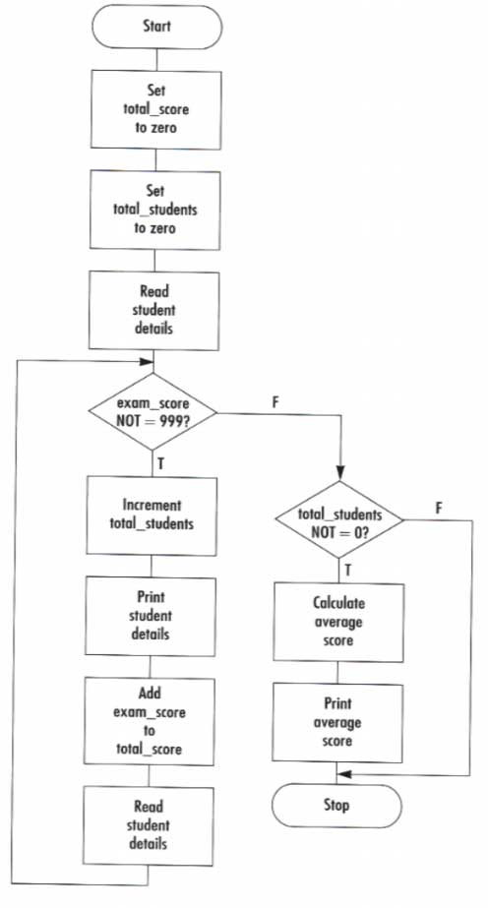

Example 5.3 Process student enrolments

A program is to read a student records file and print out only the records of students taking Programming I course.

A Defining diagram

Here is the IPO chart.

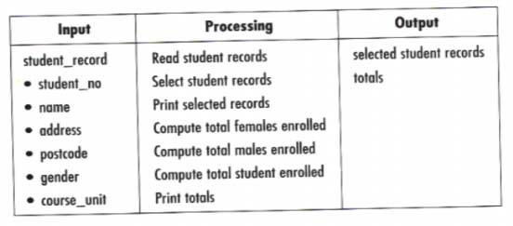

B Solution algorithm

Here is the Solution algorithm as a flowchart.

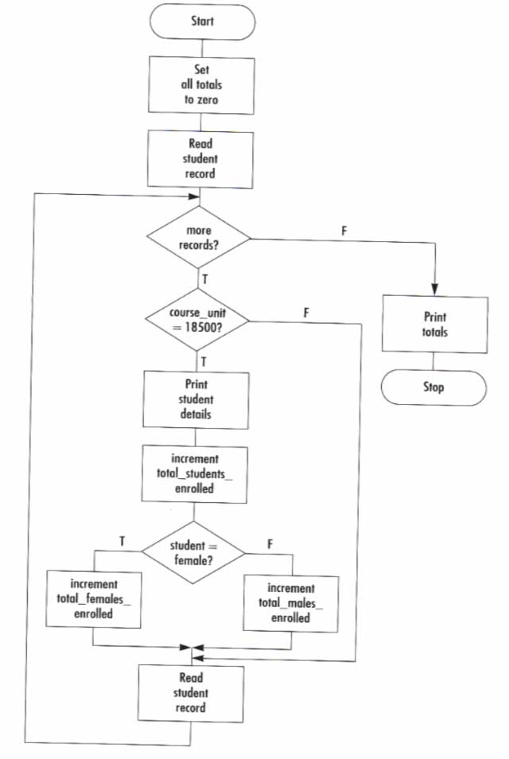

Example 5.4 Process inventory items

The program is to read an inventory file and produce a low stock items report.

A Defining diagram

Here is the IPO chart

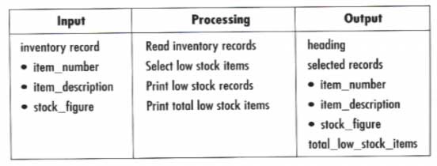

B Solution algorithm

Here is the Solution algorithm as a flowchart.

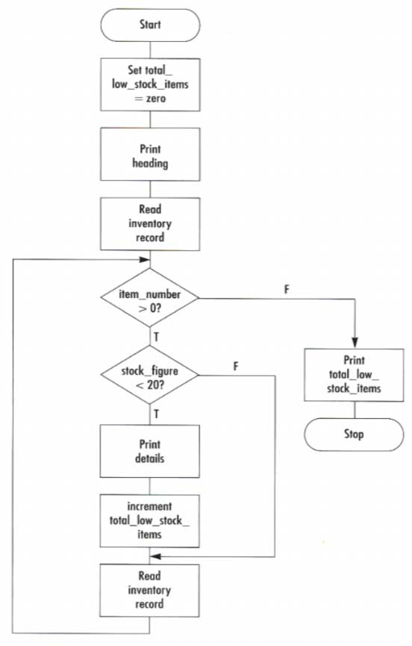

Flowcharts and Modules

Flowcharts can use the predefined symbol to break a program up into modules

Example 8.1 Read three characters

Here is the read three characters and print them out in ascending order program.

A Defining diagram

Here is the IPO chart.

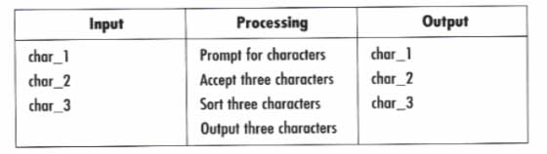

B Hierarchy chart

Here is a possible hierarchy chart.

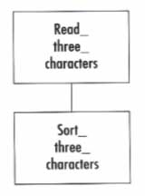

C Solution algorithm using a predefined process symbol

Here is the Solution algorithm using flowchats.

