Simple Program Design

"Chapter 1: Program Design"
Chapter Outline
Program Design
Steps in program development
Structured programming
The Design Challenge
An introduction to algorithms and pseudocode
Program data
Chapter summary

Program Design
Most good programs require good planning before they are written. This is called Program Design.
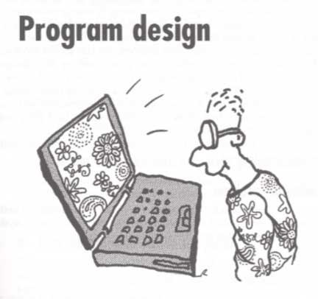

Steps in program development
The steps in program design are similar to the steps in problem solving. They are:
1. Define the problem
2. Outline the solution
3. Develop the outline into an algorithm
4. Test the algorithm for correctness
5. Code the algorithm into a specific programming language
6. Run the program on the computer
7. Document and maintain the program

Define the Problem
You need to understand the problem before you can expect to get a correct solution to the problem. What information (inputs), is given to you to use to solve the problem? What will the solution (outputs) of the problem, look like? What calculations (processes), will be used to change the input information into the desired output?

Outline the Solution
Break the problem into the steps of what must be done to solve the problem. List what tasks need to be done to solve the problem. An English outline is a good tool for doing the job.

Develop the outline into an algorithm
Expand the outline from the previous step into a complete solution. It should list all the steps that need to be done, in the correct order they need to be done in.

Test the Algorithm for Correctness
In this step, you pretend to be a computer and execute the steps in the algorithm. This is called "Desk Checking." Be care to follow the algorithm exactly! Don't add steps, or leave out any steps. Don't rearrange the steps. If you don't get the right answer to the problem, then you have an error in the algorithm. Fix it and try again until you get the right answer

Code the Algorithm into a Specific Programming Language
Once the algorithm, or complete outline works correctly, you need to translate the algorithm into a computer language that your computer undrstands. This is only 5 to 10% of the total programming process!

Run the Program on the Computer
Now, enter the program into the computer's memory, enter the input data, and hve the computer execute the program. If you get the correct answer to the problem, the program works! Otherwise, look for errors in the program and try again.

Document and maintain the program
Warning! The Documentation of the program started by writing down "What is the Problem!" It continues through each step of the design process.
Once the program works correctly, you want make sure the documentation is up to date and be ready to maintain the program. Good programs get better during the life-time as people think of better way to do things and additional taks the program might do. Up to data documentation is very important!

Program design methodology
The fundamental principle of program design is based on the fact that a program accepts input data, processes that data, and then delivers that data to the program user as output.
Here are some common design approaches:
procedure-driven
event-driven
data-driven
structured programming

Procedure-driven program design
The procedure-driven design is bases on the idea that the most important feature of a program is 'what' it does.

Event-driven program design
The event-driven program design is based on the idea that an event or interaction with the outside world can cause a program to change from one known state to another.

Data-driven program design
The data-driven program design is based on the idea that the data in a program is more stable than the processes involved.

Procedural versus object-oriented programming
Procedural programming is based on a structured, top-down approach to writing effective programs
The approach concentrates on 'what' a program has to do and involves identifying and organising the 'processes' in the program solution.

Top-down development
The development of a program design stats with an outline to a general solution.
This is broken down gradually into more detailed steps until finally the most detailed levels have been completed.

Modular design
Modular design involves grouping tasks together because they all perform the same function.

Object-oriented programming
Object oriented programming breaks the problem into a set of separate objects that perform actions and relate to each other.

An Introduction to Algorithms and Pseudocode
What is an Algorithm?
An detailed outline
A recipe
What is pseudocode?
Pseudo English! is -- an indented outline with key words showing structure.

Program Data
Information processed by the computer is data.

Variables, constants and literals
A variable stores a particular type of data in some memory location(s). The value in a variable may be changed as the program executes.
A constant is a data item with a name and value that can't be changed during program execution.
A literal is a constant whose name is the written representation of its value. For example: '50'.

Elementary data items
Elementary data items are single variables. Their types are integer, real, character, and boolean.
integer -- holds a whole number
real -- holds a decimal value, or is a number with a factional part
character -- holds a symbol such as a through z, 1 through 9, or !, @,#,$,%,^, etc.
boolean -- holds either a value of true or false.

Data structures
A data structure is a collection of other data items. Some of the data structures are: record, file, array, and string.
record -- a collection of data items or field related to eachother, such as an entire in an address book.
file -- a collection of records.
array -- a collection of data items, all of the same type!
string -- a collection of zero or more characters.

