Simple Program Design

"Chapter 5: Repetition control structures"
Chapter Outline
Repetition control structures
Repetition using the DOWHILE structure
Repetition using the REPEAT...UNTIL structure
Counted repetition constructs
Chapter summary
Programming problems
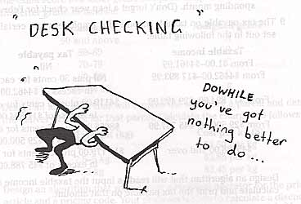
The Repetition control structure allows a group of instructions to be repeated zero or more times. It is one thing that makes it worthwhile to program computers, because as you will find out, it takes a long time to program a computer. Then having the computer execute those instructions many, many times makes up for the hard work.

Repetition using the DOWHILE structure
The DOWHILE structure repeats a group of instructions while some condition is true. Its format is:
DOWHILE condition p is true
statement block
ENDDO
The DOWHILE loop is a leading decision loop. The proceesing steps are:
a. The logical condition p is tested
b. If condition p is found to be true, the statements within the statement block are executed once. Control then returns to the retesting of condition p (step a).
c. If condition p is found to be false, control passes to the next statement after the ENDDO and no further processing takes place within the loop.

Example 5.1 Fahrenheit-Celsius conversion
Write a program to convert 15 Fahrenheit temperatures to Celsius.

A Defining diagram
Here is the Temperature convertion IPO chart.
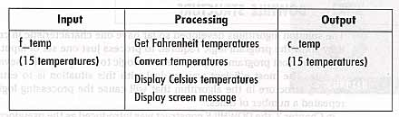

B Solution algorithm
Here is the algorithm using a DOWHILE and ENDDO loop.
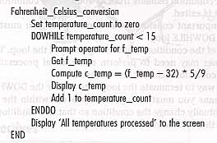
This is the same algorithm using the keywords WHILE...DO and ENDDO. It is identical to the previous algorithm.
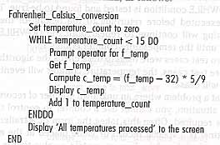

C Desk checking
Now, choose two data sets for testing the algorithm.
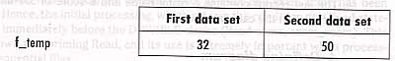
Here are the expected results for the two data sets. Of course you really need 15 values in each data set to test the algorithm!
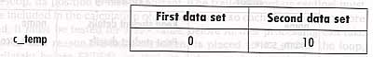
Here is the desk check table showing how the algorithm reacts to the two test values.
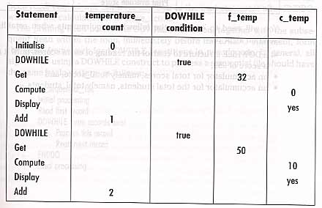

Example 5.2 Print examination scores
This time we want a program to read exam scores. It is to print out the name and scores for each student, then print out the average score.

A Defining diagram
Here is the IPO chart for this program.
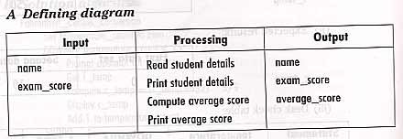

B Solution algorithm
Here is the algorithm for the program.
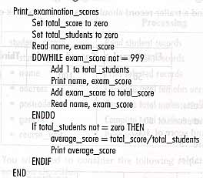
Please notice the priming read used with WHILE statements. This is necessary in order to have something valid to do the conditional test against. It is shown below as a simplifed algorithm.
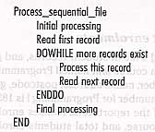

C Desk checking
Here are the three test data for this program.
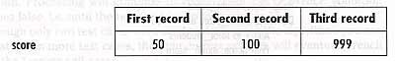
The expected results are:
1st name, and score of 50
2nd name, and score of 100
Average score 75
Here is the desk check table.
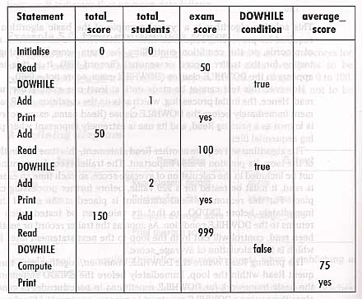

Example 5.3 Process student enrolmentss
A program is to read student records and print out those students enrolled in Programming I course, along with appropriate totals.

A Defining diagram
Here is the IPO chart for the student record program.
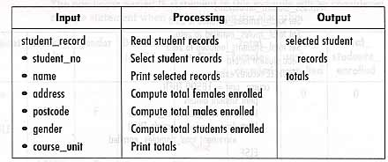

B Solution algorithm
Here is the algorithm for the student records.
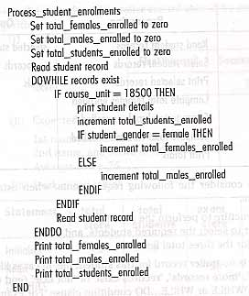

C Desk checking
Here is some test data.
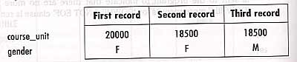
The expected results are:
Student number, name, address, postcode, F (2nd student)
Student number, name, address, postcode, M (3rd student)
Total females enrolled 1
Total males enrolled 1
Total students enrolled 2
Here is the desk check table.
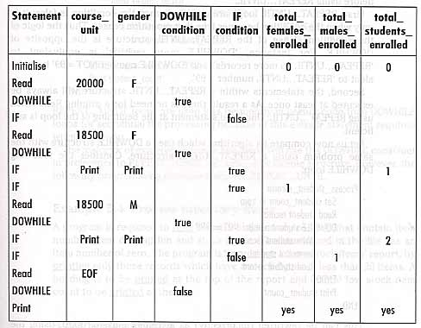

Repetition Using The Repeat..Until Structure
The Repeat..Until structure always executes the loop instructions at least once! It doesn't test for the condition until the end of the loop. The format for the Repeat..Until is:
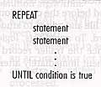
Here is the student record program using a DOWHILE loop with a leading test.
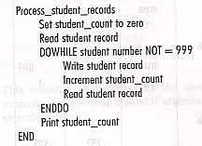
Here is the student record program incorrectly written with a Repeat..Until loop with a trailing test.
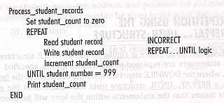
Here is the student record program correctly rewritten with a Repeat..Until loop.
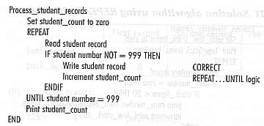

Example 5.4 Process inventory items
Design a program to read the inventory records and print a report of low shock items.

A Defining diagram
Here is the IPO chart.
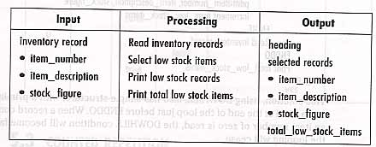

B1 Solution algorithm using REPEAT..UNTIL
Here is an algorithm using the Repeat..Until.
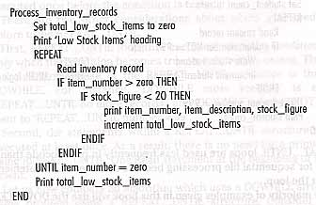

B2 Solution algorithm using DOWHILE
Here is an algorithm using the DOWHILE.
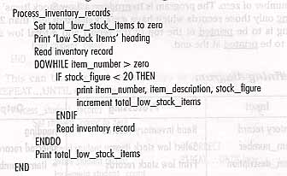

C Desk checking
Here is some test data.
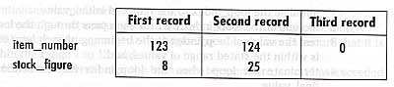
The expected results are:
Low Stock Items
123 8 (first record) Here is the desk check table.
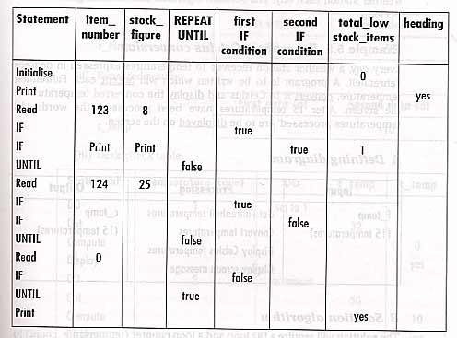

Counted Repetition Constructs
Counted repetiton occurs when the exact number of loop iterations is known in advance. These are called simply DO loops. Their format is:
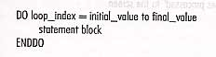

Example 5.5 Fahrenheit-Celsius conversion
Design a program to convert exactly 15 Fahrenheit temperatures to Celsius.

A Defining diagram
Here is the IPO chart.
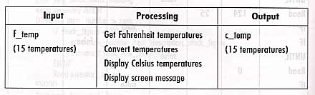

B Solution algorithm
Here is the algorithm using a DO loop.
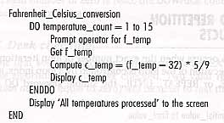

C Desk checking
Now we think up some test data.
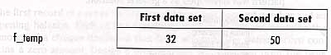
Here are the expected results.
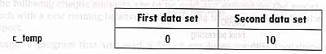
Here is the desk check table.
