Simple Program Design

"Chapter 8: First steps in modularisation"
Chapter Outline
First steps in modularisation
Modularisation
Hierarchy charts or structure charts
Further modularisation
Communication between modules
Using parameters in program design
Steps in modularisation
Programming examples using modules Chapter summary
Programming problems


Modularisation
Modularisation means dividing a problem into subtasks. As problems become more complicated, the major task should be subdivided into subtasks to make it easier to understand the problem. Suppose the major task is to make an apple pie. Some subtasks of making the pie are: buying the ingredients, making the ingredients, and baking the pie.

The modularisation process
Division of a problem into smaller subtasks, or modules, is a relatively simple process. When defining the problem, write down the activities or steps to be performed. Group the activities into subtasks or modules. Module names should tell the task being done. For example.
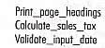

The mainline
The mainline module controls the program by tieing all the other modules together. With the use of good module names, the mainline module becomes the top level outline for the program.
Let's revisit two algorithms from chapter 4.

Example 8.1 Read three characters
Design a program to read three characters and print them out in ascending order. The program contiues to cycle until XXX is entered for the three numbers.

A Defining Diagram
Here is the IPO chart.
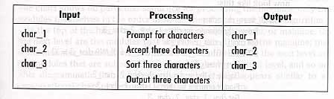

B Initial solution algorithm
Here is the original algorithm.
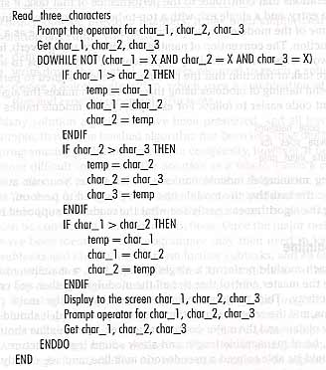
It is cumbersome and awkward. The sorting logic gets in the way of understanding the program.

C Solution algorithm using a module
Now, let's move the sorting logic to another module. Call it Sort_three_characters. The mainline module is much easier to understand and the sort module is easier to follow as well!. Here is the revised algorithm.
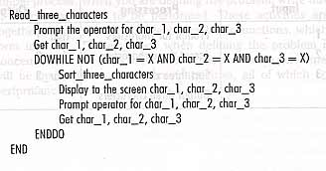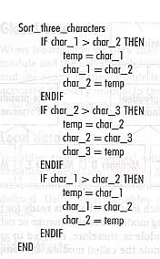

Hierarchy Charts or Structure Charts
THE BOOK OVER SIMPIFIEDS! Hierarchy charts show the relation of modules from top to bottom. Structure charts also show the control and data flow between modules, including loops and decision! That is, structure charts include all communications between modules.
Here is a hierarchy charts showing a companies' organization.
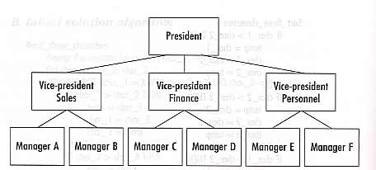
Here is the hierarchy chart for the read_three_characters program.
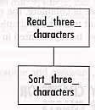

Further modularisation
The above example could also have been designed to use a mainline and three modules, one each of the main processing steps in the defining diagram as follows:
Read three characters
Sort three characters
Print three characters

A Defining Diagram
Here is the IPO chart.

B Solution algorithm
Here is the new solution algorithm
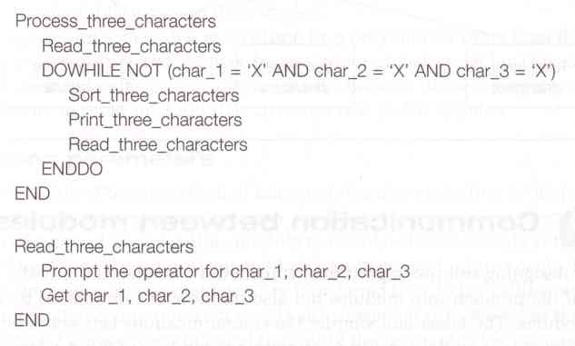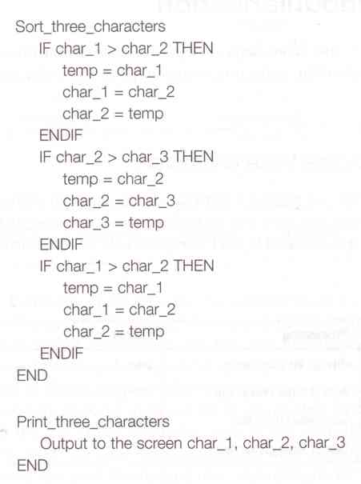
Here is the new hierarchy chart.
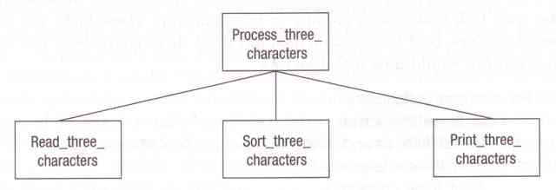

Communication Between Modules
The fewer and simpler the communications between modules, the better. This flow of information, called intermodule communication, can be accomplished by the scope of the variable (local or global data) or the passing of [arameters.

Scope of a variable
The scope of a variable is the portion of the program in which that variable has been defined and to which it can be referred.

Global data
Global data can be accessed by every module in the program. Not all data should be global!

Local data
Variables defined within a subordinate module are called local variables. They can only be referenced by this modules and modules called by this module.

Side effects
Side effects are where a module changes values of variables in other parts of the program.

Passing parameters
Passing parameters means a calling module transfers information to the called module. Under some circumstanes, the called module also returns information to the calling module. Structure charts show this by using arrows
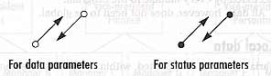

Using Parameters In Program Design
Here is the Read_three_characters program again. This time we show the communications between the modules.

Examples 8.2 Read three characters
Design a program to read three characters and print them out in ascending order. The program contiues to cycle until XXX is entered for the three numbers.

A defining diagram
Here is the IPO chart.
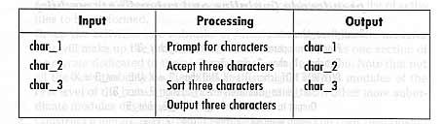

B Group the activities into modules
There are two main activities: Read_three_characters, and Sort_three_characters..

C Construct a hierarchy chart
Here is a partical hierarchy chart showing the information interchange.
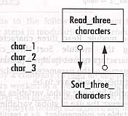

D Establish the logic of the solution algorithm using pseudocode (mainline and subordinate module)
Here is the algorithm including the parameters being passed.
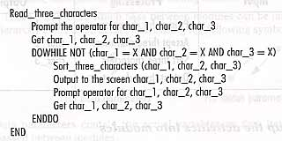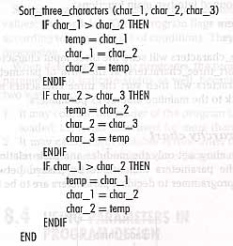

Steps In Modularisation
Here are the steps in top-down modular design.
1. Define the problem using the IPO chart.
2. Group activites into subtasks or functions.
3. Construct a hierarchy chart.
4. Establish the mainline algorithm.
5. Develope the algorithms for each successive modules.
6. Desk check the solution algorithm.

Programming Examples Using Modules
Here are some sample program designs using modules.

Example 8.3 Calculate employee's pay
The program is to read an employee record, calculate weekly pay, and print out everything.

A Define the problem
Here is the IPO chart.
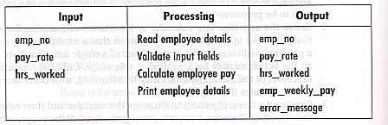

B Group the activities into modules
The modules are Compute_employee_pay, Validate_input_fields, and Calculate_employee_pay.
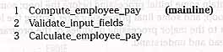

C Construct a hierarchy chart
Here is the simple structure chart
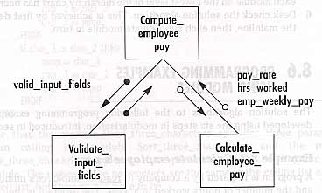

D Establish the logic of the mainline of the algorithm, using pseudocode
Here is the mainline algorithm.
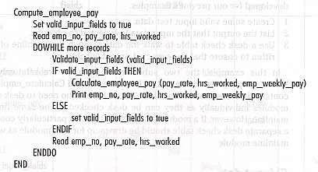

E Develop the pseudocode for each successive module in the hierarchy chart
Here is the algorithms for the rest of the modules.
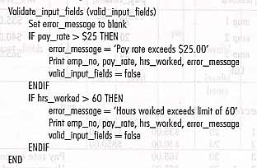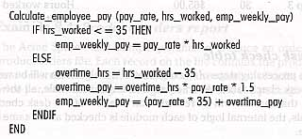

F Desk check the solution algorithm
Now, we create some valid input test data, calculate the expected results, and desk check the algorithms.

Input data
Here are four test cases, since EOF is a test case!
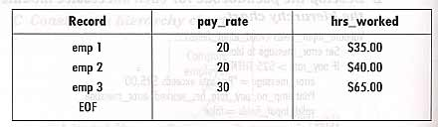

Expected results
Here are the expected results.
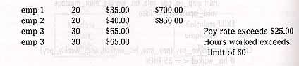

Desk check table
Here are the results of doing the desk checking.
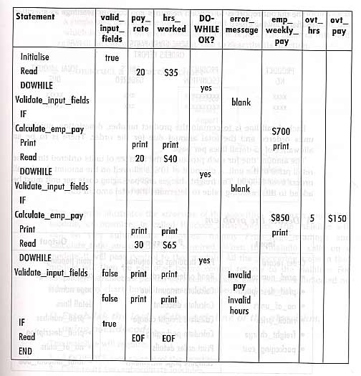

Example 8.4 Produce orders report
A program is to read a product orders file and produce an orders report. Here is a sample of the output report.
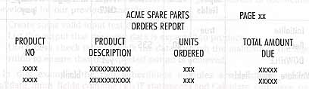

A Define the problem
Here is the IPO chart.
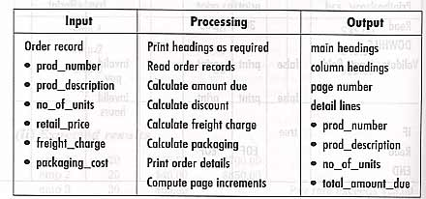

B Group the activities into modules
The modules are Print_page_headings, Calculate_total_amount_due, and the mainline of Produce_orders_report.

C Construct a hierarchy chart
Here is a hierarchy chart! It really is!
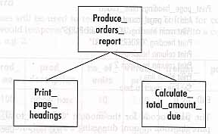

D Establish the logic of the mainline of the algorithm, using pseudocode
Here is the algorithm for the mainline module.
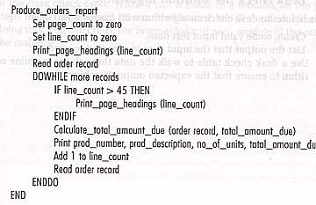

E Develop pseudocode for each successive module in the hierarchy chart.
Here are the other two algorithms.
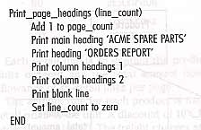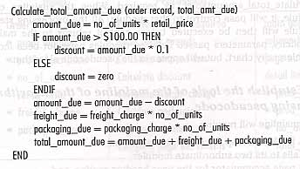

F Desk check the solution algorithm

input data
Here are four sets of test data.
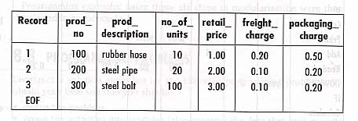

Expected results
Here are the expected results with sample titles and column headings.
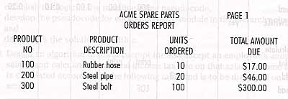

Desk check table
Here are the results of desk checking the program.
