Software Testing

The Ehrlich Principle:
To err is human, but to really foul things up requires a computer.

Testing =
The process of exercising a program with the specific intent of finding errors prior to delivery to the end user.

Purpose of testing:
- Logic testing
- Usability testing
- Performance testing

Who tests software?
- Developer
- Independent tester

Approaches to testing:
- Black box: Exercise all functional requirements for a program.

- White box: Exercises all program logic paths, checks all loop execution constraints, and internal data structure boundaries.
In terms of scope
- Exhaustive
- Selective

In terms of levels
- Unit testing
- System (Integration) testing Alpha testing
- Acceptance testing
- Beta testing (target: a sample of the intended audience)
In terms of direction
- Top down testing
- Bottom Up testing
- Sandwich testing

An exercise in program testing

An Exercise in Program Testing

Consider a program that accepts any three positive numbers as input and then displays whether the triangle whose three sides are equal to these three numbers is equilateral, isosceles, or scalene. It displays the output in the following format:

The triangle formed by these three numbers is . . .

For example, if the user entered 2, 2, 3, then the response would be:

"The triangle formed by these three numbers is isosceles."

The following logic has been proposed for this program:

Read A, B, C

Y Y
A = B
A = C
Equilateral

N N
A = C
Isosceles
Y

N
Scalene

Test the above logic with the following test data, and document the results of each test case.

Test  Case | Condition  Tested | Test Data  A B C | Expected  Result | Actual  Result | O.K.?  (Y/N)
1 | A = B = C |  | Equilateral
2 | A = B ≠ C |  | Isosceles
3 | A ≠ B = C |  | Isosceles
4 | A = C ≠ B |  | Isosceles
5 | A ≠ B ≠ C ≠ A |  | Scalene

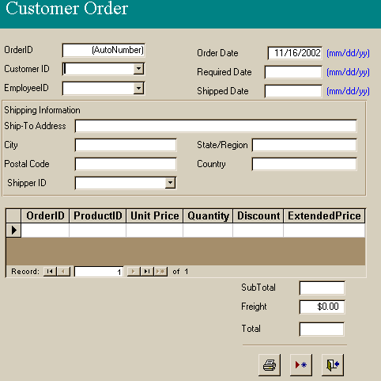

Software Testing Template

Module Tested: ________________________

Test Performed By: _____________________ Date: _____________

Feature  Tested | Test  Data/Event | Expected Result | Actual  Result | Action

Software Testing Case Study

Module Tested: Process Customer Order
Test Performed By: Sasan Rahmatian Date: November 18, 2004

Feature  Tested | Test  Data/Event | Expected Result | Actual  Result | Action
OrderID is assigned automatically  Customer is entered thru drop down menu  Customer name is shown when customer selected  Order date appears by default  Required date is by default a week past order date  Shipped date has input mask: mm/dd/yyyy  Ship-to address appears by default  Unit price is retrieved by default  Extended price is calculated correctly  Subtotal is calculated correctly  Total is calculated correctly | Enter customer or employee  Click on drop down arrow  Enter customer 113  Open order form  Open order form  Place cursor in shipped-date field  Enter customer 113  Select product P1  Product = P1  Quantity = 10  Discount = 50  Add to above: Product = P10  (price = $7.00)  Quantity = 2  Discount = 0  Freight = 5 | OrderID assigned automatically  Drop down menu includes all customers  McDonalds  11/16/2002  11/23/2002  12/04/2002  default address  1.25  6.25  (6.25 + 14 =)  20.25  25.25 | Same  Same  113  Same  Blank  12/04/02  Blank  Same  Same  Same  Same | …………..  …………..  …………...  …………...

Feature  Tested | Test  Data/Event | Expected Result | Actual  Result | Action
Retrieved data (unit price) cannot be tampered with.  Cannot close a transaction with incomplete data  There is a Cancel Transaction function  Historic data cannot be tampered with | Click in UnitPrice  Leave employee field blank  Close a transaction without saving it  Change Quantity in a past record | Cannot click in UnitPrice  System produces error message  Record is not saved  Cannot change | CAN click in UnitPrice  System saves incomplete record  Record is saved  Same | ………..  …………  ………..

