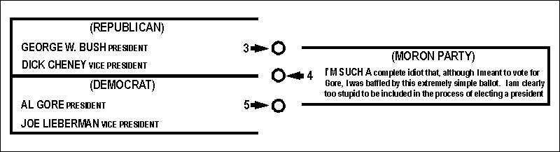

Who Should Design the User Interface?!

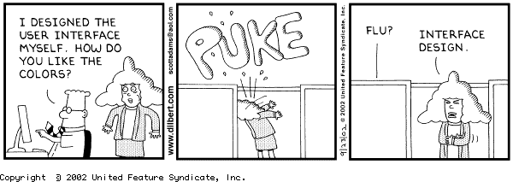

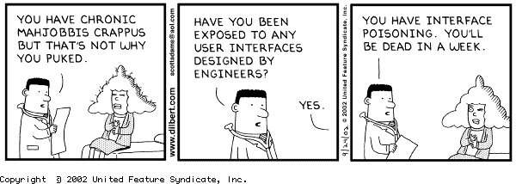

Alarm Clock Settings

Alarm Alarm Set Set
On Off Alarm Clock

A Near-Miss

KLM Flight XYZ from London to Rotterdam – originally scheduled for 7 pm

Arrival at the terminal at 6 pm

PA System:
“KLM Flight XYZ has been delayed. Please go to your gate for the latest information”

At the gate:
Flight Number Boards At ...........
........................ ...
........................ ...
KLM XYZ 9
........................
........................ ...

“We will make the boarding announcement when the time comes”

The 6:30 pm announcement ........

How are the following screens different?

Reply to a Message:
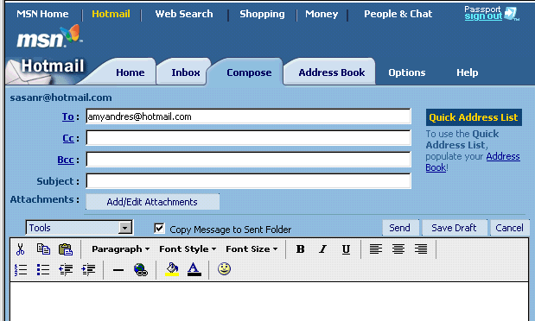

A Sent Message:

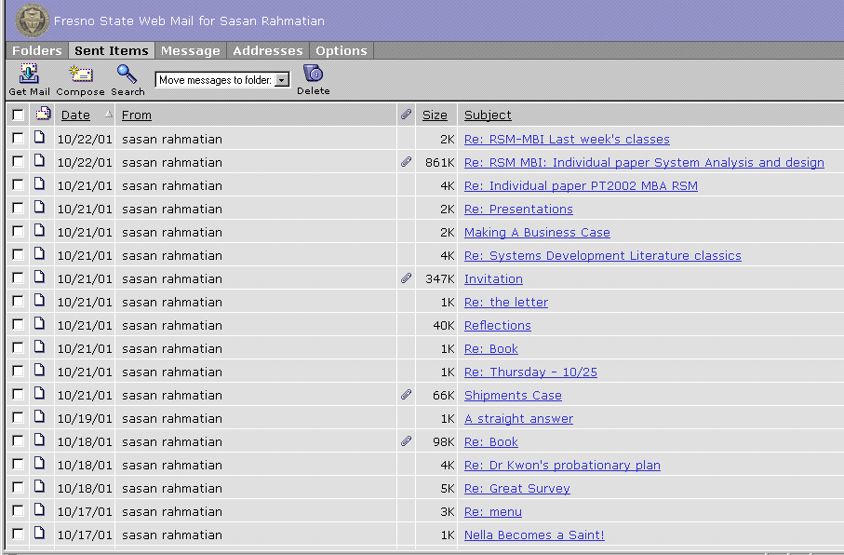

What happened to the gray?!

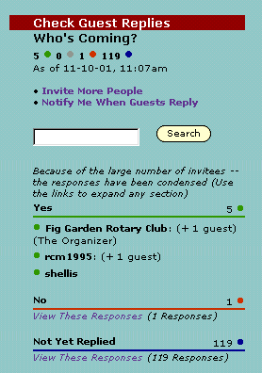

Green

Red

Blue

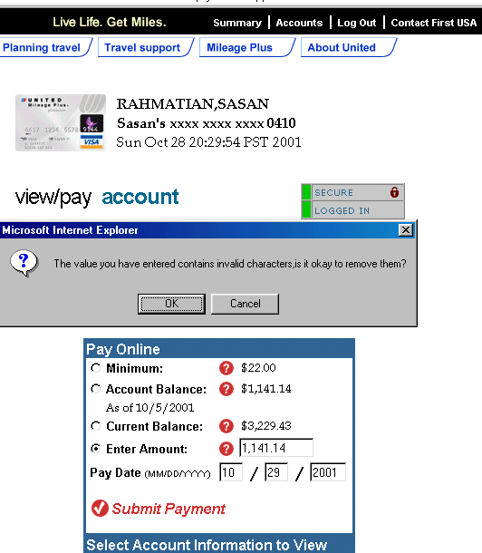

The status screen one minute into downloading

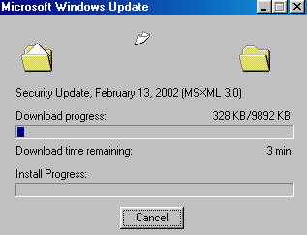

Amazon.com: Order Review

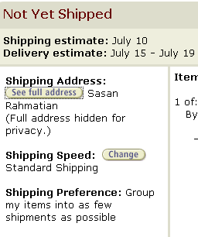

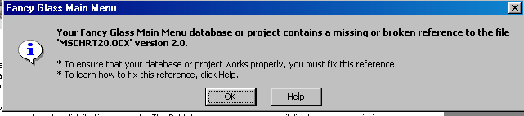

Norton Antivirus

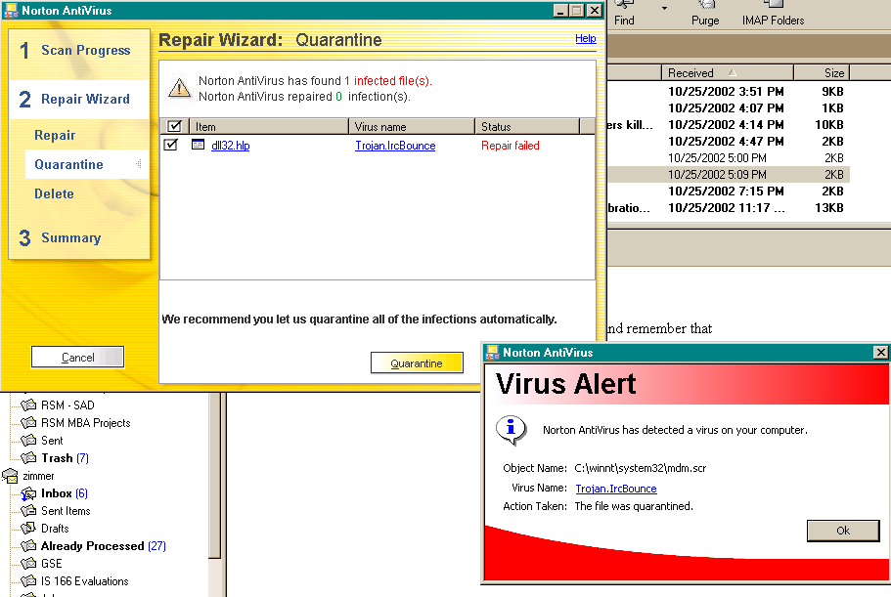

Clicking on OK would not close the Virus Alert window.

It closed after 10 clicks!

http://journalsurvey.jitta.org/

